Model-based non-invasive assessment of respiratory muscle strength.
Ella F. S. Guy¹, Jaimey A. Clifton¹, Trudy Caljé-van der Klei¹, Lui R. Holder-Pearson², Jennifer L. Knopp¹, J. Geoffrey Chase¹
¹Mechanical Engineering Department, University of Canterbury, Christchurch, Canterbury, New Zealand.
²Electrical and Computer Engineering Department, University of Canterbury, Christchurch, Canterbury, New Zealand.
Introduction/Aim:
Maximal inspiratory and expiratory pressures are current clinical indicators of muscular strength, but highly technique dependent. It is hypothesized muscular work of breathing (WOB) trends will show a strength dependent response to a challenge (e.g. load, resistance, or PEEP). This study aims to develop a simple method of assessing muscular WOB, which could then be analysed in relation to strength in clinical testing.
Method:
Pressure and flow sensors record respiratory data as a person breathes normally through a tube with a shuttered occlusion every 0.02s for 0.20s during expiration. Passive lung mechanics are identified based on the interrupter technique. Muscular and overall WOB is calculated using a clinically validated single compartment lung model and second-order b-splines. A mechanical test lung with set compliances of 0.03 and 0.05 L⁻¹cmH₂O, a 5cmH₂O parabolic resistor (2.70 cmH₂O at 1 L⁻¹s), and tidal volumes of 0.5, 1.0, 1.5, and 2.0 L (10 hand actuated breaths at each combination) is used for validation with identified mechanics compared to set values.
Results:
Median identified compliances were 0.0348 and 0.0521 L⁻¹ cmH₂O, for 0.03 and 0.05 L⁻¹cmH₂O settings, with differences likely caused by manual spring-setting error and non-linearity in spring elastance with extension/tidal volume. Identified resistances ranged from 1.6-3.4 cmH₂OL⁻¹s, which are within expected ranges for the expiratory flow range (0.0-2.9 L⁻¹s). Absolute model-identified muscular WOB increased with increased tidal volume and elastance (Figure 1).
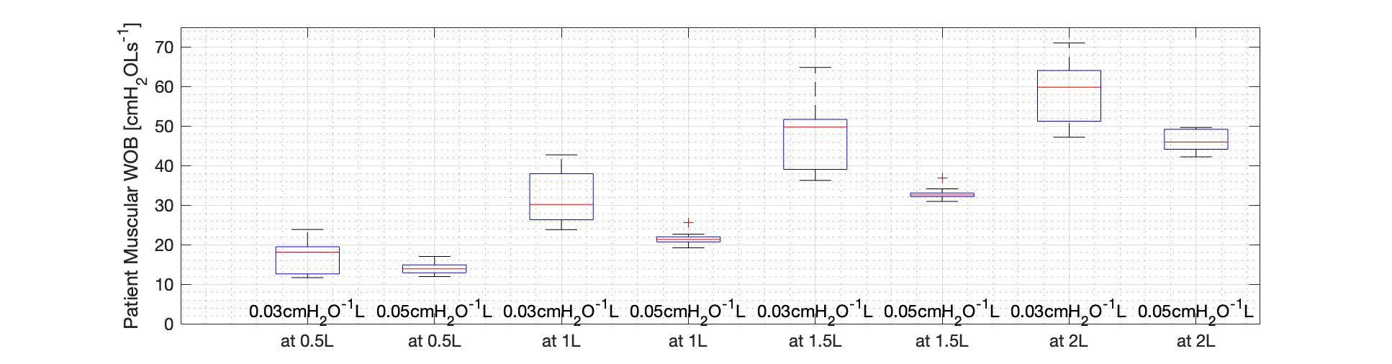
Figure 1: Distribution of muscular WOB, generated by hand-actuation (lifting bellows) on the mechanical lung.
Conclusion:
Mechanical test lung results provide proof-of-concept validation for a normal breathing test method to assess muscular breathing effort and WOB. Future clinical testing of known cases of respiratory muscle weakening against a control group would characterise relationships between muscular strength and recruitment and further validate potential clinical monitoring utility.
Key Words: Work of Breathing, Muscular Strength, Mechanics, Remote Monitoring
Grant Support: Te Tītoki Mataora MedTech Research Translator Research Acceleration Programme Stage 1 Project.

