An Artificial Intelligence Algorithm for Meal Announcement Free Automated Insulin Delivery

Introduction: Current Automated Insulin Delivery (AID) systems used for the treatment of Type 1 Diabetes (T1D) require human-machine teaming, with user input at least for announcing and estimating meal carbohydrates. This manual intervention is cognitively burdensome for people with T1D and their caregivers.

Aim: Design and develop fully automated personalised treatment strategies using Artificial Intelligence (AI) and demonstrate, both quantitatively and visually, their ability to eliminate the need for manual input for meals without worsening outcomes.

Methods: We implemented the Implicit Q-Learning (IQL) algorithm to produce a fully automated AID-system which analysed glucose measurements/insulin delivery patterns in 1-hour windows to estimate the subsequent insulin dosage required. We then assessed the performance of IQL on clinically-sourced data for 310 adult subjects (18-70-year-olds) with hybrid closed loop pump systems using manual meal adjustments, drawn from the T1-DEXI dataset, provided by the Helmsley Charitable Trust.

Results: Our fully closed loop IQL method was estimated to achieve a significant, though marginal, improvement (p < 0.001), as calculated though a paired 2-tailed t-test, in estimated glycaemic control performance over a baseline behavioural cloning method, while not diverging too drastically from the original hybrid closed loop pump system it trained from.

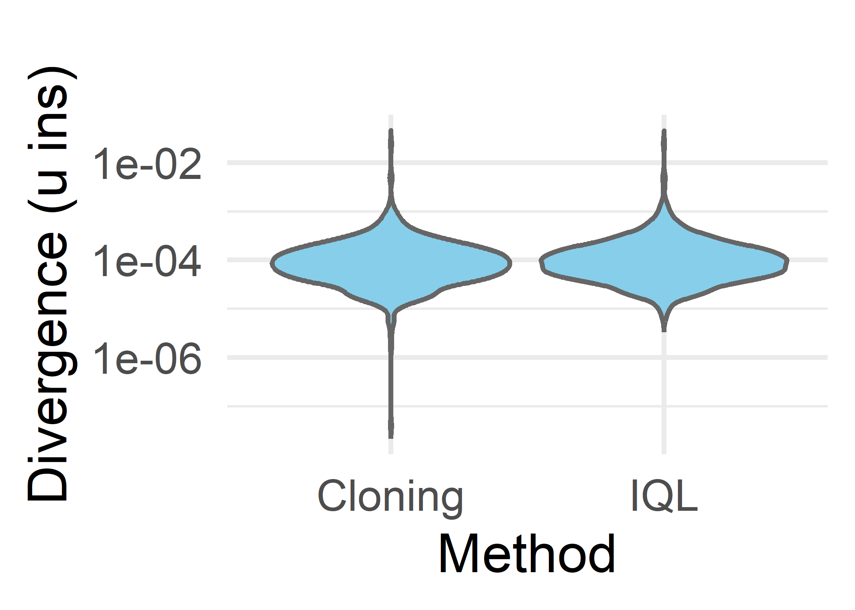
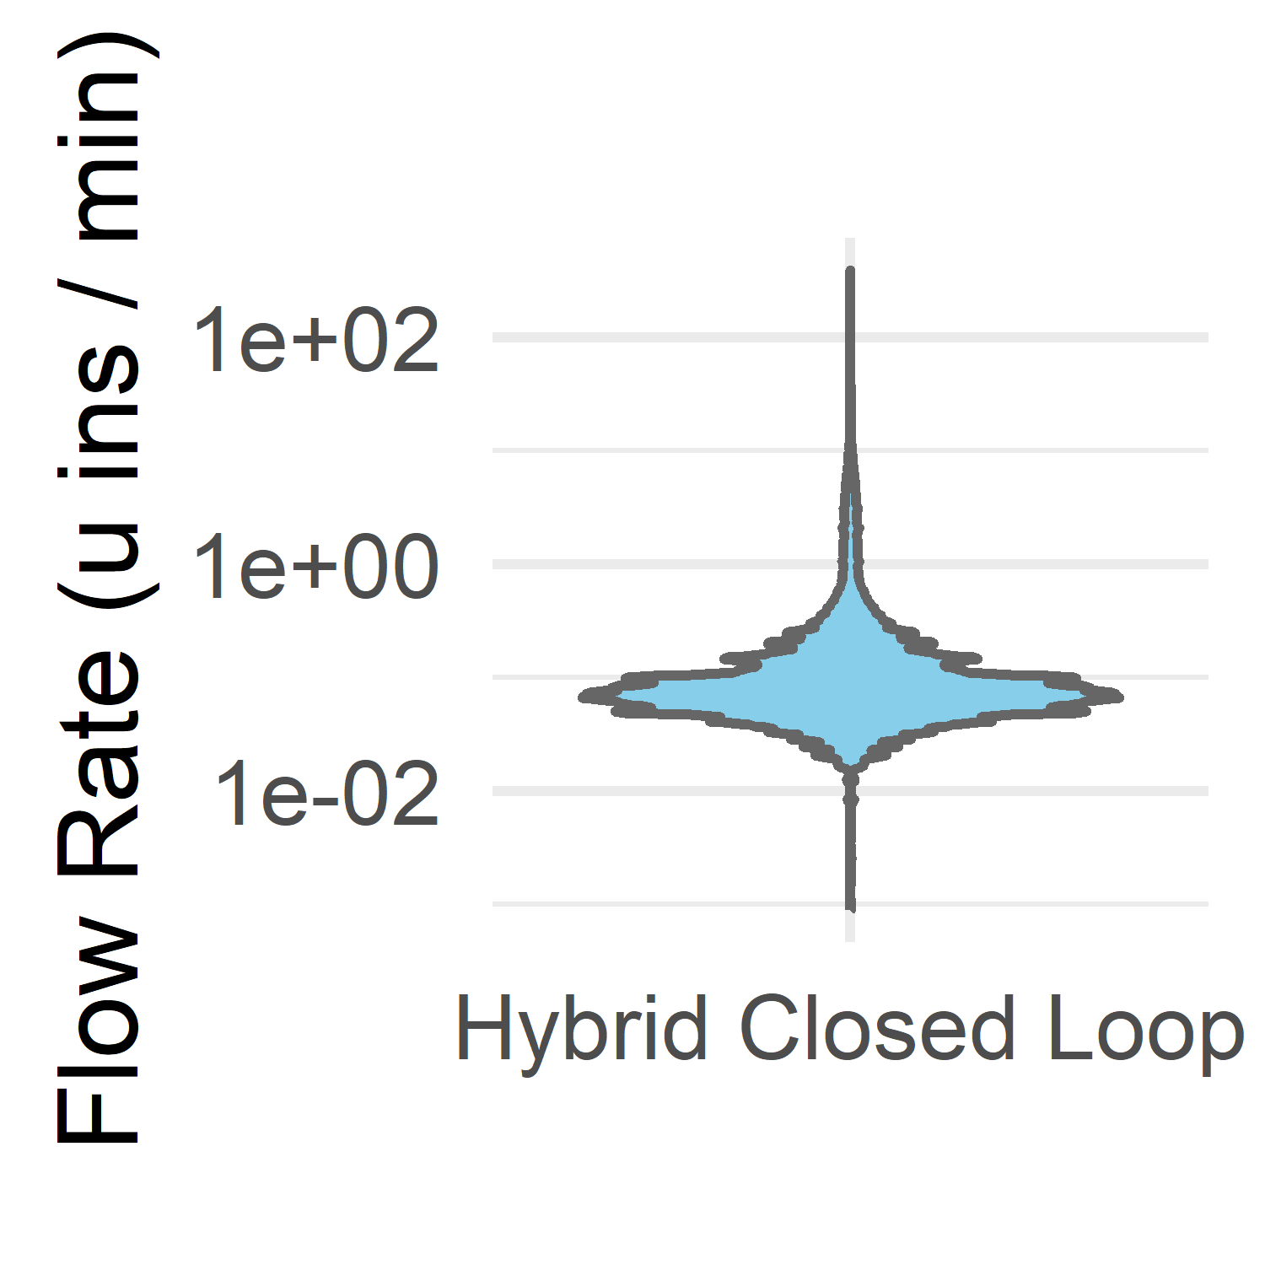
A. B.
Fig 1. (A) Distribution and (B) Divergence of Insulin Flow
Rates by Method. Data shown on a log scale, and
divergence calculated by Mean Squared Error (MSE).
Values where no insulin is given are excluded from the
distribution.

Conclusion: Our systems validate that manual meal announcement and carbohydrate estimation may not be necessary for effective AID-systems. Supporting analytical validations on digital twins of subjects provided further evidence for efficacy, supporting potential further clinical validation studies, with appropriate safety guardrails in place.

