Comparison of different oximetry devices during six-minute walk tests
Marshall E^{1,3}, Filiex A², Schulte M³, Logie KM³, Gin J⁴, Horrigan M⁴ , Dowman L^{1,2,5} Churchward TJ^{1,3}, Khor YH^{1,3,6}
¹Institute of Breathing and Sleep, Victoria, Australia
²Respiratory Research@Alfred, Monash University, Victoria, Australia
³Department of Respiratory and Sleep Medicine, Austin Health, Victoria, Australia
⁴Department of Cardiology, Austin Health, Melbourne, Victoria, Australia
⁵Department of Physiotherapy, Austin Health, Melbourne, Australia
⁶Department of Medicine, University of Melbourne, Victoria, Australia
Introduction/Aim: Pulse oximetry is commonly used to assess the oxygenation status in patients with cardiac or respiratory diseases. Different devices are available for measuring pulse oximetry. This study aimed to compare the performance of three test oximetry devices (BioBeat Wristwatch, Nonin Wrist-ox₂ 3150 Oximeter, and Heart Sure Pulse Oximeter A320) against the existing clinical standard oximeter (Masimo Rad-5) during 6-minute walk tests (6MWTs).
Methods: This was a single-centre prospective study with 10 participants being recruited for each of the five groups: chronic obstructive pulmonary disease, interstitial lung disease, pulmonary hypertension, oxygen users, and other cardiac/respiratory diseases. All participants completed a 6MWT wearing the 4 oximetry devices. Oxygen saturation (SpO₂) were recorded every 30 seconds during 6MWT. The percentage of missing SpO₂ data for each test oximetry device was assessed. Participants were asked to rate their preference amongst the test oximetry devices.
Results: The study population primarily consisted of females (58%) with a mean age of 68 (SD 13) years. For nadir and mean SpO₂ during the test (Table), compared to Masimo Rad-5, the Nonin WristOx had lower measurements (p=0.01) and the Biobeat had higher measurements (p<0.01), with no differences for the Heart Sure (p=0.60). Time spent at SpO₂ ≤ 88% was higher for the Nonin WristOx (p<0.01) and lower for the Heart Sure (p<0.01) compared to that for the Masimo Rad-5. A substantial amount of SpO₂ data was missing for the Biobeat (80%) due to device technical errors. Most participants (n=31) preferred using the Biobeat, followed by Heart Sure (n= 11).
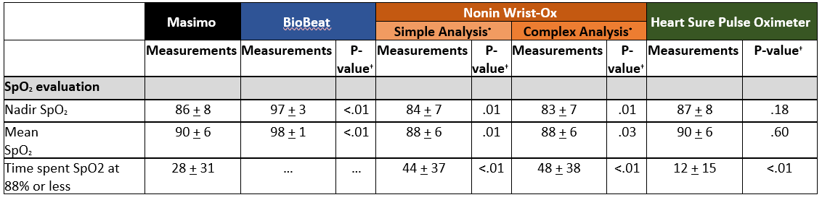
Conclusion: The Heart sure has the most comparable performance for SpO₂ measurements to the clinical standard oximeter. While the BioBeat is preferred by patients, it appears to be challenging for clinical use due to device technical errors.
Grant Support: Nil

Key Words: Pulse Oximetry, 6MWT, Cardiopulmonary.

