Obstructive lung disease in an adult with prior bronchopulmonary dysplasia
Weiling, Lim¹
¹ Respiratory and Critical Care Medicine, Changi General Hospital, Singapore
Introduction/Aim:
Bronchopulmonary dysplasia is a chronic respiratory disease seen in premature infants who require postnatal respiratory support. The effects of neonatal lung injury in this group of patients may extend into adulthood. A case of obstructive lung disease in an adult patient with previous bronchopulmonary dysplasia and its computed tomography (CT) pulmonary findings are described in this report.

Case Report:
A 29-year-old gentleman presented with seizures due to extensive cerebral venous thrombosis complicated by intracranial hemorrhage. His background was significant for bronchopulmonary dysplasia requiring prolonged neonatal intensive care and mechanical ventilation as well as childhood asthma. A CT scan of the thorax, abdomen and pelvis to evaluate for underlying malignancy revealed incidental findings of paraseptal, centrilobular and panlobular emphysematous changes in bilateral upper lobes, left lower lobe congenital lobar emphysema and a right lower lobe bronchocele due to airway atresia. There was no history of regular exposure to tobacco smoking or air pollution. Alpha-1 antitrypsin levels were normal. He reports chronic productive cough with minimal sputum production. There is no dyspnea at rest or on exertion. He experienced previous episodic wheezing and breathlessness as well as exertional dyspnea in his childhood, but these symptoms have improved over the years. Pulmonary function test showed moderately-severe airflow obstruction with significant bronchodilator reversibility, moderately reduced DLCO and alveolar volume as well as air trapping. TLC and KCO (transfer coefficient for carbon monoxide) were normal. He was diagnosed with chronic obstructive lung disease and started on bronchodilators with significant clinical improvement.

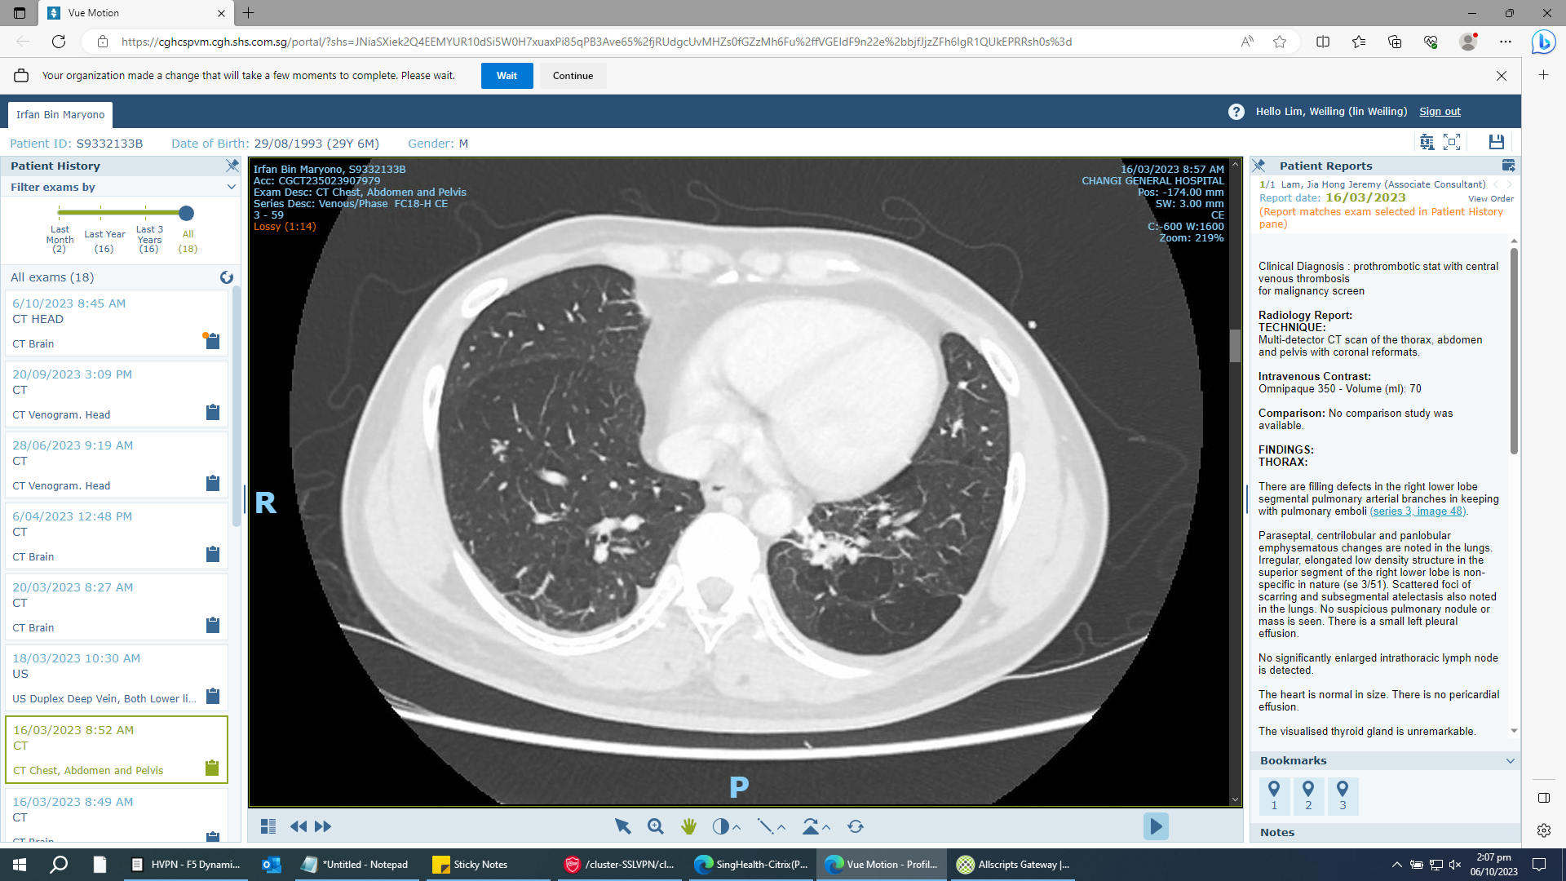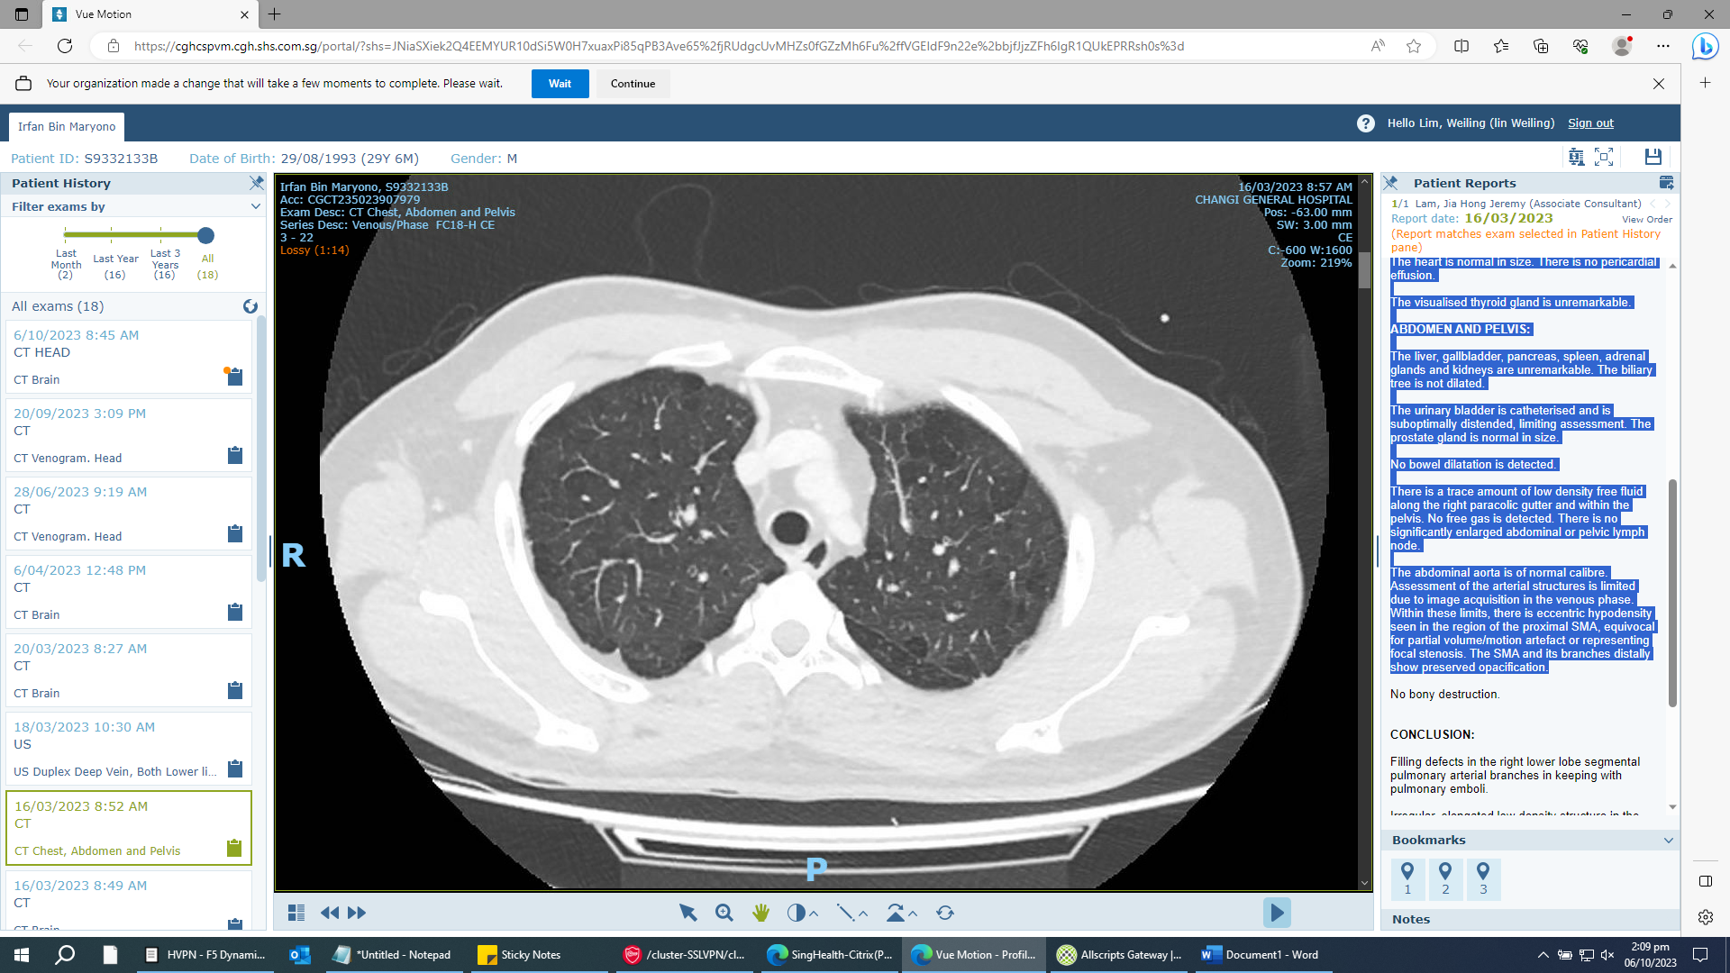
Figure 1. Chest CT shows left lower lobe congenital lobar emphysema (arrow, left image) and bilateral upper lobe emphysema (right image)

Conclusion:
The development of chronic obstructive pulmonary disease (COPD) in patients with prior bronchopulmonary dysplasia is a relatively new entity and may be considered as a new COPD endotype. The long-term complications of bronchopulmonary dysplasia should not be overlooked when evaluating an adult COPD patient with no obvious causative environmental or genetic factors for COPD.

Key Words: Adult, Bronchopulmonary dysplasia, Obstructive lung disease.
Declaration of interest: None

