Topic coverage and working party representation of TSANZ documents
William C.L Soon¹, Yvonne Ng², Daniel Seow³, Arwel W. Jones⁴, Yet H. Khor^{1,4,5}
¹Austin Health, Melbourne, VIC, Australia
²Monash Lung Sleep Allergy Immunology, Monash Health, Clayton, VIC, Australia
³Department of Internal Medicine, Sengkang General Hospital, Singapore
⁴Respiratory Research @Alfred, Monash University, VIC, Australia
⁵Institute of Breathing and Sleep, VIC, Australia
Introduction/Aim: The Thoracic Society of Australia and New Zealand (TSANZ) is the leading Australasian professional society for respiratory medicine that develops clinical practice guidelines and position statements to advance lung health through improved clinical care and research efforts. This study reviewed TSANZ guidance documents with a focus on the topic coverage and working party representativeness.
Methods: Published TSANZ guidance documents were identified from the Society online repository up to March 2023. Each document was independently assessed by two reviewers (YN and DS), with discrepancy being resolved by a third reviewer (WS). Data extracted included document publication year, document types, topic category, and working party memberships (representing state, territory, or country; methodologist involvement).
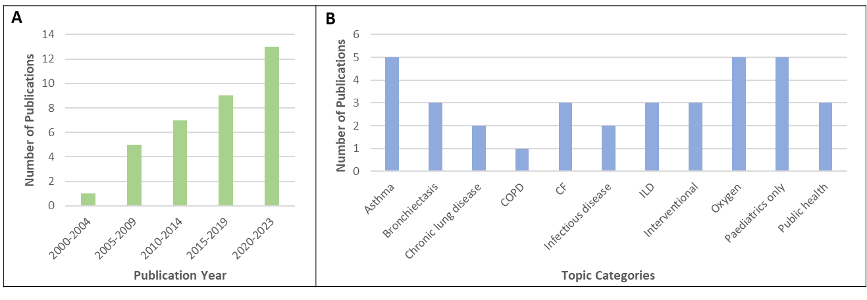
Results: A total of 35 TSANZ guidance documents were published between 2002 and 2023. An increasing trend in the number of documents published over the last two decades was noted, with the highest number of 13 documents in the last 3 years (Figure 1A). There were 25 position statements, 7 clinical practice guidelines, 2 short reports, and 1 training guideline. The published guidance documents covered 14 different topic categories, with the most featured ones being asthma (n=5) and oxygen (n=5) (Figure 1B). The working party memberships were geographically most represented from Victoria (97%), followed by New South Wales (91%), Queensland (75%), Western Australia (66%), New Zealand (62.5%), and South Australia (56%), with Tasmania (25%), Northern Territory (12.5%), and Australian Capital Territory (9%) being under-represented. Two documents featured an international affiliation. Only 5 TSANZ guidance documents listed the involvement of a trained methodologist in their development.
Conclusion: While there has been a steady increase in the number of TSANZ publications over the years, there remain several topics without society guidance documents, as well as a lack of involvement of methodological expertise and unequal representation across states, territories, and countries.
Grant Support: Nil

