The performance of TECIS for forest parameters estimation by combination of waveform LiDAR and multi-angle optical observations
Introduction/Aim:
Accurately measurement of forest parameters is essential and challenging topic in forest remote sensing field. China’s terrestrial ecosystem carbon monitoring satellite (TECIS) was successfully launched on August 4, 2022, becoming the world’s first satellite for forest detection by integrating active and passive sensors. TECIS incorporates two key sensors, namely the Carbon Sinks and Aerosol LiDAR (CASAL) and the Directional Multi-Spectral Camera (DMC). CASAL consists of five large footprint lasers operating in the near-infrared band at 1064 nm. Each laser captures waveform data within a footprint diameter of approximately 25 m. DMC consists of five Visible and Near-Infrared (VNIR) cameras with specific observation angles at 0°, ±19°, and ±41° angles with a swath width of 20 km. TECIS is the first mission for forest carbon mapping by integrating full waveform LiDAR and multi-angle optical observations. Here we will evaluate its performances in typical forest types from Europe and China.

Methods:
The estimated forest height and biomass products using airborne LiDAR and field plots were used as references. Then the waveform from CASAL were used to estimate forest height and biomass at footprint level using random forest model. The BRDF reconstructed DMC reflectance was used to spatial extrapolation according to the CASAL footprint estimations. A deep neural network (DNN) was built based on the training datasets from CASAL and DMC. At last, full coverage forest height and biomass maps could be obtained from the multi-angle optical images.
Results:
The detailed performances of TECIS in typical forests from boreal(Switzerland/Europe), temperate (Genhe/China), subtropical (Puer/China), and tropical (Hainan/China) will be shown. The wall to wall forest biomass mapping accuracy is higher than 85% when validated at 500 m * 500 m scale, and 2.5 km * 2.5 km scale.

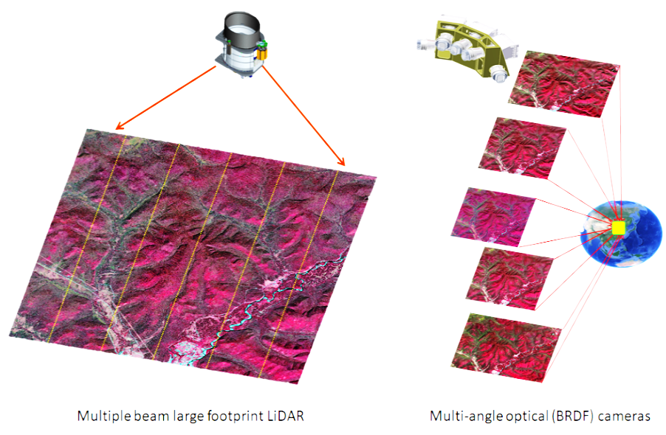
Fig.1 The full waveform LiDAR and multi-angle optical cameras configuration of TECIS
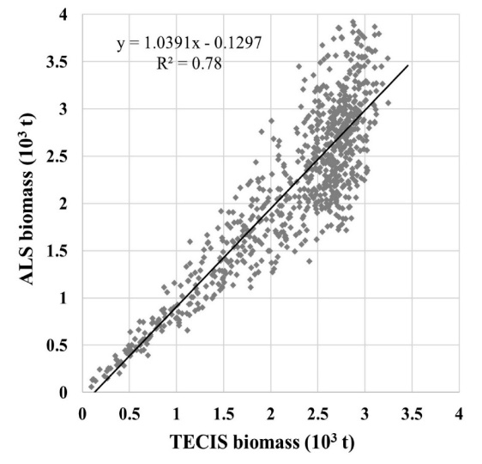 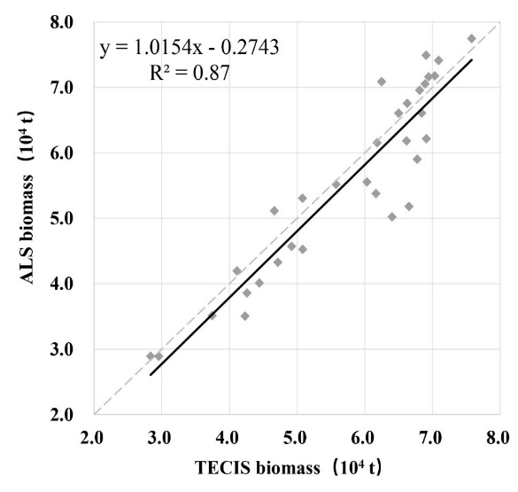
Fig. 2 Accuracy validation of biomass estimation at the (a) 500 m * 500 m and (b) 2.5 km * 2.5 km scale, respectively

Conclusion:
The TECIS satellite has achieved multi-beam (LiDAR) and multi-angle (optical) collaborative observation of forest parameters for the first time. Multi-beam full waveform LiDAR data provide forest parameter information at footprint level. Multi-angle information improves the wall-to-wall forest parameter estimation capacity.

Please note the headings provided are optional, please remove or change to best suit your content.

