**Evaluation of model of care using Health2Sync (H2S) App to support management of women with gestational diabetes.**

**Background & Aim**

To manage the increasing numbers of women with gestational diabetes (GDM), novel models of care (MOC) are needed. We developed a new MOC centred on implementing a digital App-based platform, Health2Sync (H2S). This enabled automatic syncing of glucose levels (BGLs) into an App with remote monitoring via a clinician dashboard. We aimed to assess acceptability, improve BGL monitoring and increase virtual care.

**Methods**

The H2S-supported MOC was implemented in August 2024 at Westmead Hospital, a quaternary centre in Sydney. Women received GDM education and onboarding support virtually. Synced BGLs and other individual data such as dietary input and insulin doses were automatically transmitted to the dashboard. The cohort was monitored via the dashboard, with regular virtual communication and escalation where indicated (see flowchart). Acceptability was evaluated by H2S utilisation and patient surveys. Indication for insulin commencement and modality of diabetes educator reviews were compared between the periods 12 months pre and 9 months post-H2S implementation.

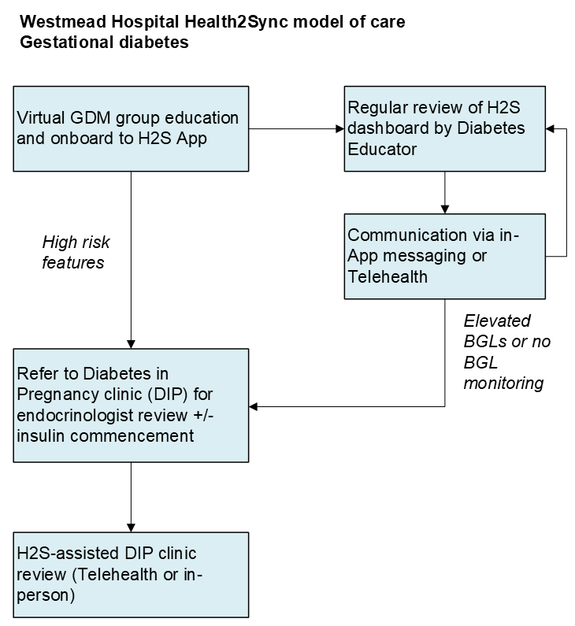

**Results**

There were 1010 women with GDM 12 months pre (1/08/2023-31/07/2024) and 708 women 9 months post-H2S (1/08/2024-30/04/2025). Four women declined or were unable to use H2S; none were interpreter-requiring. Of 73 patient survey respondents, H2S eased data sharing for all and improved overall experience for 64 (87.7%).

Insulin commencement was indicated in 435 (43.1%) pre and 340 (48.0%) post-H2S (p=0.04). Of all diabetes educator consultations, virtual reviews comprised 3287/4586 (71.7%) pre and 1933/2606 (74.2%) post-H2S (p=0.02). For the latest three months (1/02/25-30/04/2025), all follow-up reviews were virtual, 644 (53.8%) via in-App messages and 533 (46.2%) via Telehealth.

**Discussion/Conclusion**

The H2S-supported MOC has increased virtual consultations for GDM, facilitating improved remote data sharing and communication. There has been high acceptability. H2S may also have increased identification of hyperglycaemia needing insulin. Overall, H2S has been a valuable tool in supporting a hybrid App-supported MOC for GDM.