**Abstract title:**

A dose-response association between the presence of risk factors/comorbidities and diabetic foot complications in patients with type 1 and type 2 diabetes

**Aim:** To investigate the association between diabetic foot complications and the presence and number of comorbidities/cardiovascular risk factors in adults with type 1 (T1DM) and type 2 diabetes (T2DM) including novel discordant comorbidities.

**Methods:** Diabetes-related lower-extremity complications (DRLECs), defined as a composite of diabetic neuropathy, foot ulcer and amputation, were evaluated in a cross-sectional analysis of 7,068 adults with T1DM and 17,424 with T2DM from the Australian National Diabetes Audit between 2015-2022. A mixed effect logistic regression model was used to analyse the relationship between the number of comorbidities and/or risk factors and the presence of DRLECs. Diabetes-discordant comorbidities included dementia, depression, malignancy and liver disease. Diabetes-concordant comorbidities included stroke, CABG, MI, CCF, PVD, CKD (eGFR<60ml/min/1.73m2) and retinopathy/blindness.

**Results:** DRLECs were present in 24.2% (5,926/24,492) of patients with 2.4% (598/24,492) having all three. A dose-dependent association was found between the total number of comorbidities and DRLECs and patients with more than 4 comorbidities having the highest odds of foot complications (Figure 1). Patients with ‘concordant comorbidities only’ had significantly increased risk of DRLECs (OR 4.66, 95% CI 3.45–6.29, p<0.001) but not those with ‘discordant comorbidities only’ (p=0.213). The odds of DRLECs were also significantly higher in individuals with cardiovascular ‘risk factors only’ (OR 1.28, 95% CI 1.11–1.48, p=0.001).

**Conclusion:** There is a significant dose-response association between the number of comorbidities and DRLECs in patients with T1DM and T2DM. Identifying DRLEC risk factors should enable implementation of preventive measures.

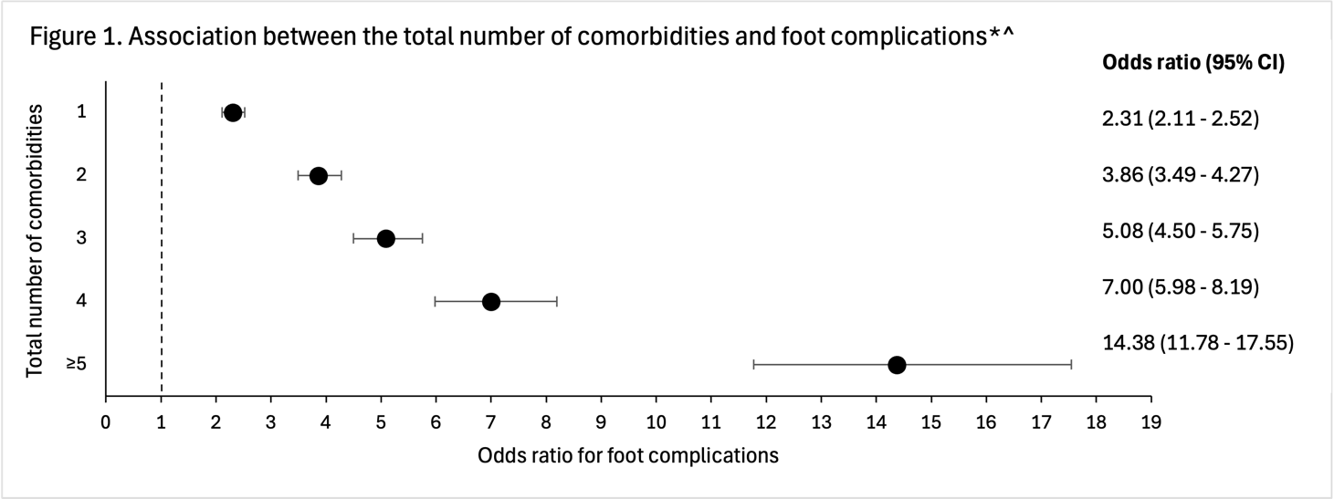

*Adjusted for age, sex, type of diabetes, duration of diabetes, HbA1c, year of visit and cardiovascular risk factors

^P-value <0.001 for all odds ratios