Among inpatients with diabetes, cardiovascular disease prevalence is high and cardioprotective medication usage is low

Background/Aim: Australian reports of inpatients with diabetes that examine their prevalence of cardiovascular diseases, procedures, and devices are scant. We aimed to characterise this population, and to examine cardioprotective glucose-lowering medication use (SGLT2 inhibitors and injectable incretin mimetics).

Methods: We performed a hospital-wide audit in November 2025 of all acute inpatients with diabetes admitted for any condition to a quaternary hospital in Victoria. Data were collected at two timepoints: during admission (demographic and clinical data) and at 30-day follow-up (medications for inpatients discharged by this time).

Results: 162/537 (30%) inpatients had diabetes. Among those with diabetes, 49% were women, the median age was 72 years-old (IQR 63−81 years), and 8.6% had newly-diagnosed diabetes. Of the inpatients with diabetes, 95/162 (59%) had prior or current cardiovascular disease, had undergone a cardiac procedure, and/or had a cardiac device in situ (Figure). Of the inpatients with diabetes and cardiovascular disease, 91/95 were discharged by 30-day follow-up. Of these 91 discharged inpatients, 27/91 (30%) were taking an SGLT2 inhibitor prior to admission, of whom six ceased it on discharge. 2/91 (2.2%) patients had a new SGLT2 inhibitor commenced during admission. 8/91 (8.8%) inpatients were taking an injectable incretin mimetic prior to admission and all continued it on discharge. No patients had an incretin mimetic started during admission.

Conclusions: Most inpatients with diabetes have cardiovascular disease. Among inpatients with diabetes and prior or current cardiovascular disease, rates of cardioprotective glucose-lowering medication prescribing are low.

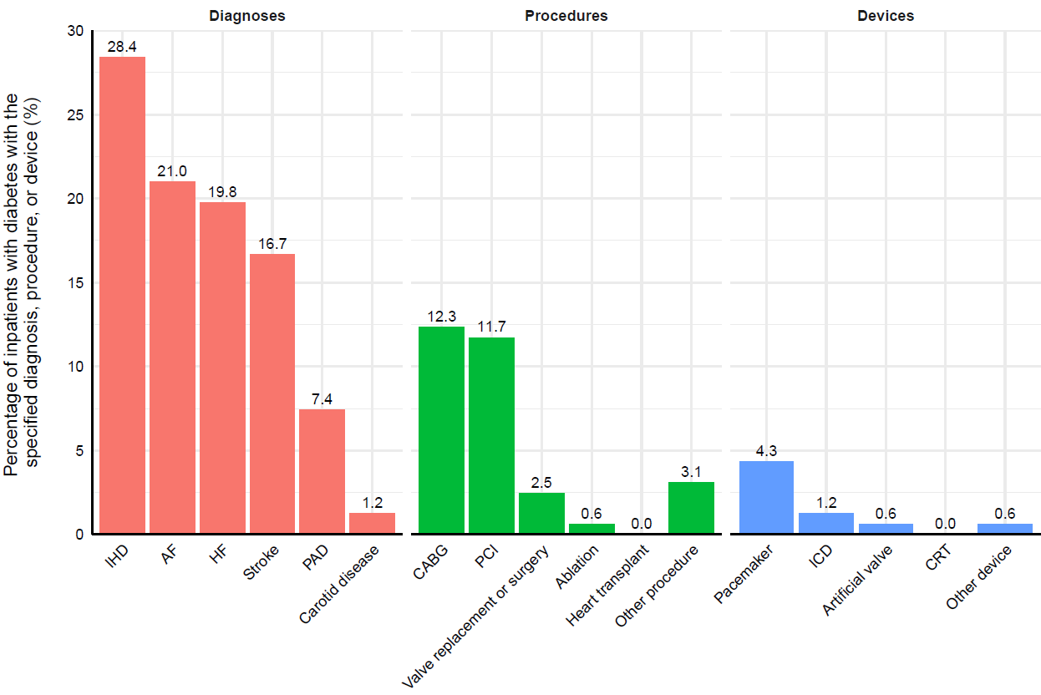
Figure. Point prevalence (%) of cardiovascular diagnoses, procedures, and devices among 162 inpatients with diabetes. Bars arranged in descending order within colour groups, with the exception of ‘Other procedure’ and ‘Other device’. IHD = ischaemic heart disease; AF = atrial fibrillation; HF = heart failure; PAD = peripheral artery disease (lower limb only); CABG = coronary artery bypass graft; PCI = percutaneous coronary intervention; Ablation = cardiac ablation procedure; Other procedure = other cardiovascular procedure; ICD = implantable cardioverter-defibrillator; CRT = cardiac resynchronisation therapy; Other device = other cardiovascular device.

