Paper
Emerging living islands: An architectural framework for island growth in coral reef environments

Over the past decades, increased population demands, limited land resources, and tourism development are key drivers of artificial land expansion in coral reef environments. Current methods for creating artificial islands on atolls involve either land reclamation or raised structures on stilts, both of which have been linked to ecosystem degradation. This research explores an alternative architectural approach that supports island growth by utilising the existing natural resources and integrating corals as fundamental elements in the design, offering a more sustainable strategy for low-lying coral islands.
This study aims to develop a force-based design framework that integrates environmental, coral, and human systems and their subsystems to generate Living Islands. The main objectives are two. First, to identify the environmental, coral and human-driven variables/forces that affect island formation. Second to develop a design framework that leverages these forces to grow habitable land both for humans and corals.
This research adopts a design-systems thinking approach, using mixed methods to develop and test its framework:
- Multidisciplinary literature review to examine island formation, coral ecology, and adaptive architecture.
- Field studies in the Great Barrier Reef and Maldivian atolls to assess environmental conditions and ecological synergies.
- Workshops and interviews with architects, ecologists, coastal and environmental engineers, and local communities.
- Research by design, using prototyping and computational modelling to explore design strategies.
The framework consists of three phases, a) Information Gathering – Identifying key forces and setting design priorities. b) Design Synthesis – Translating environmental and coral-driven forces into architectural proposals. c) Evaluation – Assessing the ecological and structural viability of the developed concepts (Figure 1).
The study finds that activating specific ecological and design variables triggers interdependent system responses, influencing island formation. Using coral growth as a primary design driver, the research demonstrates how built interventions can foster rather than disrupt reef and island development. The force-based framework ensures that design solutions remain adaptive, scalable, and ecologically integrated.
This research introduces a new design model for island formation, shifting from static land reclamation to dynamic, coral-driven growth strategies. The framework provides:
- A sustainable design methodology for integrating architecture with coral reef ecosystems.
- A scalable solution for climate adaptation in atoll environments.
- Guidelines for architects, policymakers, and conservationists to support island development in coral reef environments.
The force-based framework presents an alternative vision for climate-resilient island formation, balancing human and coral needs with the environmental forces.

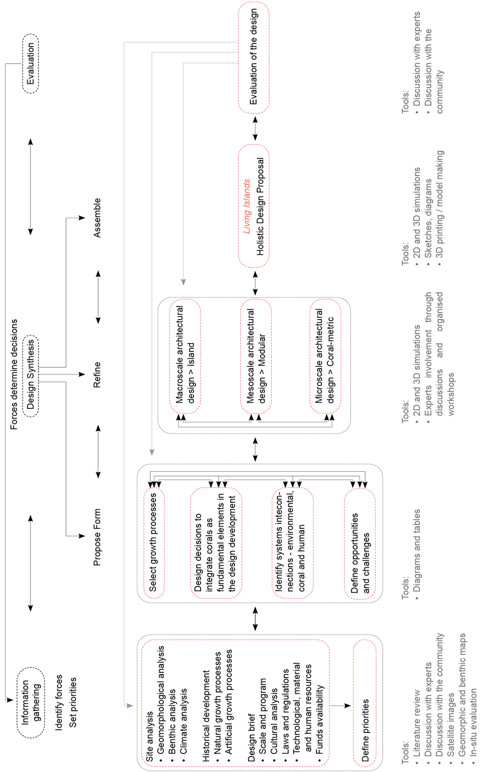
Figure 1 Phases and steps within the framework to grow Living Islands.

