Preventable respiratory hospital readmissions and the utilisation of reduction strategies
Adam Sykes¹, Thomas Knowlman^{1,2}, Bronwyn Learmouth¹, Ian A. Yang^{1,2}, Philip Masel^{1,2}
¹ Department of Thoracic Medicine, The Prince Charles Hospital, Queensland, Australia
² Faculty of Medicine, The University of Queensland, Queensland, Australia
Introduction/Aim:
Hospital readmissions signal potential inefficiencies in healthcare. Since July 2021, the Independent Hospital Pricing Authority (IHPA) introduced risk-adjusted penalties for readmissions deemed preventable by the Australian Commission of Safety and Quality in Healthcare (ACSQH). Notably, IHPA penalties only apply to the ‘primary’ coded diagnosis, meaning arbitrary determinations (e.g., ‘Type 2 Respiratory Failure (T2RF) from Chronic Obstructive Pulmonary Disease (COPD)’ versus ‘COPD causing T2RF’) can have significant funding implications. This audit aimed to (a) ascertain factors leading to readmissions in a respiratory department and (b) evaluate the implications of discrepancies in the primary coded diagnosis on readmission penalties.

Methods:
The audit targeted the 3 most common respiratory readmission diagnoses – pneumonia, respiratory failure, and venous thromboembolism. Records for patients readmitted to The Prince Charles Hospital (TPCH) from July 2021 to January 2022 were audited to ascertain those who received readmission reduction interventions during the index admission (see Table 1). Readmission diagnoses were adjudicated to determine whether a diagnosis not on the ACSQH list of preventable admissions could be considered an equally valid primary diagnosis, thus avoiding penalty.

Results:
43 patients with the 3 diagnoses of interest were readmitted following an index admission at TPCH during the study period. Nine were readmitted to other hospitals and were not included. Of the remaining 34 patients, an alternative primary diagnosis, that would not have incurred a penalty, was assessed as equally valid in 14 cases (41%). During their index admission, most patients had a pharmacist and consultant review but did not have other readmission reduction strategies (Table 1).

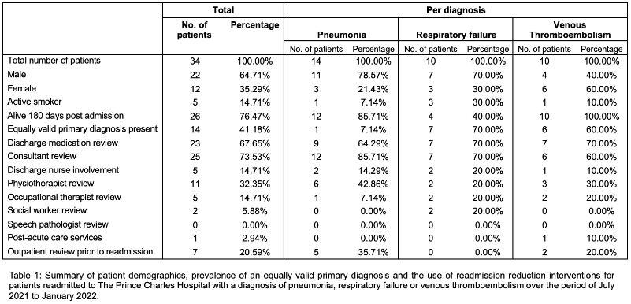

Conclusion:
Many penalised readmissions showed discrepancies in the primary readmission diagnosis and may have been incorrectly coded as preventable, highlighting the importance of clinical documentation and awareness of potential penalties. Furthermore, greater availability of proven interventions including allied health and post-discharge clinics may reduce readmission rates.

