Paper
Reductions in the future agricultural workday due to climate change

Agricultural workers are critical to global food security, yet their vulnerability to climate change-induced heat stress remains insufficiently understood. Here, we integrate high-resolution hourly projections of heat stress with new, gridded maps of the global agricultural workforce to quantify future reductions in safe working hours. We leverage downscaled daily CMIP6 climate model outputs (Williams et al., 2024) and workforce maps at ~10 km resolution (Ormaza-Zulueta et al., 2024) to calculate hourly wet bulb globe temperature (WBGT) metrics for historical (circa 2000) and future periods (2030, 2050) under SSP2-4.5 and SSP5-8.5. Unsafe conditions are determined using WBGT thresholds of 28°C, 30°C, and 32°C—limits aligned with NIOSH guidelines (NIOSH, 2016) and U.S. Department of Labor standards—providing a robust framework to assess thermal risk.
Our results reveal that although the global agricultural workforce is projected to grow modestly from 1.30 to 1.33 billion by 2050, the number of workers exposed to over 100 days of unsafe heat stress annually is expected to surge dramatically. Under SSP2-4.5, the exposed population increases from 359 million in 2000 to 663 million by 2050, with similar trends under SSP5-8.5. At a subnational level, over 30% of administrative units are anticipated to experience concurrent rises in workforce density and heat exposure, with nearly 18% of units encountering at least a 10% increase in exposure beyond the 30°C threshold. Globally, climate change is projected to reduce safe working time by 3–4% of full-day hours and 8–11% of a typical 9 AM–5 PM workday by mid-century, while even nighttime hours exhibit non-negligible risk increases.
Regional disparities are pronounced. In tropical and coastal regions of South Asia, East Asia, and Sub-Saharan Africa, extreme heat increasingly encroaches upon cooler evening hours, complicating adaptive strategies such as work schedule shifts (Pradhan et al., 2019). In contrast, regions like North America and Eastern/Central Asia display a more confined exposure window, predominantly during peak afternoon hours. These findings build on earlier assessments of heat stress impacts (Khayat et al., 2022; de Lima et al., 2021; Nelson et al., 2024) by offering a comprehensive, hourly analysis that captures both climatic and demographic drivers of risk.
Our study underscores the urgency for climate-resilient policies that safeguard agricultural workers’ health and livelihoods. As climate change extends unsafe working hours, targeted interventions are essential to secure the right to safe work, especially in the world’s most vulnerable regions.
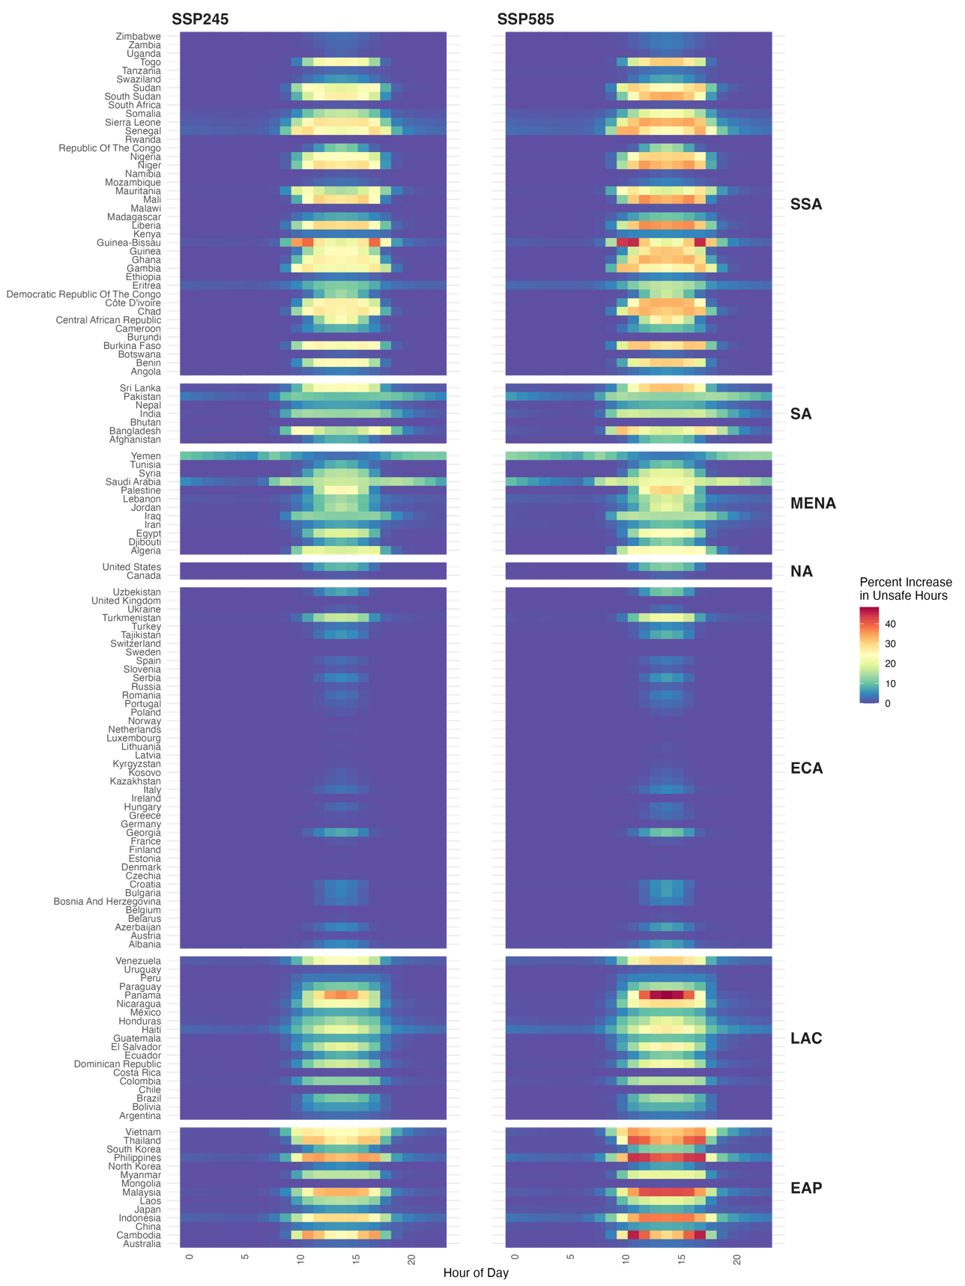
Fig. 3: Changes in unsafe working hours between 2000-2050. The heatmaps depict the percentage change in unsafe working hours categorized by region, under two climate scenarios (SSP2-4.5 and SSP5-8.5) under the 28°C WBGT threshold and for the harvesting season. The colours reflect the severity of the rise in percentage terms, where 100% represents the entire harvesting season.

References
- de Lima, C. Z., Buzan, J. R., Moore, F. C., Baldos, U. L. C., Huber, M., & Hertel, T. W. (2021). Heat stress on agricultural workers exacerbates crop impacts of climate change. Environmental Research Letters, 16(4): 044020. https://doi.org/10.1088/1748-9326/abeb9f
- Green, H., Bailey, J., Schwarz, L., Vanos, J., Ebi, K., & Benmarhnia, T. (2019). Impact of heat on mortality and morbidity in low and middle-income countries: A review of the epidemiological evidence and considerations for future research. Environmental Research, 171, 80–91. https://doi.org/10.1016/j.envres.2019.01.010
- El Khayat, M., Halwani, D. A., Hneiny, L., Alameddine, I., Haidar, M. A., & Habib, R. R. (2022). Impacts of climate change and heat stress on farmworkers’ health: A scoping review. Frontiers in Public Health, 10. ISSN 2296-2565. https://doi.org/10.3389/fpubh.2022.782811
- Linvill, D. E. (1990). Calculating chilling hours and chill units from daily maximum and minimum temperature observations. HortScience HortSci, 25(1): 14 – 16. https://doi.org/10.21273/HORTSCI.25.1.14
- National Institute for Occupational Safety and Health (NIOSH). (2016). Criteria for a recommended standard: Occupational exposure to heat and hot environments. NIOSH Publication No. 2016-106. Centers for Disease Control and Prevention. NIOSH Publication 2016-106.
- Nelson, G. C., Vanos, J., Havenith, G., Jay, O., Ebi, K. L., & Hijmans, R. J. (2024). Global reductions in manual agricultural work capacity due to climate change. Global Change Biology, 30(1): e17142. https://doi.org/10.1111/gcb.17142
- Ormaza-Zulueta, N., Miller, S., & Mehrabi, Z. (2024). Geographic distribution of the global agricultural workforce every decade for the years 2000-2100. https://doi.org/10.48550/arXiv.2412.15841
- Pradhan, B., Kjellstrom, T., Atar, D., Sharma, P., Kayastha, B., Bhandari, G., & Pradhan, P. K. (2019). Heat Stress Impacts on Cardiac Mortality in Nepali Migrant Workers in Qatar. Cardiology, 143(1-2): 37–48. https://doi.org/10.1159/000500853
- Spencer, J. W. (1971). Fourier series representation of the position of the sun. Search, 2(5): 172.
- Williams, E., Funk, C., Peterson, P., & Tuholske, C. (2024). High resolution climate change observations and projections for the evaluation of heat-related extremes. Scientific Data, 11(1): 261.

