Functional lung imaging using X-ray Velocimetry predicts pneumothorax following post-endobronchial valve placement
Nilsen K¹, Eikelis N¹, Marchetti N², Rashid M², Walia P², Criner H², Hatt C¹, Criner G²
¹4DMedical Limited, Melbourne, Australia, ²Temple Health, PA, USA
Introduction: Bronchoscopic lung volume reduction (BLVR) is used to treat advanced emphysema and is approved as a treatment strategy in the Global Initiative for COPD guidelines. During this procedure, valves are placed in the airways to promote atelectasis in the targeted lobe, thereby improving respiratory mechanics. Pneumothorax (PTX) is a well-known post-BLVR risk due to the rapid expansion of the non-target ipsilateral lobe. To address this, we have developed novel spatial measurements of lung stiffness using X-ray Velocimetry (XV, 4DMedical Limited, Australia). We hypothesize that increased lobe stiffness increases the risk of PTX post-BLVR, and imaging measurements can be used to predict this PTX risk.
Methods: A prospective cross-sectional study was performed on subjects with advanced emphysema undergoing BLVR treatment at Temple University Hospital, USA. Each subject underwent chest CT and XV imaging before BLVR treatment. Novel lobe stiffness measurements were obtained from XV. Lobe volumes were obtained from CT. A logistic regression model was used to assess PTX risk from imaging variables.
Results: 29 subjects were recruited to the study, and 11 developed a PTX post-BLVR. The volume ratio between the target and ipsilateral lobe (from CT), number of valves, stiffness of the ipsilateral lobe (from XV), and stiffness of the target lobe (from XV) were used as model predictors with a binary PTX outcome as the dependent variable. The model predicted PTX probability with an AUC of 0.879 (p=0.016) and Accuracy of 0.862. Using a probably cutoff of 0.5 yielded Sensitivity=0.727 and Specificity =0.944.
Conclusion:
Combining functional imaging from XV with chest CT can predict PTX risk post-BLVR. Furthermore, this modeling confirms that lobe stiffness in both the target and ipsilateral lobes contributes to this PTX risk. This study can potentially improve patient outcomes and alter clinical management in BLVR treatment.
Grant Support: Supported by a grant from 4DMedical.
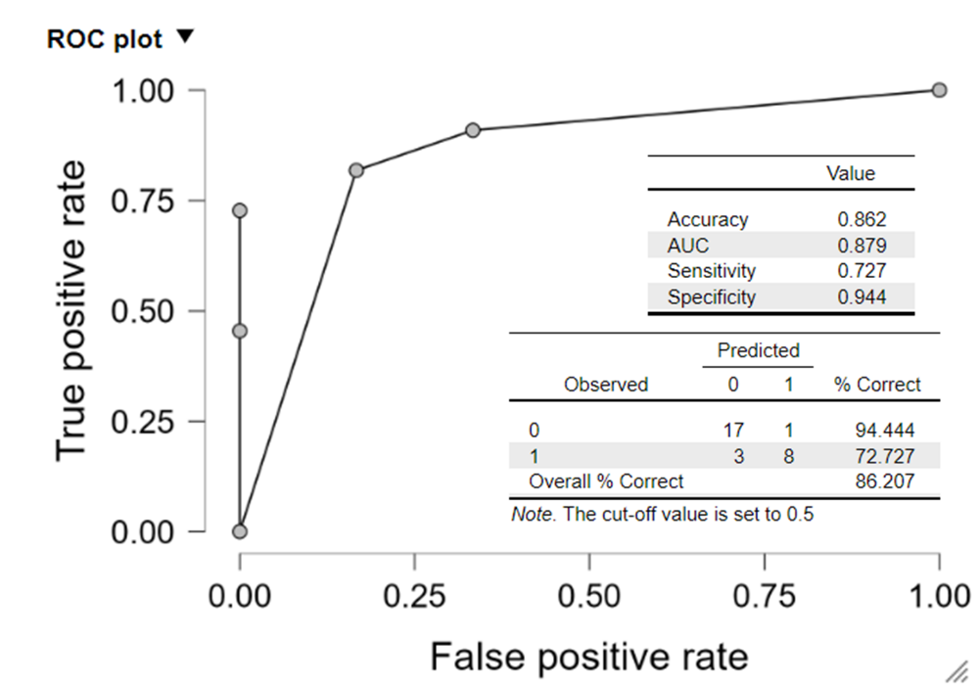
Figure 1: ROC curve for the logistic regression model predicting PTX risk post-BLVR from imaging parameters.

