Comparative analysis of FEV1 expressions: assessing the predictors of all-cause mortality.
Vahid Sharifi^{1,2,} Celia J Lanteri^{1,2}, Warren R Ruehland^{1,2}, Danny J Brazzale^{1,2}
- Institute for Breathing and Sleep, Austin Hospital, Heidelberg, VIC, Australia
2. Department of Respiratory and Sleep Medicine, Austin Hospital, Heidelberg, VIC, Australia
Introduction/Aim: FEV₁ z-score determines the severity of airflow obstruction, however other methods have been proposed and various ways for expressing FEV₁ have also been used to predict mortality, including FEV₁ quotient (FEV₁Q). We compared six distinct approaches for expressing FEV₁ in predicting all-cause mortality.
Methods: We retrospectively analysed data from a previous study, which included spirometry results measured between 2000 and 2002, age, sex, BMI, smoking history, death records, and time to death or loss to follow-up over a 20-year period. FEV₁% predicted, FEV₁ z-score, FEV₁Ht⁻², FEV₁Ht⁻³, FEV₁Ht⁻⁴, and FEV₁Q were calculated using GLI reference values. We utilized both univariable and multivariable Cox models to evaluate hazard ratios (HR) for each quartile of various FEV₁ expressions compared to the best quartile. Additionally, we assessed the predictive power for mortality of each FEV₁ expression.
Results: Out of 796 individuals, 539 people died in the follow-up period and 257 were lost to follow-up. 60% were males. Compared to females, males were older (69±8 vs. 65±9 (mean±SD); p<0.001), had smoked more (46±35 vs. 26±29 pack years; p<0.001), and had a lower BMI (26.7±6 vs. 28.7±8 kg/m²; p<0.001). The mean (range) FEV₁ was 1.35 L (0.35-3.74) for males and 1.10 L (0.28-3.00) for females. In the univariate model, FEV₁H⁻⁴ exhibits the highest HR of 3.07 (95% CI: 2.39-3.94) when comparing the worst to the best quartiles. However, after adjusting for age, sex, BMI, and smoking, FEV₁Q emerges with the highest HR of 2.45 (95% CI: 1.89-3.17) between the worst and best quartiles, followed by FEV₁H⁻² at 2.38 (95% CI: 1.84-3.08). In this adjusted model, FEV₁Q demonstrates the strongest predictive power for mortality, with a concordance index of 0.697.
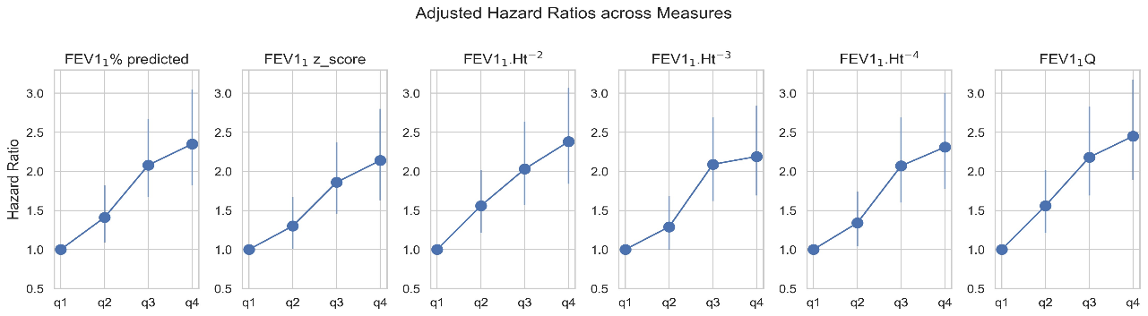
Conclusion: Among the various methods for expressing FEV₁ in our analysis, FEV₁Q is the strongest predictor of mortality, in keeping with previous studies. FEV₁H⁻² was the next best predictor.
Key Words: FEV₁ z-score, FEV₁% predicted, FEV₁Q, spirometry, survival analysis.
Nomination for New Investigator Award: No.
Grant Support: N/A

