Perioperative glycemic control with continuous glucose monitoring in patients with diabetes for cardiac surgery.

Background & Aim
Poorly controlled perioperative blood glucose is associated with higher rates of postoperative complications, longer hospital stays and higher perioperative mortality. Continuous glucose monitoring (CGM) systems have an undefined role in the perioperative setting. The relationship of prehospital, in hospital and post discharge CGM glycemic control is unknown. Exploratory analysis will look at time in range (TIR) during the 3 time periods and the predictors of TIR during hospitalisation.

Methods
After consent, patients were asked to wear the blinded Abbott FreeStyle Libre Pro Flash Glucose sensor during prehospital, in hospital and post discharge. The patient and clinical team were blinded to CGM data and glycemic control was managed according to local institutional protocols.

Results
35 patients were recruited with successful data capture of at least one time period with 80%, 71% and 63% data capture in the pre hospital, in hospital and post discharge periods respectively. The patients were naïve to the CGM technology but found it easy to remove, wear and apply the sensor.

Time in range (TIR) during hospitalisation, 45% (IQR 35-67), was lower than expected compared to pre-hospital, 77.5%, and post-discharge, 72%, periods.
Each 1% increase in HbA1c preoperatively was associated with ~ 4.15 times increase in the odds of time not in range time during hospitalisation, p=0.0205. Preoperative glycemic variability, age, gender, body mass index was not predictive. Receiver operating curve analysis shows a HbA1c of 7.8% having sensitivity of 90% to predict time not in range.

Discussion/Conclusion
Cardiac surgery patients during hospitalisation have low time in range when monitored with CGM despite satisfactory control in the preoperative and post discharge period. HbA1c preoperatively may be useful to stratify those most at risk of poor control during hospitalisation and benefit from CGM guided glycemic control.

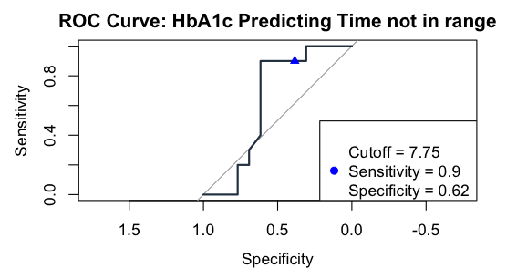
Area under the curve: 0.6269

