Paper
Coastal Adaptation and Blue Economy Strategies for Enhancing Resilience and preserving cultural identity and well being and safeguarding livelihoods in Fiji's Ocean of Islands

Introduction
Fiji, characterized by its unique geographical composition as an "ocean of islands," faces significant challenges posed by climate change, rising sea levels, and environmental degradation.

Objectives
This study aims to explore the intersection of coastal adaptation strategies and the blue economy in fostering resilience among island communities while preserving their cultural identity and well being. By examining existing legislation (global - UNDRIP, regional - Samoa Pathway to nayional), policies and practices in coastal management and sustainable economic development, the effectiveness of these strategies in safeguarding the livelihoods and well-being of Fijian communities will be assessed.
This research will also showcase examples of good practices (such as the use of Indigenous framework in the Rewa province Strategic Development Plan in Figure 1 in Appendix), tools, good practices or cases of failures and why they offer insights into accelerating adaptation.

Methodology
The research carried out at various districts in Rewa will employ a mixed-methods approach, incorporating qualitative interviews with local stakeholders, including indigenous people and local communities (IPLC), local/national government, and quantitative data analysis to evaluate the socio-economic impacts of blue economy initiatives. Novel insights from purposeful and ethical practices; and engagement with IPLC such as FPIC will be applied.
This study will also involve different communities pertaining to Eco-tourism initiatives. There is the coastal communities with a mangrove walkway, oyster farming for economic livelihoods eco-tourism and 150 years relic historical site where the remains of the M.V. Leonidas carrying Identured Labourers from India sunk.
Partnerships with NGOs include Conservation International KIWA project, UNDP Small Grants Project (SGP) and the SPREP MACBLUE project

Findings
Ultimately, this study seeks to provide actionable recommendations for enhancing the adaptive capacity and blue economy aspects of Fiji's islands communities, ensuring that their rich cultural heritage and well being is maintained in the face of environmental challenges, thereby promoting a sustainable future for both people and the ocean.

Significance of the work for policy and practice
Recommendations will be related to policies pertaining to tourism, blue economy, economic livelihoods and exploring markets. Best practices and lessons learnt will be explored for marine protection and engaging in culturally appropriate ways with IPLC

Appendix: Figure 1 - Rewa Strategic Development Plan (2024-2027):
Using the Mud Lobster Thalassina anomala spp (Mana in Fijian) for Rewa SDP
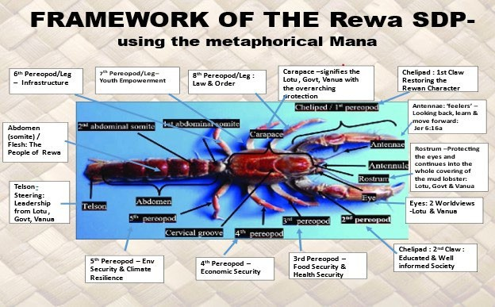

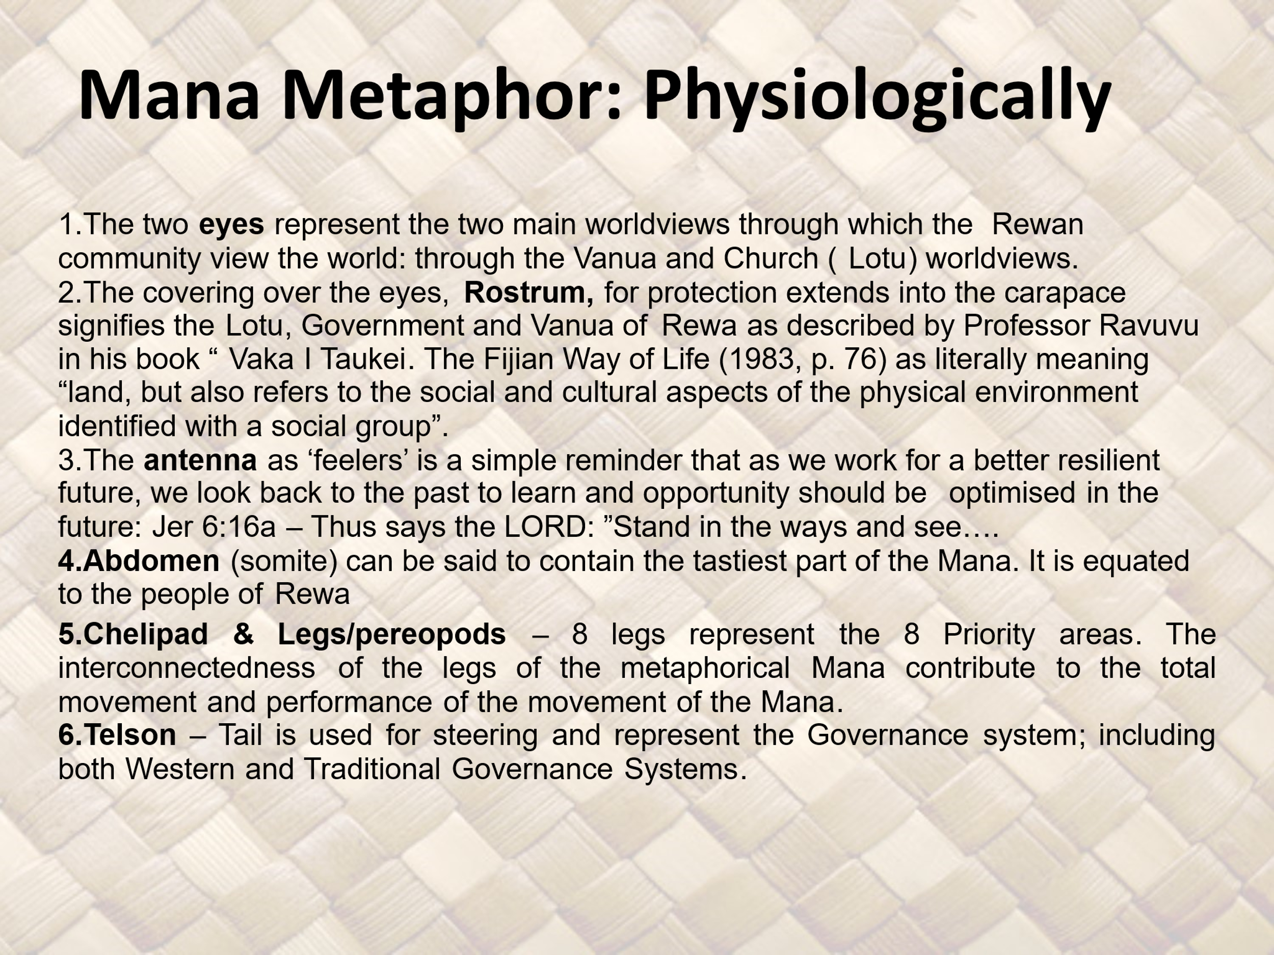

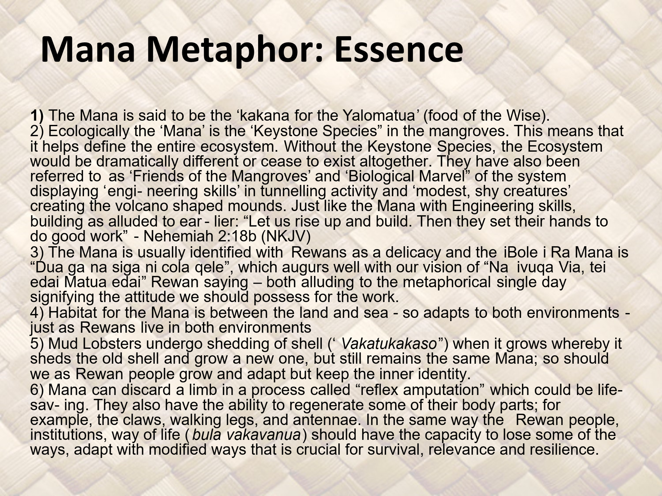

Bibliography:
- Nabobo-Baba, U. (2007). Vanua Research Framework. Paper presented at the Sutainable Livelihoods and Education in the Pacific (SLEP) Workshop Institute of Education, USP.
- Nainoca, Winifereti Ubianalaca (2011) The influence of the Fijian Way of Life (bula vakavanua) on community-based marine conservation in Fiji, with a focus on social capital and traditional knowledge. PhD Thesis. (unpublished) Massey University
- Ravuvu, A. (1983). Vaka i Taukei. The Fijian Way of Life. Suva: Institute of Pacific Studies of the University of the South Pacific.

The Rewa Strategic Development Plan (SDP) uses the Mud Lobster (a keystone species in the Rewa Ecosystem) to represent the Framework for the SDP
Rewa is the province that hosts the Fiji capital city - Suva
Based on Fiji’s Nabobo-BabaVanua Research Framework with further adaptation Nainoca, 2011

