Wānanga/Talanoa/Dialogue or Workshop
The art of change making: experimenting with art-based and creative methods to imagine climate change adaptation in cities.

Accelerated adaptation requires spaces for reflexivity and creativity through novel approaches that disrupt our traditional biased ways of thinking and connect us with other forms of knowledge and other knowledge holders (André et al. 2023, Nalau, 2024, Olazabal, Amorim-Maia, et al., 2024, Olazabal, Loroño-Leturiondo, et al., 2024). This co-creation session will employ art and participatory exercises combined with a world café approach. The objective is to co-explore the use of different art-based methods and approaches to discuss, expand and disrupt the ways we imagine and envision what adaptation is - or is not - in cities worldwide (Englund et al. 2022, Loroño et al. 2025). Participants will learn and experience how to engage in meaningful adaptation conversations through art. The outcome and impact of this session are experiential: we intend to ignite an awareness raising and learning process by opening the doors to alternative ways of doing, knowing and being related to, beyond adaptation to all participants in the session. We also intend to spread the benefits and usefulness of using creative and alternative methods in science and practice to generate or unveil relevant knowledge. Art is a powerful tool for: (1) Knowledge enhancement by enabling dialogue/communication on complex climate science and adaptation pathways in a comprehensible, accessible and creative way; (2) Allowing stakeholders, or participants in the process, to co-explore visions and novel ideas as well as share and open up to different perspectives and experiences that normally go beyond the confines of the traditional understanding of adaptation; and, (3) Building trust and confidence in the collective process of Adaptation by Visualising positive futures and shared adaptation pathways while working with complexity and uncertainty.

We intend to centre the conversation on what adaptation looks like in cities worldwide, for who and how. The different experiences will help participants connect with other perceptions and perspectives, as well as reflect on their inner understandings and biases on adaptation pathways and outcomes.

Structure of the session and method:
We will structure the session around the World Café method while allowing participants the freedom to experience different art-based approaches based on their preferences and openness to alternative and creative approaches to knowledge generation. We will organise the space to create a safe and welcoming environment, engaging participants in at least two rounds of art-based experiences. A short introduction by the Chairs/Presenters of the session will describe each table and, after this, participants will have the opportunity to visit at least two tables. A Discussion session facilitated by the Chairs will offer space for participants to share their personal and collective experiences and point out future applications and learnings.

- Introduction: Marta Olazabal & Karín André (Chairs)
- Free tour - World café style
  - World Café Table 1: Imagining and illustrating adaptation
  - World Café Table 2: Participatory collaging
  - World Café Table 3: Dys/utopian writing (postcards from the future)
  - World Café Table 4: Crafting vulnerabilities with Lego and Photography
- Discussion and Closure

Description of art-based methods:

- World Café Table 1: Imagining and illustrating adaptation
Facilitators: Marta Olazabal
Materials: 31 illustrations (IMAGINE Adaptation project, see Olazabal et al 2024, Loroño et al. 2025), crayons, pencils, paper.
Objective: Expressing through visual art our imaginaries of adaptation in our cities, opening up to others’ experiences and verbalising our understandings.
Method: participants will be given materials to draw what adaptation looks like in their city, the city their work is in or the one that is closer to their heart. they will be later shown IMAGINE Adaptation Illustrations and select the one that is closer to their creation. We will open, then, a space for discussion and sharing based on their drawings and IMAGINE Adaptation’s illustrations.

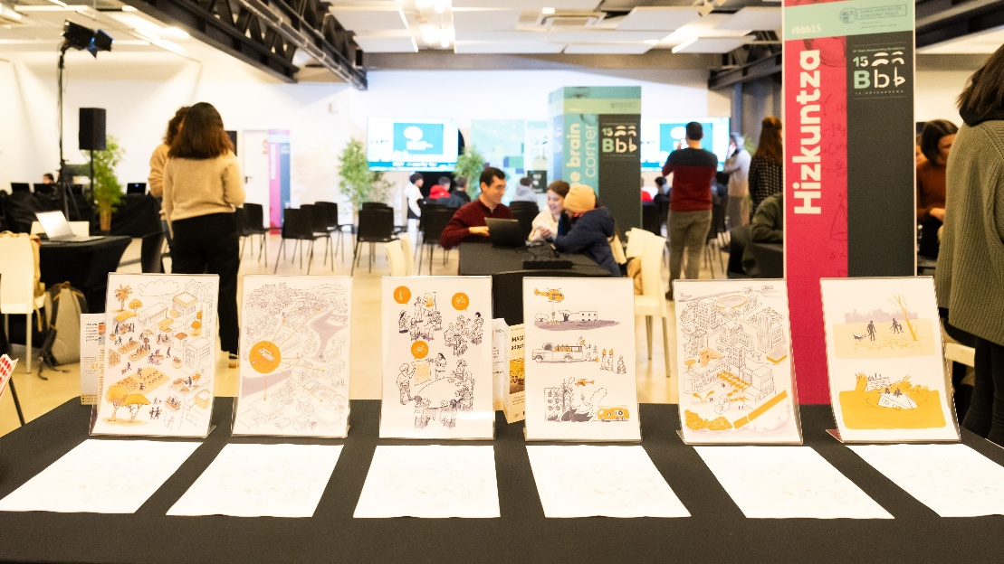
(Photo Credit: Basque Centre for Climate Change, Imagine Adaptation)

- World Café Table 2: Participatory collaging
Facilitators: Karin André + Åsa G Swartling
Materials: Newspaper clippings and images, paper, crayons, pencils, glue, and scissors
Objective: Capturing ideas and expressing them through images to envision life in our future cities and communities and by relating these to what a business-as-usual scenario would look like.
Method: Participants will use newspaper clippings and images to create their own collage visualizing two imaginary futures where adaptation has succeeded or failed. Participants will interpret and tell each other about their piece with the rest of the group to encourage reflection and dialogue. The collages will be put up on the wall for others to see.

- World Café Table 3: Dys/utopian writing (postcards from the future)
Facilitators: Ana Terra Amorim-Maia
Materials: Postcard-sized versions of the 31 IMAGINE Adaptation illustrations (Olazabal et al. 2024)
Objective: Through words and visuals, participants capture emotions, struggles, and triumphs, offering a deeply personal and place-based reflection on adaptation pathways.
Method: Postcards from the Future is an interactive and imaginative storytelling method that invites participants to step into the future and write back to the present. Using creativity and speculative thinking, individuals craft postcards from a future where climate adaptation has (or hasn’t) succeeded, describing the landscapes, communities, and daily realities they envision. By weaving these narratives together, Postcards from the Future inspire reflection, dialogue, and action in the present. Participants will be asked to choose one illustration and write the postcard on the back. After this, participants will be asked to share, not the content but their choices and their feelings.

- World Café Table 4: Crafting vulnerabilities with Lego and Photography
Facilitators: Mathilda Englund + Sean Goodwin
Materials: LEGO ® and POLAROID ® camera
Objective: Stimulate discussions on what vulnerabilities should be reduced with adaptation to climate change in cities and how to prioritise them.
Method: In this table, we will use the Photovoice method. Photovoice is a qualitative research method used in community-based participatory research that combines participant-taken photographs, experiential knowledge and critical dialogue to expose social problems and ignite social change (Sutton-Brown, C. A., 2014). We will ask participants to use the LEGO set to craft a situation in which they observe a vulnerability to climate change in their city. They will be asked to take a picture with the camera and stick it to a wall. The group of participants will then gather around the photographs and they will each share what they meant and the significance for adaptation in their city. They can group the photos or add sticky notes as they share their experiences.

Outputs:
- SEI brief entitled “Art in action: Recommendation for art-based engagement in climate change adaptation”
- IMAGINE Adaptation blog post http://imagineadapt.bc3research.org
- Three min video documentary co-produced for social media by BC3 and SEI.

Outcomes and Impact:
- Inspiration for how to engage with multiple knowledges for co-prodiuction with alternative art-based approaches beyond science
- Allows participants to experience reflexivity and inclusivity so they can use these methos in their daily research, practice or decision making work
- Promotes moving beyond problem focused thinking to solutions in an inclusive and creative manner
- Promotes reflection on adaptation, mitigation and sustainable development as all key indivisible parts of climate-resilient urban development pathways.
- Promotes experimentation, innovation and creativity in adaptation work for accelarated climate-resilient-futures

References

André, K., Gerger Swartling, Å., Englund, M., Petutschnig, L., Attoh, E. M. N. A. N., Milde, K., Lückerath, D., Cauchy, A., Botnen Holm, T., Hanssen Korsbrekke, M., Bour, M., & Rome, E. (2023). Improving stakeholder engagement in climate change risk assessments: Insights from six co-production initiatives in Europe. Frontiers in Climate, 5. https://doi.org/10.3389/fclim.2023.1120421
Englund, M., André, K., Gerger Swartling, Å., & Iao-Jörgensen, J. (2022). Four Methodological Guidelines to Evaluate the Research Impact of Co-produced Climate Services. Frontiers in Climate, 4. https://doi.org/10.3389/fclim.2022.909422
Loroño-Leturiondo, M., Olazabal, M., Lewis, W., Amorim-Maia, A. T., & Zabala, A. (2025). Urban adaptation imaginaries unlocked: A global study. Nature Cities, Under review.
Nalau, J. (2024). Decision-making about climate change adaptation. Dialogues on Climate Change, 29768659241297761. https://doi.org/10.1177/29768659241297761
Olazabal, M., Amorim-Maia, A. T., Alda-Vidal, C., & Goodwin, S. (2024). What is limiting how we imagine climate change adaptation? Current Opinion in Environmental Sustainability, 71, 101476. https://doi.org/10.1016/j.cosust.2024.101476
Olazabal, M., Loroño-Leturiondo, M., Amorim-Maia, A. T., Lewis, W., & Urrutia, J. (2024). Integrating science and the arts to deglobalise climate change adaptation. Nature Communications, 15(1), 2971. https://doi.org/10.1038/s41467-024-47400-7
Sutton-Brown, C. A. (2014). Photovoice: A Methodological Guide. Photography and Culture, 7(2), 169–185. https://doi.org/10.2752/175145214X13999922103165

PARTICIPANTS

Participant 1
Full Name: Marta Olazabal
Organisation: Basque Centre for Climate Change, BC3, Spain.
Bio: Dr Marta Olazabal is an interdisciplinary scientist exploring pathways of progress on climate action in cities worldwide. She is an Ikerbasque Research Associate and Ramon y Cajal Fellow at BC3 where she leads the Adaptation Research Group. She is the Principal Investigator of the European Research Council project IMAGINE Adaptation.
Participant 1 Contribution: Co-chair. Moderation of the session. General introduction. Facilitation of World Café Table 1.

Participant 2
Full Name: Karin André
Organisation: Stockholm Environment Institute (SEI), Sweden.
Bio: Karin André is a Senior Research Fellow and Team Lead for the Cities, Communities and Consumption Team at SEI Headquarters in Stockholm. Areas of expertise include participatory research methods and the role of science-based stakeholder dialogues on issues related to climate adaptation and other complex sustainability issues.
Participant 2 Contribution: Co-chair. Moderation of the session. General introduction. Facilitation of World Café Table 2.

Participant 3
Full Name: Ana Terra Amorim Maia
Organisation: Basque Centre for Climate Change, BC3
Bio Dr. Amorim-Maia is an interdisciplinary socio-environmental scientist exploring the intersections of climate change adaptation, urban governance, and social justice. She is a Juan de la Cierva Fellow and postdoctoral researcher at BC3, where she contributes to IMAGINE Adaptation, supporting cities in envisioning resilient futures and assessing progress toward achieving them.
Participant 3 Contribution: Facilitation of World Café Table 3.

Participant 4
Full Name: Åsa Gerger Swartling
Organisation: Stockholm Environment Institute
Bio Åsa Gerger Swartling (Senior Research Fellow; Head of Knowledge Management) has extensive professional experience that integrates social science research and scientific leadership within the sustainability sphere. Her interests encompass sustainability governance at subnational levels, with an emphasis on participatory methods; collaborative processes; co-design of climate services; adaptation; and disaster risk reduction.
Participant 4 Contribution: Facilitation of World Café Table 2.

Participant 5
Full Name: Sean Goodwin
Organisation: Basque Centre for Climate Change, BC3
Bio: Sean Goodwin is a multidisciplinary researcher with a focus on urban climate adaptation, nature-based solutions, and monitoring, evaluation and learning. His research addresses pressing questions facing communities of research and practice at the intersection of climate change, biodiversity conservation, urban planning and social justice.
Participant 5 Contribution: Facilitation of World Café Table 4.

Participant 6
Full Name: Mathilda Englund
Organisation: Stockholm Environment Institute (SEI) and Linköping University
Bio: Mathilda Englund is a transdisciplinary researcher exploring the intersection of climate change adaptation, knowledge co-production, and epistemic injustice. She is a PhD student at the Stockholm Environment Institute (SEI) and Linköping University, where she is exploring power and politics in knowledge co-production for climate change adaptation.
Participant 6 Contribution: Facilitation of World Café Table 4.

