Paper
Keeping Canada’s National Assessment Process Inclusive, Relevant, and Impactful: The Case for an Adaptive Approach

Introduction
Canada’s National Assessment Process, Canada in a Changing Climate has recently launched its 5th cycle. The Assessment Process is a highly collaborative, multi-year initiative that assesses and synthesizes existing literature and knowledge on climate change science, impacts and adaptation to produce reliable, relevant and accessible reports. These foundational reports are essential resources for governments, policymakers, and adaptation decision-makers across sectors and regions, helping to raise awareness of key issues and ensure informed decisions, especially in the current era of widespread mis/dis-information.

Objectives
This presentation will highlight how we have evolved the National Assessment Process over time to ensure continued relevancy in a constantly shifting landscape, highlighting both successes and lessons learned. We will discuss ways we have increased our reach, strengthened engagement, and improved the integration of multiple sources of knowledge, including Indigenous Knowledge Systems. We will also address current issues we are grappling with, such as the ethical use of AI in knowledge assessment processes and increasing demands to demonstrate impact with limited meaningful and established metrics.

Methodology
Engagement (including through surveys, and interactive sessions at conferences and meetings) throughout the process provides us with feedback to improve our approaches. In this session, we will discuss the different approaches we have used to adapt the various steps of our process, from scoping to release (see Figure). This will include broadening and extending the timelines for scoping activities, shifting to a digital-first approach to report delivery, building a sense of shared ownership amongst the contributors, creating tiers of information using a key message approach and making concerted and dedicated efforts to better uplift Indigenous Knowledge Systems. We will also address integrating new practices, such as videos and art into the process, and developing guidelines for use of AI.
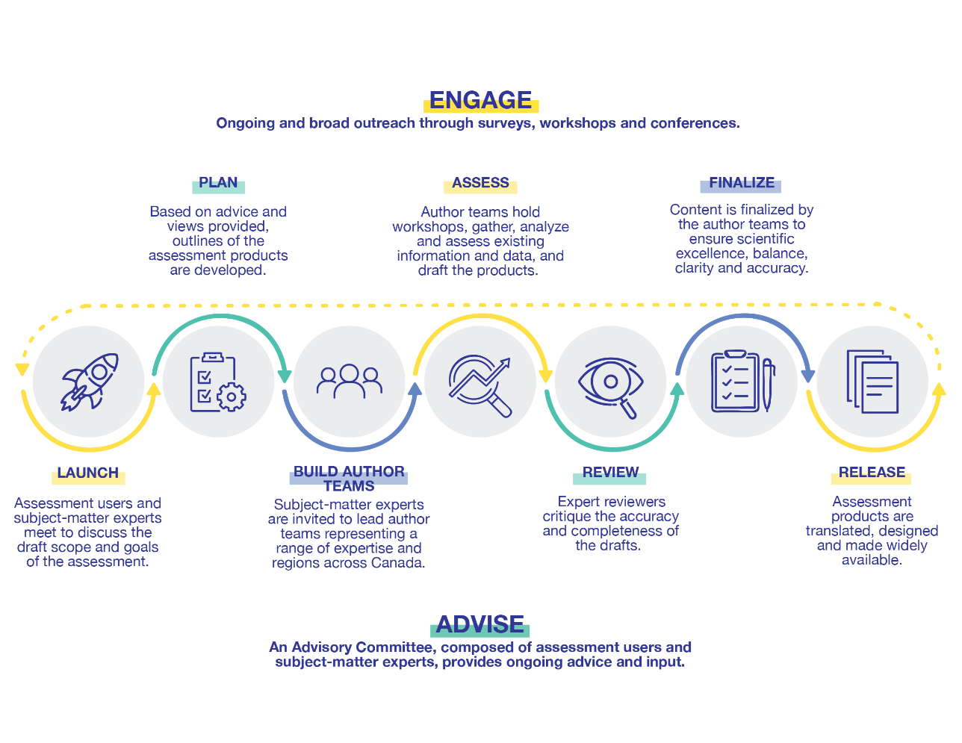

Findings
Findings to be presented will include:
- The success of an interactive, digital platform, raising our access rates by orders of magnitudes.
- The lessons learned from using a key message approach to chapter writing.
- The successes and challenges in better uplifting Indigenous Knowledge Systems in the Assessment Process.
- The impact of art, videos and storytelling to both engage and communicate.
- Early lessons learned on emerging areas, such as guidance on the use of AI within the process, and new ways of measuring our impact.

Significance of the work for policy and practice
Assessment processes inform both policy and practice on adaptation, providing foundational reports for decision makers and practitioners, who are often faced with information overload, but insufficient access to trusted knowledge sources. Ensuring assessment processes are adaptive to be more inclusive and relevant allow the reports produced to have a stronger impact. By sharing our lessons learned in leading a national-scale assessment process with the international adaptation community, we hope to inspire and help advance similar work in other countries and learn from them as well.

