|  |
| --- |
| **Fine-scale mapping of forest leaf chlorophyll content using 3D radiative transfer modeling** |
| **Introduction/Aim:**  Leaf chlorophyll, as the primary pigment involved in plant photosynthesis, is crucial for estimating vegetation productivity and maintaining the balance of carbon flux in terrestrial ecosystems. Therefore, mapping vegetation leaf chlorophyll content (LCC) is of significant practical importance for various agroforest and ecological applications. The integration of remote sensing with radiative transfer models for estimating vegetation biochemical parameters is considered an effective technique. However, the ideal assumption of 1-dimensional radiative transfer models makes it difficult to accurately characterize heterogeneous vegetation environments, resulting in chlorophyll products remaining at coarse resolution scales (300 m -1.15 km), further hindering the development of refined agricultural and forestry management tasks. Although 3-dimensional radiative transfer models based on real scenes offer great potential for finely mapping high-resolution vegetation chlorophyll, the high computational cost of model calculations and the need to calibrate model parameters with field measurements are necessary to simulate more accurate remote sensing signals.  A semi-empirical accelerated 3-dimensional radiative transfer model(3D RTM), named Semi-LESS, is capable of effectively overcoming the aforementioned issues, providing more than 100x accelerations of radiative transfer simulations over heterogeneous canopies. However, the model's inversion of fine-scale vegetation parameters has not been thoroughly investigated due to the covariance of different vegetation biochemical and biophysical parameters and the interference from background.  **Methods:**  In this study, a semi-empirical 3D RTM, Semi-LESS, was first employed to rapidly simulate multi-band images of UAV under different biochemical parameters combinations. To achieve more realistic simulation of UAV spectral reflectance, airborne LiDAR point clouds were employed to construct detailed 3D forest scenes for model parameterization, with soil heterogeneity also considered by coupling a GSV soil reflectance model. During the inversion process, a 1D residual network was utilized to train the simulated UAV dataset, aiming to account for the influence of various biochemical and structural parameters on LCC inversion. Specifically, the UAV images were aggregated to a 3-meter scale. Subsequently, each pixel's multi-band reflectance, along with corresponding biochemical and structural parameters (LAI), were divided into training (80%), validation (10%), and testing (10%) datasets for training and testing the residual network. To assess the robustness of the model, ground-measured chlorophyll content was also utilized to evaluate the residual network's capability in chlorophyll inversion. The flowchart of the research is presented in Fig.1.  **Results:**  Our results show a coefficient of determination(R2) of 0.92 and an RMSE of 2.87ug/cm2 for leaf chlorophyll inversion in 10% of the simulated dataset's testing samples by the residual network. The corresponding values for the ground-measured samples are R2 =0.26, RMSE=8.76 ug/cm2, respectively.  **Conclusion:**  Our results demonstrate the capability of Semi-LESS coupled with deep learning to quickly achieve fine-scale inversion of LCC without the need for field-measured data calibration. Our approach also holds potential for rapidly achieving fine-scale inversion of other vegetation parameters in crop or orchard scenes. |

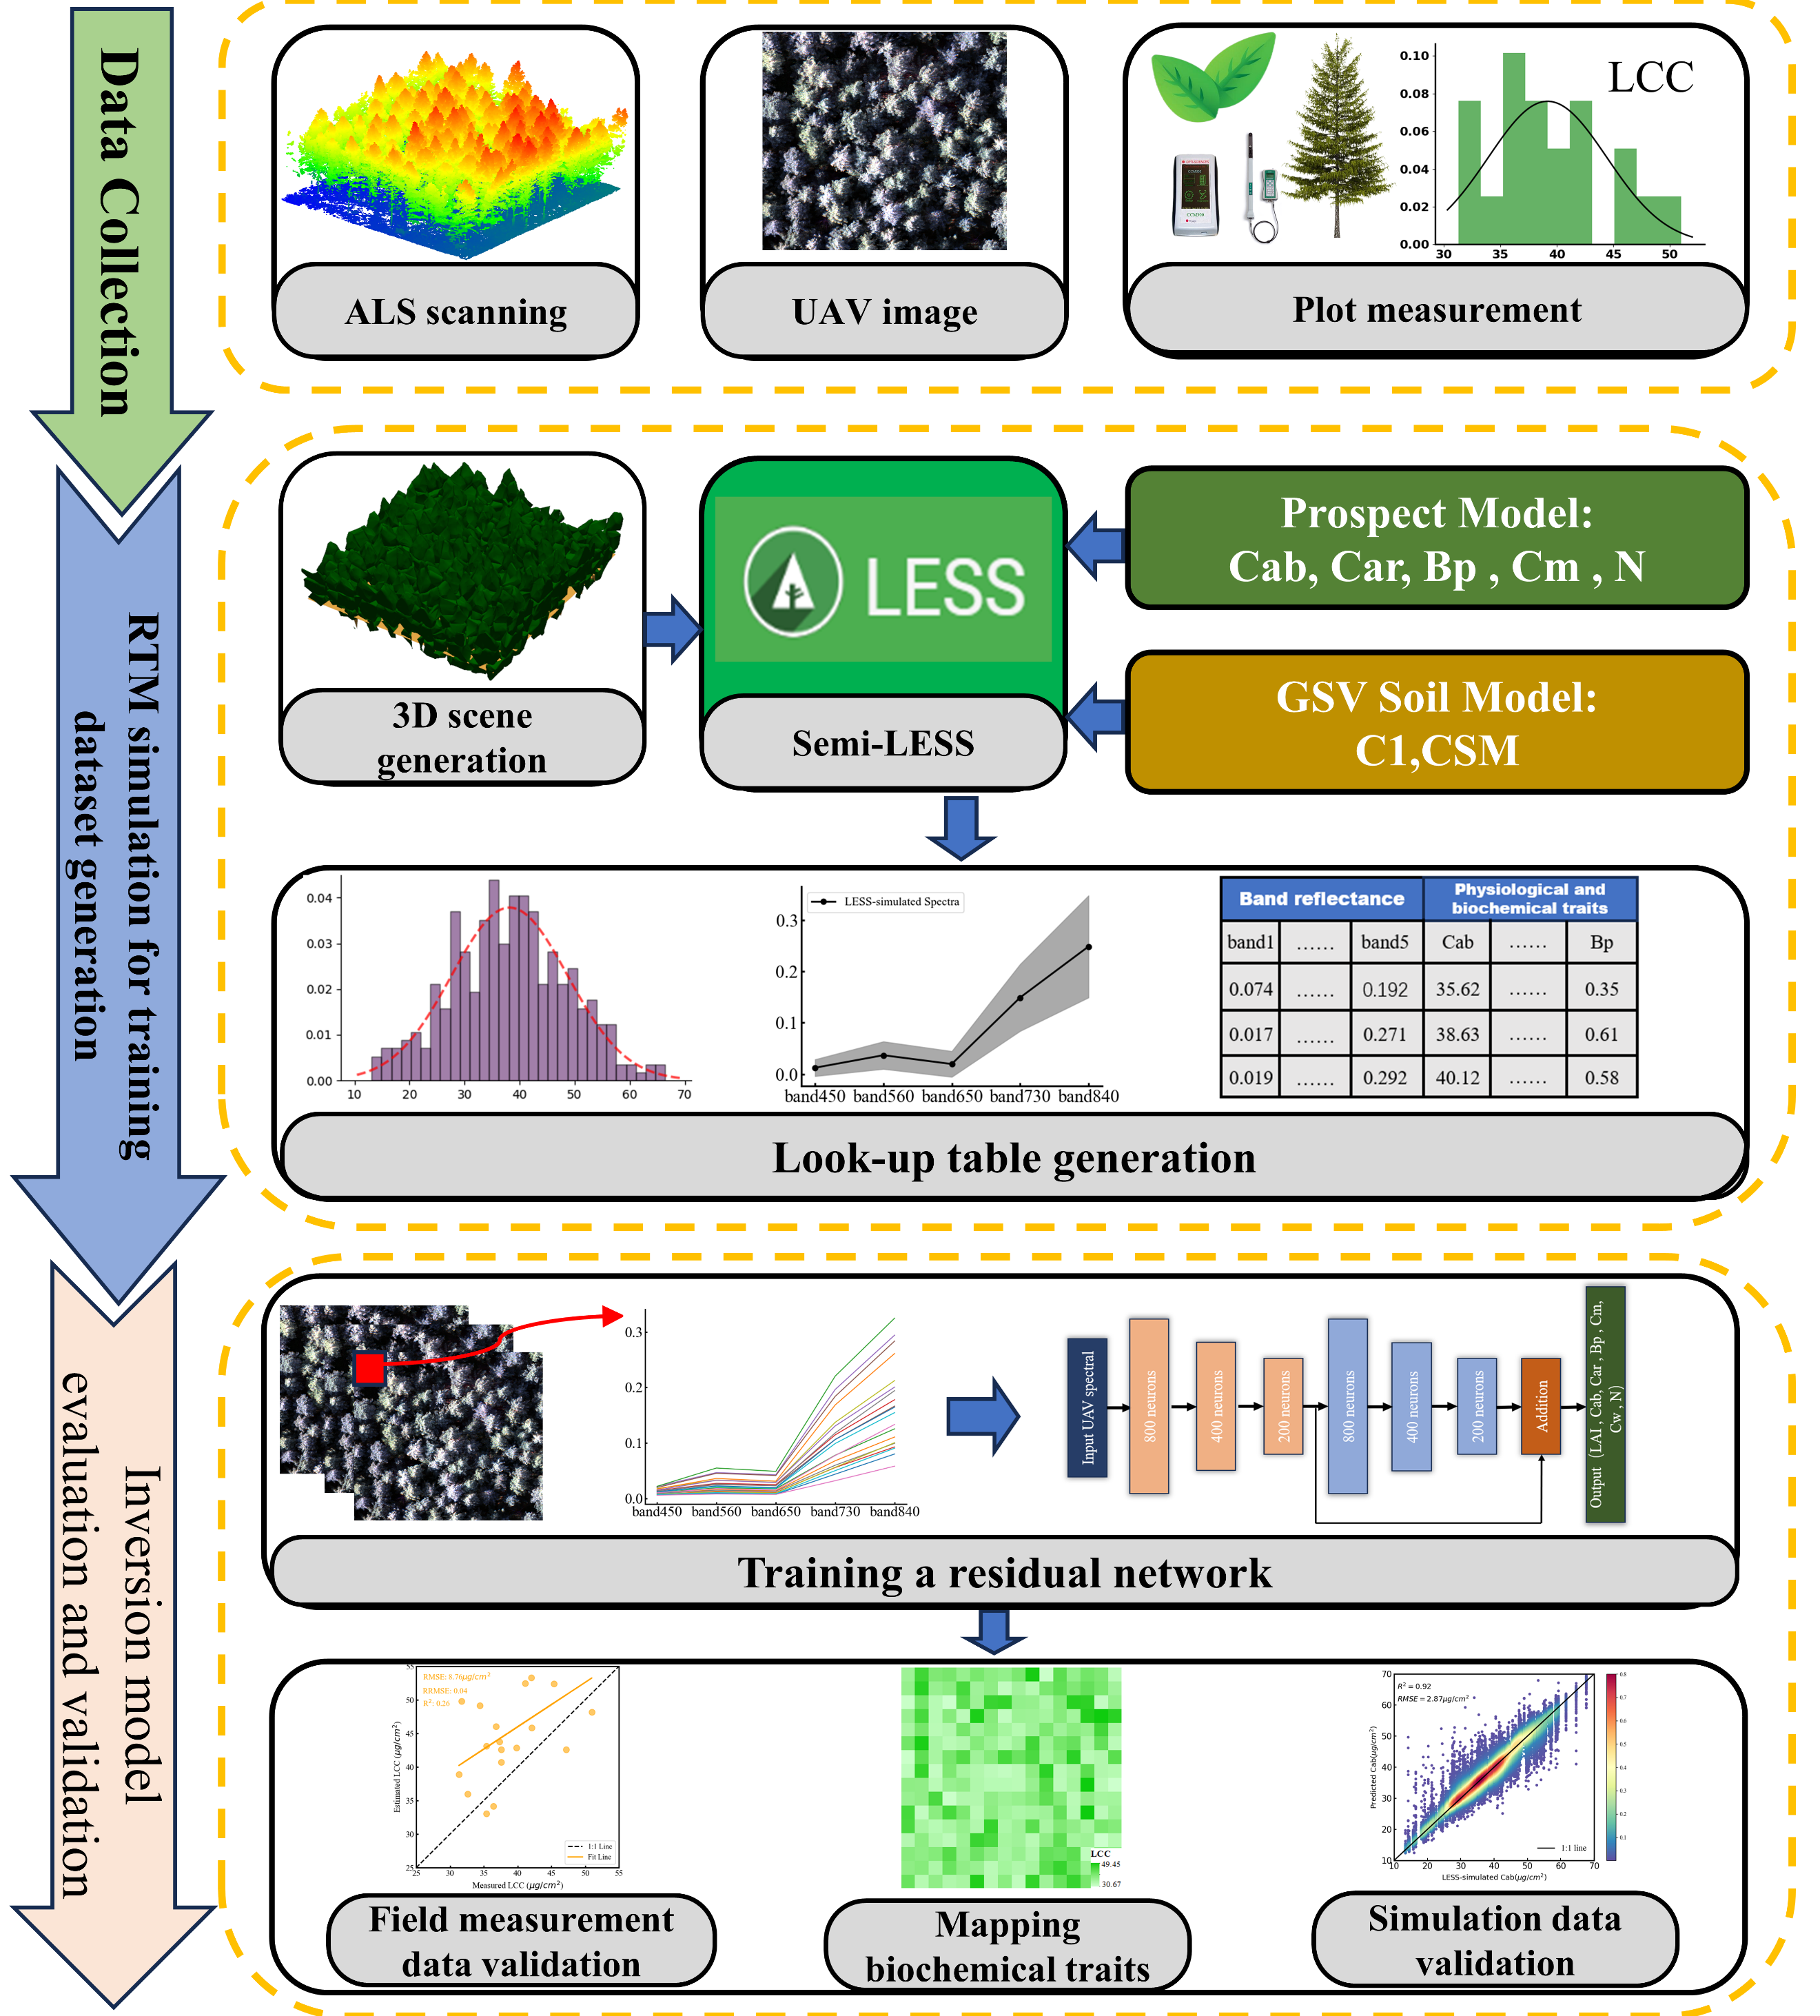

Fig.1. Fine-scale vegetation LCC inversion flowchart diagram