Hands-on activity
Building capacities for transformational climate adaptation: a hands-on workshop

Landscapes globally face transformational impacts of climate change that will fundamentally alter social and ecological systems, affecting land use patterns, agricultural production, water availability, and the habitats that support biodiversity and healthy communities. When combined with other pressures like population growth, economic shifts, and environmental changes, these impacts necessitate that communities address challenging trade-offs.
We propose that carefully designed and curated transformative practices can create the conditions and capabilities needed for communities, organisations, Traditional Owners, and government agencies to identify and enable transformational adaptation to climate change in ways that are resilient and equitable.
Building on the limited global understanding of practices that create enabling conditions for transformational adaptation, we argue that developing key capacities including systemic inquiry, embracing uncertainty, and courageous leadership (Lonsdale, K. et al., 2015) is essential for achieving meaningful change.
An effective methodology centres on immersive workshops that experiment with new ways of thinking about and discussing climate change, grounded in systems thinking, futures thinking, and Indigenous ways of seeing and knowing. This approach combines curated climate information with innovative tools and structured dialogue, incorporating First Nations knowledge and practice.
Transformative practices can include interactive spatial mapping to visualise landscape connectedness across scales, systems mapping templates incorporating spatial and temporal dimensions, and visual pattern thinking and Yarning Circles (respectful talking circles) that enable deep listening and complex relationship understanding. Place-based learning combined with climate projections and speculative storytelling helps participants imagine future scenarios and ground their understanding in lived experience.
These integrated practices help participants expand the solution space by challenging assumptions and uncovering deeper systemic relationships that shape social systems, structures, and institutions. When thoughtfully implemented, this approach can increase participant hope and sense of agency while generating concrete ideas for transformational change.

Session Overview
This co-creation session will introduce participants to transformative practices that build the essential capacities needed for transformational climate adaptation. Drawing from successful fieldwork in the Bellarine coastal landscape (Victoria, Australia), participants will engage with systems mapping, futures thinking, and reflexive practices that foster transformational approaches to climate challenges. The session combines theoretical frameworks with practical tools that participants can immediately apply in their own contexts.

Relevance to Conference Themes
This workshop directly engages with the conference themes of Beyond Adaptation, the Art of Adaptation, Communication, and Education, and Health, Wellbeing, and Future Generations. It specifically delves into scenarios and futures thinking, strategic communication, and considering rights of future generations and Indigenous peoples in long-term decision making under potentially destabilised futures. The session highlights how thoughtfully designed transformative practices can guide practitioners and communities in moving past incremental adaptation. It focuses on enabling them to envision and implement systemic changes that address long-term, highly uncertain climate impacts while fostering equitable socio-ecological shifts.

Background
What is Transformational Adaptation?
Transformational adaptation refers to fundamental, systemic changes in response to climate impacts that significantly alter the structure and function of socio-ecological systems. Unlike incremental adaptation, which preserves existing systems while making minor adjustments, transformational adaptation enables entirely new strategies that transform places and potentially shift locations to better cope with climate impacts. It encompasses deep societal changes that influence sustainable development, including shifts in values, worldviews, governance structures, and decision-making processes.
Transformational adaptation has become necessary because climate change is exposing fundamental flaws in our current systems. Vested interests, economic lock-ins, institutional path dependencies, and dominant cultural norms often hinder the transformational changes needed. When trigger events like extreme weather disasters occur, communities with pre-prepared transformational options can leverage these policy windows to implement significant changes rather than defaulting to familiar but inadequate responses.
What capacities enable transformational adaptation?
Creating conditions for transformational adaptation requires developing three interconnected capacities (Lonsdale, K. et al., 2015):
- Capacity for systemic inquiry: The ability to understand complex systems by:
  - Examining underlying structures, connections, and dependencies
  - Challenging assumptions and existing mental models
  - Considering historical context and trajectory of current developments
  - Recognising patterns and causes of change over time
  - Understanding relationships between different parts of a system.
- Leadership for transformation: The skills to navigate uncertain futures by:
  - Balancing day-to-day tasks with future-focused activities
  - Embracing uncertainty to explore complex situations fully
  - Articulating issues and encouraging broad participation
  - Uniting people and providing visionary guidance
  - Navigating different "action logics" to catalyse social transformation
- Learning from practice: The capability to generate insights from experience by:
  - Being present, noticing details, and embracing uncertainty
  - Creating opportunities to reframe understanding
  - Facilitating multi-stakeholder learning processes
  - Incorporating diverse forms of knowledge, including Indigenous perspectives
  - Using reflective practices to question assumptions and integrate new insights.
Recent work in the Bellarine landscape demonstrated that even brief but intensive engagement with transformative practices can significantly enhance these capacities and shift thinking from site-specific protections to landscape-scale interventions and system-level change. Carefully designed learning environments allow participants to engage with complexity without becoming overwhelmed, resulting in increased hope, individual agency, and collective action potential.

Workshop objectives
By the end of this session, participants will:
- Understand key concepts and capacities for transformational climate adaptation
- Experience hands-on transformative practices that build these capacities
- Explore preliminary transformational adaptation strategies for their own contexts
- Build connections with others engaged in similar work.

Workshop Structure and Activities
Opening
- Brief introduction to transformational adaptation concepts
- Distinction between incremental and transformational approaches
- Overview of key capacities: systemic inquiry, embracing uncertainty, and learning from practice
Murnong mapping
Murnong mapping draws on various frameworks and mental models including: long-term past, present, and futures thinking; futures design fiction and storytelling using creative narratives to envision possible futures; multi-level perspectives (Geels, 2011); causal layered analysis or the "iceberg model" (Inayatullah, 1998); and S-curve transition theory (Loorbach, 2010). This integrated approach enables participants to think systemically about climate challenges and identify transformational adaptation pathways that address root causes rather than symptoms.
Participants will work in small groups using simplified "Murnong Map" templates to:
- Map relationships between climate impacts and social, economic, and ecological systems
- Identify underlying structures, worldviews, and narratives that shape current responses
- Discover leverage points where transformational change might occur
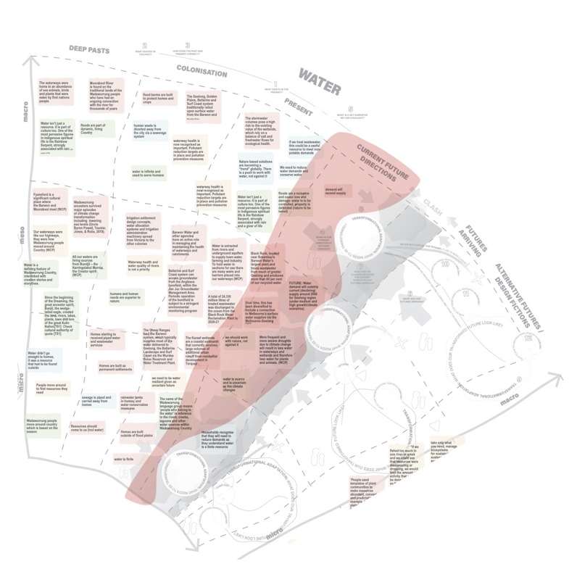

From vision to action
Building on insights from the previous activities, participants will:
- Identify at least one transformational adaptation strategy relevant to their context
- Consider how this strategy challenges business-as-usual approaches
Closing reflection
- Small group sharing of key insights from the mapping exercise
- Facilitated discussion of how these practices enhanced participants' thinking
- Reflection on how these approaches can build hope and agency
- Sharing of resources for continued learning and application

Facilitation Approach
The workshop will be facilitated using an approach that models the transformative practices being taught:
- Creating a safe space for expansive thinking and challenging assumptions
- Balancing structured activities with open exploration
- Encouraging diverse perspectives and deep listening
- Integrating emotional, intellectual, and practical dimensions of learning

Materials and Requirements
- Pre-printed systems mapping templates
- Pens, markers, sticky notes
- Tables arranged for small group activities (4-6 people per table)

Key references
Geels, F. W. (2011). The multi-level perspective on sustainability transitions: Responses to seven criticisms. Environmental Innovation and Societal Transitions, 1(1), 24-40.
Inayatullah, S. (1998). Causal layered analysis: Poststructuralism as method. Futures, 30(8), 815-829.
Lonsdale, K., Pringle, P., & Turner, B. (2015). Transformative adaptation: What it is, why it matters and what is needed. UK Climate Impacts Programme, University of Oxford.
Loorbach, D. (2010). Transition management for sustainable development: A prescriptive, complexity-based governance framework. Governance, 23(1), 161-183.
Fedele, G., Donatti, C. I., Harvey, C. A., Hannah, L., & Hole, D. G. (2019). Transformative adaptation to climate change for sustainable social-ecological systems. Environmental Science & Policy, 101, 116-125.

PARTICIPANTS
This workshop will be led by three facilitators with complementary expertise, bringing experience from their yearlong collaboration on the Bellarine landscape project. Nicole Baker brings extensive experience in climate policy and systems thinking methodologies, having worked on various climate initiatives in Australia, New Zealand and Pacific Island Countries. Dr. Tristan Schultz is a respected strategic designer, contributing critical expertise in integrating First Nations perspectives and cultural protocols into conversations about the future. Amelia Tomkins offers practical expertise in translating complex climate information into accessible formats that enable communities to envision and work toward transformational change.

Participant 1
Full Name: Nicole Baker
Organisation: Hope Road
Bio:
Nicole is a strategy and policy expert who orchestrates transformative climate and nature initiatives through multi-stakeholder collaboration. She specialises in applying futures thinking and systems approaches to empower organisations and communities in making bold climate transition decisions. Her work bridges the gap between long-term environmental planning and actionable policy, catalysing meaningful change across complex stakeholder landscapes.

Participant 1 Contribution:
Nicole will lead the introduction to the concepts of transformational adaptation, and how transformative practices can build the capacities needed to enable transformational adaptation, drawing on her experience from the Bellarine landscape project to demonstrate how integrated approaches can reveal connections across ecological, social, and economic dimensions of climate adaptation. She will also share practical examples of how transformational adaptation strategies have been implemented in diverse contexts, providing participants with tangible models they can adapt to their own work. Nicole will also facilitate the closing reflection, drawing on her expertise in building adaptive capacity among diverse stakeholders to help participants translate workshop insights into practical applications.

Participant 2
Full Name: Tristan Schultz
Organisation: Relative Creative
Bio:
Tristan Schultz, a First Nations designer, researcher, and strategist, has 20+ years of experience across design disciplines. Holding a PhD in Design, he directs Relative Creative and is an honorary fellow at UTS and RMIT. His work focuses on futures thinking, sustainability, and social justice in place transformation.
Participant 2 Contribution:
Tristan will guide participants through the simplified "Murnong Map" templates using his expertise as a design-led facilitator, helping them identify leverage points where transformational change might occur in their own contexts. Drawing on his design expertise, Tristan will help participants recognize how dominant worldviews and narratives shape current responses to climate change, and how incorporating Indigenous ways of knowing can open new possibilities for transformational adaptation. His contribution will ensure that cultural protocols are respectfully integrated throughout the workshop, particularly in futures thinking exercises that consider intergenerational responsibility and non-human stakeholders.

Participant 3
Full Name: Amelia Tomkins
Organisation: Arup
Bio:
Amelia Tomkins is a climate risk and resilience specialist with diverse experience using hazard modelling and climate risk analysis to inform design, planning, and long-term strategy in the built environment. Combining her background in climate science and economics, Amelia works with communities and stakeholders to navigate decision-making about how we may protect or adapt what we value in the face of a dynamic and uncertain future climate.
Participant 3 Contribution:
Amelia will demonstrate how carefully curated climate information can be presented in accessible formats that support meaningful engagement with complex climate projections. Drawing on her experience in climate adaptation planning, Amelia will help guide participants in envisioning climate futures and identifying barriers and enablers to adaptation. Amelia will also ensure that small group discussions remain focused and productive, helping participants translate workshop insights into practical applications for their own contexts.

