Title: Don’t forget the ‘C’ in DKA: A Vitamin C induced DKA mimic with risk of inappropriate insulin therapy.
Dr Catherine Willis: Supervised by Dr Ee Mun Lim.
Case description: A 36-year-old woman presented with a seizure during a 15 g ascorbic acid and glutathione infusion for cosmetic purposes. Point-of-care testing demonstrated marked hyperglycaemia and ketosis (6 mmol/L). Venous blood gas confirmed metabolic acidosis with glucose 15.9 mmol/L. Laboratory plasma glucose was 15.5 mmol/L and β-hydroxybutyrate 5.0 mmol/L. A DKA protocol was initiated until resolution of acidosis. Following completion of the DKA protocol, no further insulin was required; her HbA1c was 5.3%, and she was deemed not to have diabetes.
Subsequent review suggested analytical interference from high-dose vitamin C. This was confirmed in vitro using vitamin C–spiked serum across multiple glucose and ketone platforms (Tables 1 and 2). The findings were replicated in a healthy individual receiving a 15g infusion while wearing Dexcom G7 and FreeStyle Libre 2, demonstrating device-dependent CGM interference lasting up to 12 hours, with elevated point-of-care glucose and ketones comparable to the case patient.
Questions arising from the case:
- How can clinicians distinguish true diabetic ketoacidosis from test interference in patients recently exposed to high-dose intravenous vitamin C?
- What are the clinical risks of vitamin C related interference (including inappropriate insulin use), and how should this change patient counselling and management?
Summary of proposed discussion
This case highlights a diagnostic pitfall whereby intravenous vitamin C can mimic diabetic ketoacidosis (DKA) through interference with both glucose and ketone assays. The interference with continuous glucose monitoring (CGM) and glucometer readings also highlights risk for patients with established diabetes on insulin therapy, where reliance on inaccurate readings risks inappropriate insulin dosing.
We confirmed analytical interference from high-dose vitamin C with point-of-care glucose and ketone measurements, as well as certain laboratory assays involving peroxidase and oxidase based enzymatic reactions.¹⁻³ Positive interference has been demonstrated in glucose measurement using Accu-Chek glucometers at vitamin C concentrations of 150–300 mg/L.¹ However, the effect on ketone measurement has not previously been described.
Our in vitro spiking experiment demonstrated interference across multiple glucose and ketone platforms. This was replicated in vivo, with device-dependent interference on CGM following a 15 g intravenous vitamin C infusion (Figures 1 and 2), resulting in falsely elevated glucose readings for up to 12 hours.
This has important clinical implications, particularly the risk of inappropriate insulin administration in patients relying on glucometers or CGM to guide treatment decisions. Clinicians should recognise this phenomenon, confirm unexpected results with alternative methods, and advise patients to avoid CGM or glucometer-based decisions during suspected interference.

Table 1: Blood spiked with varying Vitamin C concentrations: Glucose measurements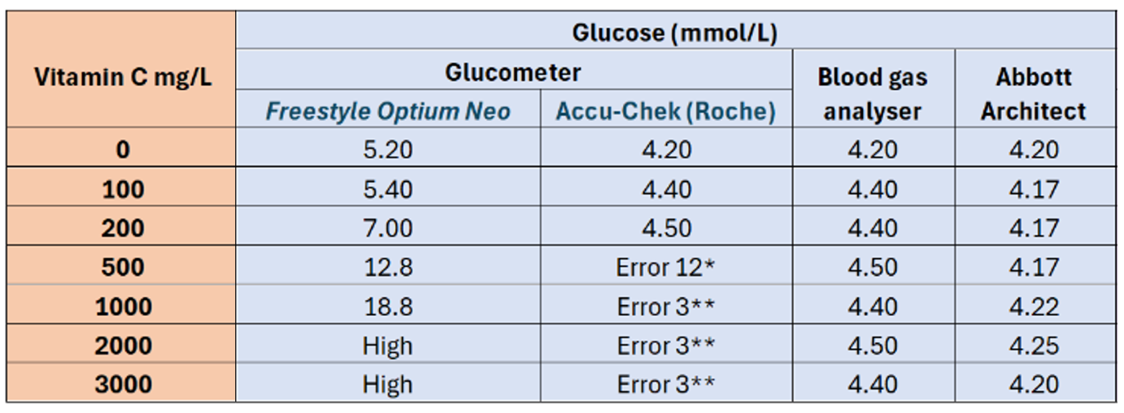Error 12: “The blood sample may contain a high level of Ascorbate”.4
** Error 3: “meter or a test strip error has occurred. In rare cases, an E-3 message may indicate that your blood glucose is extremely high and above the system’s measuring range.”4.

Table 2: Table 1: Blood spiked with varying Vitamin C concentrations: Ketone measurements
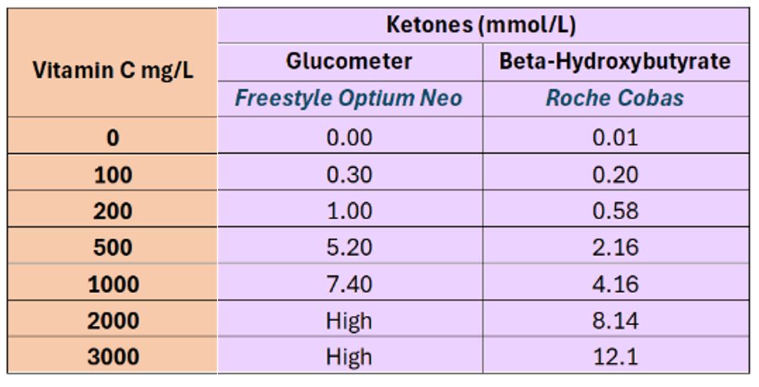

Figure 1: Impact of vitamin C infusion on glucometer readings (Libre 2)

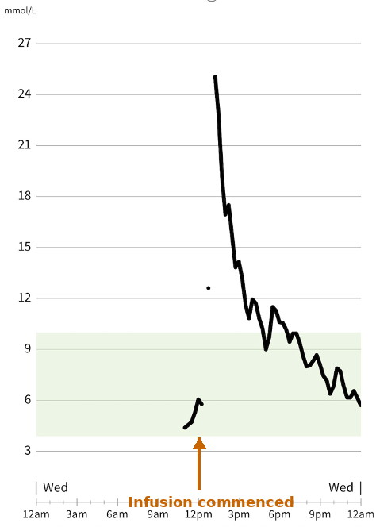

Figure 2: Impact of vitamin C infusion on glucometer readings (Dexcom G7)

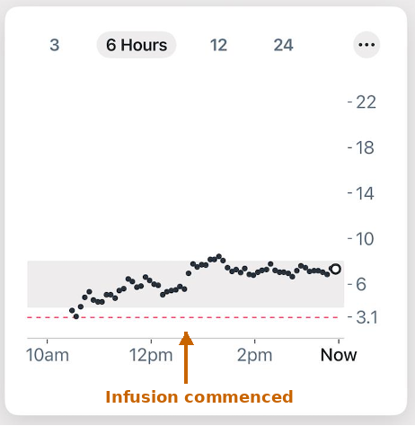
REFERENCES:
1. Cho J, Ahn S, Yim J, Cheon Y, Jeong SH, Lee SG, Kim JH. Influence of vitamin C and maltose on the accuracy of three models of glucose meters. Ann Lab Med. 2016 Feb 23;36(3):271–4. doi:10.3343/alm.2016.36.3.271.
2. Hauss O, Huffman B, Hinzmann R. Drug interference in self-monitoring of blood glucose and the impact on patient safety: we can only guard against what we are looking for. J Diabetes Sci Technol. 2024;18(3):727–32. doi:10.1177/19322968221140420.
3. Orija IB, Zahid SH. Pseudohyperglycemia secondary to high-dose intravenous vitamin C managed as diabetic ketoacidosis: an endocrinological catastrophe. AACE Clin Case Rep. 2021;7:239–42.
4. 4. Error-codes | Accu-Chek [Internet]. Accu-chek.com. 2024 [cited 2025 May 16]. Available from: https://www.accu-chek.com/support/products/guide/error-codes

