Knowledge Café
Enabling climate action: New UNESCO Intergovernmental Oceanographic Commission guidance for community-based coastal hazard risk reduction, adaptation and climate resilient development

Synopsis
This session introduces new UNESCO Intergovernmental Oceanographic Commission (IOC) guidance for community-based coastal hazard risk reduction, adaptation, and climate resilient development.

In this session, the guidance author, Bruce Glavovic (Massey University, New Zealand), provides an overview of the guidance; explains the rationale for and distinctive features of the guidance; describes how the guidance has been stress-tested and applied; and introduces capability building opportunities to support application by UN member nations.

Participants will workshop opportunities and challenges for community-based adaptation in different coastal settings and explore ways to test and / or apply the guidance to support local climate action.

Background to this UNESCO IOC guidance
Coastal communities already experience the direct impacts of climate change. Prospects are bleak in the face of rising sea-level and compounding interactions between climate change and coastal biodiversity loss alongside vexing challenges in public health, and food, energy, and water security. Unsustainable development and resource dependency can make coastal communities vulnerable to climate impacts and limit their capacity to respond. Navigating these ‘stormy seas’ is challenging, with profound implications for transitioning to just and sustainable coastal futures. How might coastal communities prepare for a turbulent future? This new UNESCO IOC guidance addresses this question.

The two-volume guidance comprises: (i) a Community Guide of about 25 pages for at-risk residents, community members and their governing authorities who want to take practical steps to reduce risk and prepare for the future (already available in Arabic, English, French, Portuguese, Russian and Spanish); and (ii) a Workbook of over 500 pages that is a resource for practitioners who can support at-risk communities in reducing coastal hazard risk, building adaptive capacity and resilience, and enabling community-based climate resilient development.

This guidance is NOT a recipe book to be applied in a uniform manner in different coastal settings. Rather, the guidance is a resource that provides an array of practices and tools that can be creatively applied in a tailor-made way appropriate to distinctive coastal communities. For example, different modalities of engagement, and situationally-relevant tools and practices for risk assessment, adaptation planning and institutionalisation, are necessary for different settings. The guidance can be applied in a fit-for-purpose manner in diverse settings – from the Arctic to tropical coasts, small islands and the world’s southernmost coasts – and across the spectrum of human settlements – from megacities to remote villages – and in diverse cultural, socio-economic, political and governance systems, including predominantly Indigenous communities.

The guidance introduces a critical framing of adaptation as community-based pact-making that centres on building enduring relationships of trust between at-risk residents, community members, Indigenous People, and local governing authorities (including local government bodies and traditional authorities), with active involvement of relevant stakeholders who can help (or hinder) community-based adaptation, e.g., central government Ministries, non-governmental and community-based organisations, civil society and private sector bodies, as well as locally relevant interested and affected parties.

The guidance is structured around a four-step process: (i) Mobilise your community before proceeding to (ii) building shared understanding about risk, (iii) identifying plausible adaptation pathways, and (iv) negotiating how to mainstream community-based actions through both formal and informal institutional structures, processes and practices as an integral part of ongoing reflexive adaptation and climate resilient development praxis.

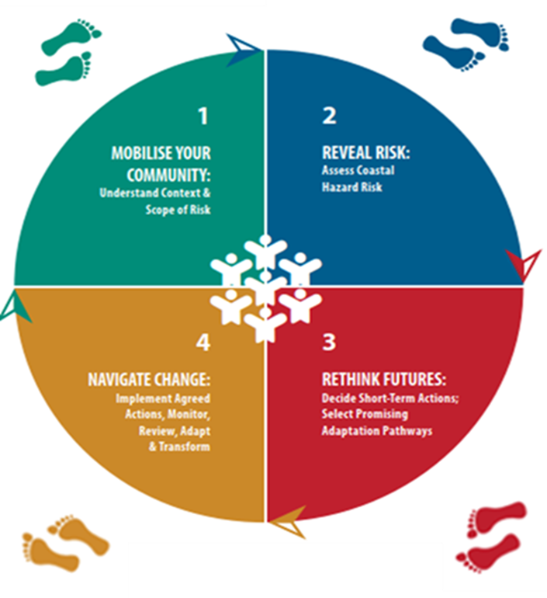
Community-based planning and local action are entwined and centre on ways to unlock and leverage collective local capabilities to address external drivers of vulnerability and risk, accounting for the pervasive influence of power and politics.

What is distinctive about the UNESCO IOC guidance?
There is much guidance already available. What is distinctive about this guidance?

First, this guidance is focused on enabling community-based, locally led coastal hazard risk reduction. In many instances, risk reduction, adaptation and resilience building are done for or to local communities, often led by well-intentioned government agencies and / or international organisations. Building enduring adaptive capacity is seldom realised through these efforts, especially if they are authoritarian or top-down. Much can be done to leverage local capabilities to reduce vulnerability and improve prospects for climate resilient development even if there is not an enabling legislative framework. A community-based approach centres on the residents at risk and the affected community, and identifies plausible short-term response options (e.g., warnings and evacuations), and their pros and cons, and identifies pathways for medium- to longer-term actions (e.g., protective works that might involve a mix of hard-engineering and nature-based solutions together with livelihood changes such as locally produced food before planned relocation might become necessary). Community-based adaptation is participatory and engages with uncertainty, ambiguity and manifest conflict in conditions of extreme climate stress. Community-based adaptation planning specifies community-specific signals (i.e., warnings that prevailing measures are becoming ineffectual or inappropriate) and trigger points (i.e., the decision points at which a new pathway of interventions should be followed) so that those in peril can transition from one set of adaptation actions to alternative interventions consistent with community values and aspirations, and accounting for prevailing power and politics.

Second, well-intentioned initiatives often prioritise technical analysis of hazard exposure and rely on protective works like stopbanks and seawalls. Understanding physical exposure to natural hazards may be necessary but is seldom sufficient for effective community-based risk-reduction and adaptation. Attention needs to focus on the drivers and root causes of vulnerability – that which makes people susceptible to harm. Only then can natural hazard risk (the product of both physical exposure and social vulnerability) be more fully understood and effectively addressed.

Finally, the guidance goes beyond planning to address implementation, i.e., mainstreaming or institutionalising adaptation and resilience building actions. It outlines ways to integrate community-based adaptation into local planning, budgeting, decision-making, and day-to-day community activities; and into the processes, practices and structures of relevant governing authorities, including local councils and/or traditional authorities. Binding commitments by relevant governance actors to work together on an ongoing basis need to be brokered by skilled mediators / facilitators. These commitments necessarily involve at-risk residents, Indigenous People, local government and community-relevant stakeholders, and are foundational for advancing locally led community-based risk reduction, adaptation and resilience building.

This session
Participants will be introduced to practical steps and tools that can be used to enable community-based risk reduction and adaptation and resilience building. The four-step mediated approach creates opportunities for at-risk coastal communities and their governing authorities to develop novel ‘fit-for-purpose’ ways to institutionalise empowering and transformative climate action.

An overview of the guidance will be presented by Bruce Glavovic, including its rationale and distinctive features, how it has been stress-tested and applied, as well as the capability building opportunities being developed to support application of the guidance. Examples are drawn from case studies around the world, with a focus on the Pacific.

Participants will workshop opportunities and challenges for testing and / or applying the guidance in different coastal settings and identify barriers and enablers for enabling just transitions through community-based coastal hazard risk reduction, adaptation and climate resilient development.

The session aims to provide participants with new guidance and new ideas about how to support coastal communities so that they can proactively prepare for an uncertain future and chart pathways towards climate resilient development. UNESCO’s IOC aims to build a cadre of practitioners who can use this guidance and other relevant resources to support at-risk coastal communities to prepare for turbulent times.

Both in-person and remote participation are provided for.
PARTICIPANTS

Participant 1
Full Name: Bruce C. Glavovic
Organisation: Massey University
Bio: Bruce has worked as a policy advisor, consultant planner, and academic in South Africa, the USA, and New Zealand. His applied research centres on how to make societal choices in turbulent times, with a focus on climate change adaptation; natural hazards planning; coastal governance; and collaborative planning and conflict transformation.

