Assessment of outcomes using phase-resolved functional lung (PREFUL) MRI in a child with Primary Ciliary Dyskinesia
Frohlich M^{1,2}, Hillenbrand CM³, Prentice B^{1,2}, Fawcett L^{1,2,6}, Purcell M¹, Burke S³, Grimm R⁴, Voskrebenzev A⁵, Vogel-Claussen J⁵, Waters S^{1,2,6,7}, Owens L^{1,2}, Morgan L^{8,9}, Jaffe A^{1,2}
¹Discipline of Paediatrics and Child Health, School of Clinical Medicine, Faculty of Medicine and Health, UNSW Sydney, NSW, Australia. ²Department of Respiratory Medicine, Sydney Children’s Hospital, NSW, Australia. ³Research Imaging NSW, Division of Research & Enterprise, UNSW Sydney, NSW, Australia.⁴Siemens Healthineers, Erlangen, Germany. ⁵Institute of Diagnostic and Interventional Radiology, Hannover Medical School, Hannover, Germany. ⁶Molecular and Integrative Cystic Fibrosis Research Centre (miCF_RC), UNSW Sydney, NSW, Australia. ⁷School of Biomedical Sciences, Faculty of Medicine and Health, UNSW Sydney, NSW, Australia. ⁸Department of Respiratory Medicine, Concord Hospital, Sydney, NSW, Australia. ⁹Faculty of Medicine, University of Sydney, NSW, Australia.
Introduction: Primary Ciliary Dyskinesia (PCD) is a rare lung disease characterised by defects in ciliary function leading to peripheral airway dysfunction. Spirometry and lung clearance index (LCI) are available techniques to measure lung ventilation but these techniques estimate whole lung ventilation and do not provide regional information. CT chest is used to monitor the progress of regional structural disease however does not provide ventilation information and involves radiation exposure. Phase-resolved functional lung (PREFUL) MRI is a radiation free imaging technique that offers assessment of both lung morphology and regional lung ventilation during free breathing. In this case report we describe the novel application of PREFUL MRI in assessment of treatment outcomes pre and post lung bilobectomy in a person with PCD.

Methods: A 13 year old boy with Kartagener syndrome had progressive severe cystic bronchiectasis of the left middle and lower lobes (in the context of situs inversus totalis and a trilobed left lung) on CT scans and was infected with P.aeruginosa and M.avium complex. The decision was made to proceed to left middle and lower bilobectomy to prevent further destruction of less diseased lung. Spirometry, LCI and PREFUL MRI were performed 1 week prior and 16 weeks after bilobectomy.

MRI examinations were performed on a 3T Siemens scanner during free breathing with no contrast agent administered. PREFUL processing¹ was used to derive regional pulmonary ventilation and perfusion distribution from proton MRI data.

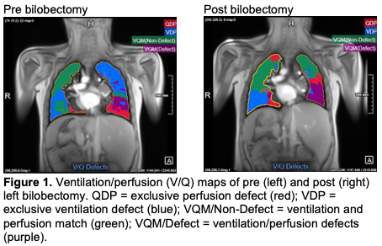
Results: Following surgery, LCI improved from 10.09 to 9.32. There was no change in spirometry parameters (FEV1 z-score -2.65 vs -2.34, FVC z-score -2.24 vs -2.37, FEV1/FVC z-score -1.18 vs -0.25). Pre-operative MRI confirmed bronchiectasis of the left middle and lower lobes. PREFUL MRI demonstrated an improvement in mean ventilation from 3.5% pre surgery to 22.7% and a reduction in ventilation/perfusion (V/Q) defect from 38.7% to 23.9% (figure 1).

Conclusion: PREFUL MRI is a novel radiation free imaging technique which allows lung morphology and regional ventilation assessment, with utility in monitoring treatment outcomes.

Grant Support: This pilot project was supported by Research Imaging NSW

References:
1. Voskrebenzev A, Gutberlet M, Klimes F, et al. Feasibility of quantitative regional ventilation and perfusion mapping with phase-resolved functional lung (PREFUL) MRI in healthy volunteers and COPD, CTEPH, and CF patients. Magn Reson Med. 2018;79(4):2306-2314.

