Regional lung function assessment using the novel XV scanner: a feasibility study in chronic respiratory diseases
Frohlich M^{1,2}, Strachan R², Hillenbrand C³, Thomas P^{4,5}, Yates D^{6,7}, Sivam S^{8,9}, Corte T^{8,9,10}, Fermoyle C^{8,9,10}, Tran M^{8,9,10}, Morgan L^{9,11}, Eikelis N¹², Hardaker K^{9,11}, McBride J^{1,2}, Coward E^{1,2}, Plush L², Jaffe A^{1,2}
¹Discipline of Paediatrics and Child Health, School of Clinical Medicine, Faculty of Medicine and Health, UNSW Sydney, NSW, Australia. ²Department of Respiratory Medicine, Sydney Children’s Hospital, NSW, Australia, ³ Research Imaging NSW, Division of Research & Enterprise, UNSW Sydney, NSW, Australia. ⁴Department of Respiratory Medicine, Prince of Wales Hospital, NSW, Australia. ⁵Prince of Wales Clinical School, Faculty of Medicine, UNSW Sydney, NSW, Australia. ⁶School of Clinical Medicine, Faculty of Medicine and Health, UNSW Sydney. ⁷Holdsworth House, Darlinghurst, NSW, Australia. ⁸Department of Respiratory and Sleep Medicine, Royal Prince Alfred Hospital, NSW, Australia. ⁹Faculty of Medicine and Health, University of Sydney, NSW, Australia. ¹⁰Centre of Research Excellence in Pulmonary Fibrosis, NSW, Australia ¹²Department of Respiratory Medicine, Concord Hospital, NSW, Australia. ¹²4DMedical, Victoria, Australia.

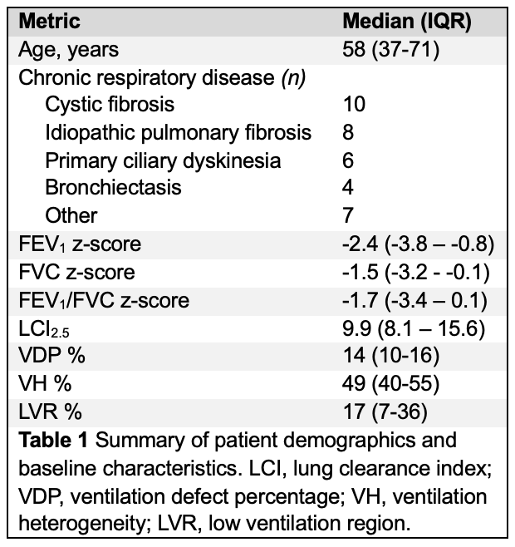
Introduction: X-ray Velocimetry (XV) is a novel technique that quantifies regional lung ventilation from X-ray fluoroscopy images. Its sensitivity has been demonstrated in animal and human studies. The XV scanner is a new, non-invasive, rapid, purpose-built device to capture images for XV analysis. This study evaluates its feasibility for assessing lung function in adults with chronic respiratory diseases (CRD).
Method: Participants ≥18 years with CRD were recruited from four Sydney sites. Participants underwent multiple breath nitrogen washout (MBNW) via tidal breathing and spirometry according to ATS/ERS standards. An XV scan was performed, with cinefluorographic images across four synchronised angles captured during one breath cycle while seated. XV images were combined with a recent chest CT, and XV analysis generated XV metrics and XV ventilation maps.
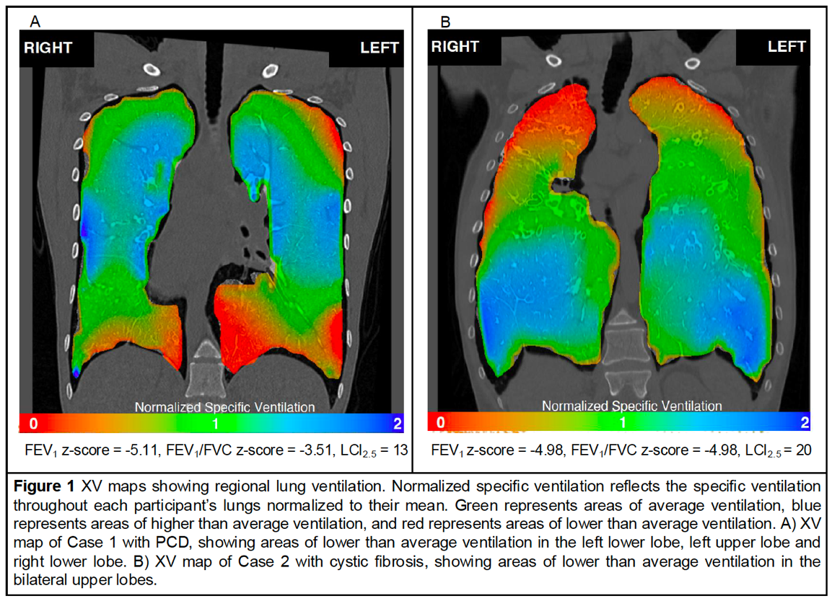
Results: Thirty-five participants with CRD were recruited. Baseline characteristics are shown in Table 1. All participants completed acceptable and reproducible spirometry and the XV scan. 12 participants were unable to complete MBNW. FEV1/FVC z-scores significantly correlated with XV metrics ventilation defect percentage (VDP) (R²=0.13, p=0.03), ventilation heterogeneity (VH) (R²=0.12, p=0.04) and low ventilation region (LVR) (R²=0.13, p=0.03). Lung clearance index (LCI_{2.5}) significantly correlated with LVR (R²=0.19, p=0.04) but not VDP (R²=0.06, p=0.27) or VH (R²=0.05, p=0.29). There was no correlation between FEV₁ z-scores and VDP (R²=0.06, p=0.17), VH (R²=0.04, p=0.23) or LVR (R²=0.04, p=0.23). XV maps revealed the location of areas of lower-than-average ventilation for each participant (Figure 1).
Conclusion: This study demonstrates the feasibility of the XV scanner to assess regional lung function in adults with CRD. XV-derived metrics correlated significantly with established measures of airflow limitation and ventilation heterogeneity, and XV maps provided regional insight not captured by standard lung function tests.
Grant Support: Funding for this research is from the Australian Government’s MRFF Grant RFRHPSI000013. We acknowledge Research Imaging NSW for their support with this study.

