**Title The** Te Kūiti Access to Cardiology Pilot Study (TKACPS) – Does NTproBNP or ST-2 help predict referral to cardiology?

**Background:**

TKACPS was designed to assess whether a simple local screening protocol could identify patients requiring cardiology referral, who might be missed by normal GP care, in a high proportion Māori GP population (Te Kūiti). NTproBNP plasma concentration, included in the screening protocol, can be altered by obesity (lowered) and renal dysfunction (increased), conditions common in the high proportion Māori, GP study population (Te Kūiti). ST2 predicts outcome in heart failure, but is less affected by obesity and renal dysfunction. The ability of ST-2 or NTproBNP to predict referral to cardiology was assessed.

**Method:**

Te Kūiti GP patients aged 35-74, with a 5 year CVR of ≥10% (PREDICT CVD) were eligible for inclusion. Current cardiology patients (or those seen within two years), were excluded. Screening protocol (Phase 1: symptom questionnaire, electrocardiogram and plasma TroponinT, NTproBNP and ST-2) was followed by, if indicated, Phase 2: screening echo, Holter Monitor or exercise tolerance test (ETT). Appropriate patients were referred to cardiology / tertiary services. The values for ST-2 or NTproBNP in those who did not progress to further investigation (group 1), those who progressed to Stage 2 (group 2) and those referred to cardiology (group 3) were compared.

**Results:**

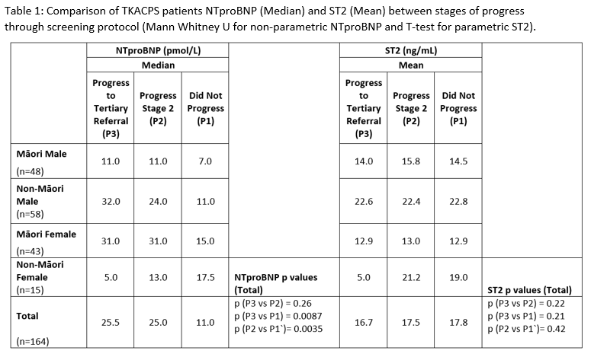

**Conclusion:**

ST-2 was similar across groups 1-3, suggesting ST-2, in this population, would not help distinguish those needing cardiology referral. NTproBNP was increased in participants that progressed to either Stage 2 investigations or referral compared to those that didn’t, suggesting it may help distinguish those needing further investigation.