ERR𝛾 loss promotes neuroendocrine differentiation in PTEN-deficient prostate cancer

Ting Li^{1,4,5,#*}, Catherine R. Dufour¹, Lingwei Han^{1,2}, Mu-Yang Huang³, Jin-jian Lu^{3,4,5}, and Vincent Giguère^{1,2*}
¹ Goodman Cancer Institute, McGill University, Montréal, QC, H3A 1A3, Canada.
² Department of Biochemistry, Faculty of Medicine and Health Sciences, McGill University, Montréal, QC, H3G 1Y6, Canada.
³State Key Laboratory of Quality Research in Chinese Medicine, Institute of Chinese Medical Sciences, University of Macau, Macao, China.
⁴ MoE Frontiers Science Center for Precision Oncology, University of Macau, Macao, China.
⁵ Department of Pharmaceutical Sciences, Faculty of Health Sciences, University of Macau, Macao, China.

Introduction. Increasingly effective therapies targeting the androgen receptor have paradoxically contributed to the incidence of neuroendocrine prostate cancer (NEPC). Although NEPC is the most lethal subtype of castration-resistant prostate cancer, the underlying mechanisms remain incompletely understood and effective treatments remain undiscovered.
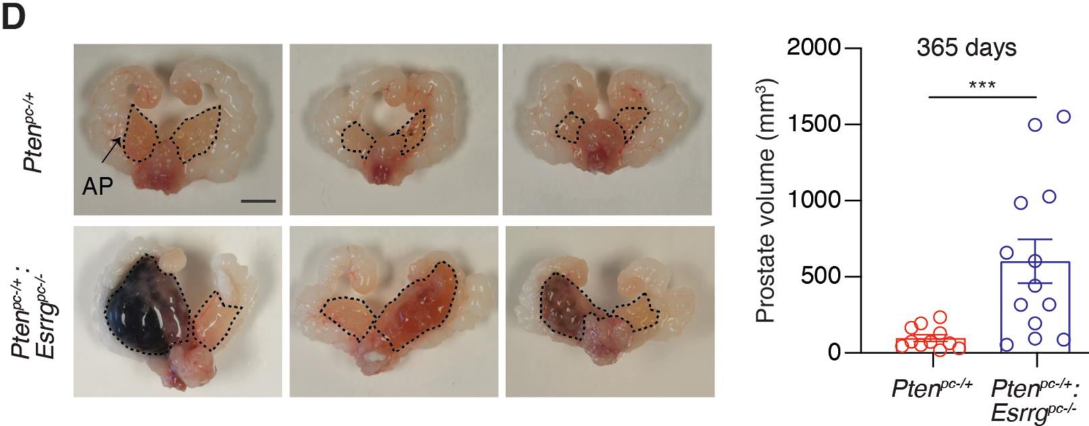
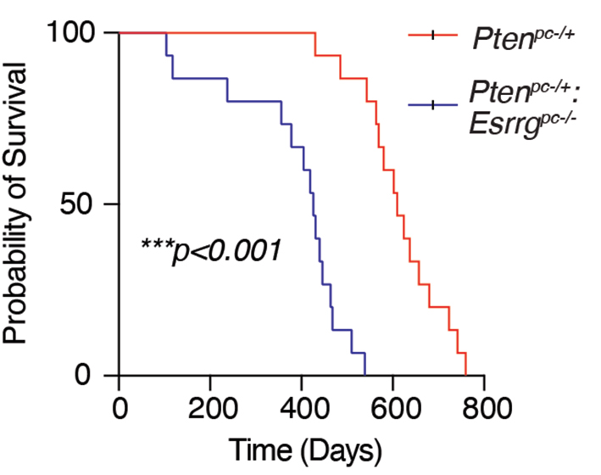
Aims. Given the prominent roles that members of the nuclear receptor family play in developmental processes and cancer, we initially searched for genes encoding nuclear receptors in which their level of expression changes during PCa progression toward NEPC.
Methods. Several prostate-specific pre-clinical models includes genetically engineered mouse models (GEMMs) and cell lines, xenografts as well as organoids were applied.
Results. Loss of nuclear receptor ERRγ expression promotes neuroendocrine differentiation of PTEN-deficient prostate adenocarcinoma.
Discussion. This study delineates a novel nuclear receptor-dependent molecular mechanism driving lineage plasticity towards NEPC through downregulation of ERRγ signaling, thus offering new insights and possibilities into potential therapeutic approaches for PCa.

