**Advanced 3D Models of Early Pregnancy Placental Tissue for Drug and Biomarker Screening**

**Lana McClements1,2**, Claire Richards1,2, Ananya Raman1, Niamh Mills1, Ashley Bannister1, Louise Cole3, Kristine McGrath1, Chunyan Liu1,4, Aihua Liao4

1School of Life Sciences, Faculty of Science, University of Technology Sydney, NSW, Australia

2 Institute for Biomedical Materials and Devices, Faculty of Science, University of Technology Sydney, NSW, Australia

3Australian Institute of Microbiology and Infection, University of Technology Sydney, NSW, Australia

4Institute of Reproductive Health, Tongji Medical College, Huazhong University of Science and Technology, Wuhan, PR China

**Background and aims.** Placenta is an essential organ that develops during pregnancy and connects the mother to the baby. Placental dysfunction can lead to serious complications including preeclampsia and fetal growth restriction (FGR). The aim of our research is to develop more representative models of early placental tissue to understand the mechanisms of appropriate and inappropriate placentation better and accelerate the discovery of biomarkers and treatments for preeclampsia or FGR.

**Methods.** The first trimester trophoblasts or trophoblast stem cells were 3D bioprinted using RASTRUM (Inventia Life Science, Australia) in a polyethylene glycol-based matrix or embedded in Matrigel to form organoids for up to 12 days. Organoid growth, proliferation and trophoblast differentiation were assessed using live cell or fluorescence imaging. Within the microfluidics chips (AIM Biotech, Singapore) or placenta-on-a-chip, the first trimester trophoblast cells, ACH-3P, were co-cultured ± human umbilical vein endothelial cells (HUVECs), M0/M1/M2 macrophages, or mesenchymal stem cell (MSC) under physiological or hypoxic (DMOG, 100µM) or inflammatory (TNF-α, 10 ng/ml), conditions. for 48-72 hours before migration and invasion were assessed in 3D culture using fluorescent labelling.

**Results.** Trophoblasts bioprinted or embedded in Matrigel self-formed 3D organoids and spontaneously or through chemical induction differentiated into important trophoblast subtypes including extravillous trophoblasts (HLA-G+) or syncytiotrophoblasts (SDC1+); Figure 1. Trophoblast and endothelial cell migration and angiogenesis, respectively, were impaired by the presence of hypoxic or inflammatory stimuli within the placenta-on-a-chip (p<0.05)1. Trophoblasts migration and invasion from the side channel (Figure 1) was stimulated by the presence of HUVECs (p<0.0001)1 or MSCs (p<0.001) in the middle channel.

**Conclusion/Discussion.** These innovative 3D bioprinted and microfluidics models of early placental tissues have been pioneered to replace animal use in pregnancy research, providing better understanding of placenta biology mechanisms and enabling testing of potential therapeutic candidates for placental dysfunction disorders in a safe and cost-effective manner.

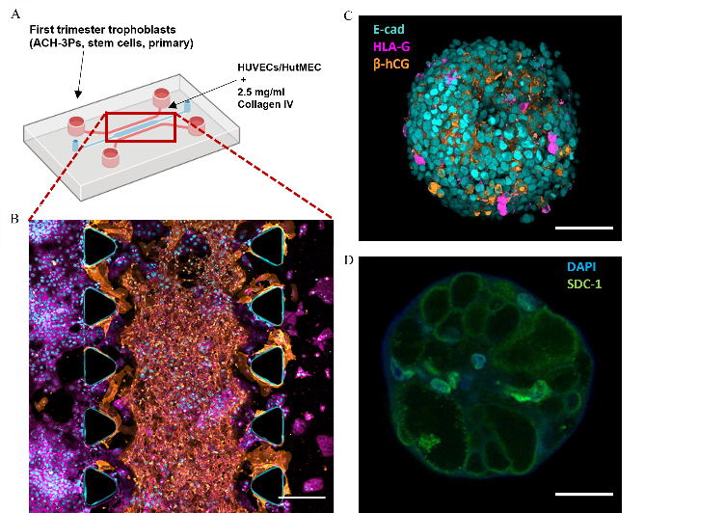**Figure 1.** 3D microfluidics and bioprinted models of the first trimester placental. (A) Schematic and (B) stained placenta-on-a-chip incorporating the first trimester trophoblasts (cytokeratin 7+, magenta) are co-cultured with HUVECs (CD31+, in orange) in the presence of collagen1. 3D bioprinted trophoblast organoids (C) using ACH-3Ps with three trophoblast cell subtypes (E-cad+ cytotrophoblasts, HLA-G+ extravillous trophoblasts and β-hCG+ syncytiotrohoblasts) or (D) trophoblast stem cells differentiated to synsytiotrophoblasts (SDC-1+).

**References:** 1. Ghorbanpour, S. M.; Richards, C.; Pienaar, D.; Sesperez, K.; Aboulkheyr Es., H.; Nikolic, V. N.; Karadzov Orlic, N.; Mikovic, Z.; Stefanovic, M.; Cakic, Z.; Alqudah, A.; Cole, L.; Gorrie, C.; McGrath, K.; Kavurma, M. M.; Ebrahimi Warkiani, M.; McClements, L. A Placenta-on-a-Chip Model to Determine the Regulation of FKBPL and Galectin-3 in Preeclampsia. Cell. Mol. Life Sci. 2023, 80 (2), 44. https://doi.org/10.1007/s00018-022-04648-w.