Tetrastigma hemsleyanum polysaccharide enhances the anti-cancer efficacy of anti-PD-L1 therapy
Yu-Chi Chen¹, Mu-Yang Huang¹, Wei Shi¹, Yan-Ming Zhang¹, Wei-Bang Yu¹, Can-Yu Huang¹, Xiuping Chen¹, Ting Li¹, Xin Chen¹, Zhi-Shan Ding², Jin-Jian Lu¹. State Key Laboratory of Quality Research in Chinese Medicine, Institute of Chinese Medical Sciences, University of Macau¹, Macao, MO, China; School of Medical Technology and Information Engineering, Zhejiang Chinese Medical University², Hangzhou, ZJ, China.
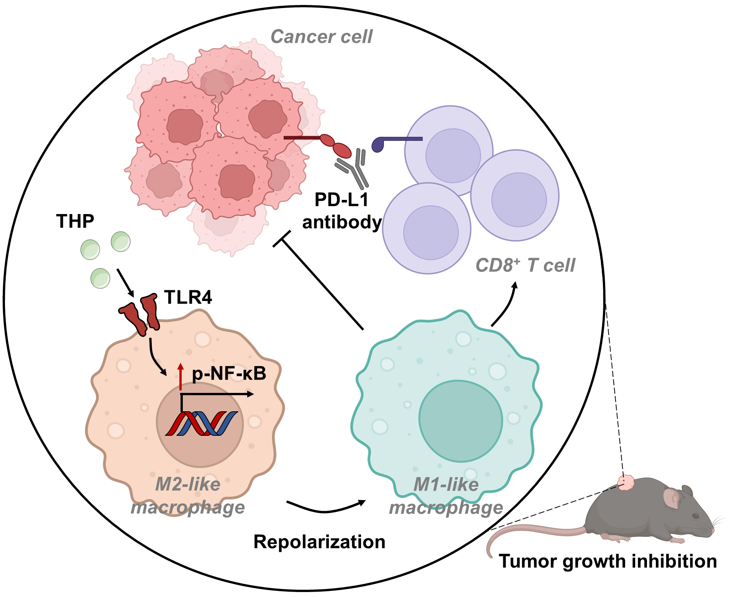
Introduction. Despite the effectiveness of programmed cell death receptor-1 (PD-1) and programmed cell death ligand-1 (PD-L1) antibodies, many patients are unresponsive due to the immunosuppressive tumor microenvironment. Innovative approaches to enhance PD-1 or PD-L1 blockades are needed.
Aims. To explore the effect of Tetrastigma hemsleyanum polysaccharide (THP) on enhancing anti-cancer effects of anti-PD-L1 and its potential mechanism.
Methods. Murine tumor models evaluated the anti-cancer effect of anti-PD-L1 combined with THP. Flow cytometry analyzed tumor-infiltrating immune cells. In vitro studies examined THP’s impact on macrophage polarization and underlying mechanisms using flow cytometry, qRT-PCR, and western blot. Co-culture assessed THP-primed macrophages’ effects on cancer cell growth inhibition and T cell proliferation. The roles of CD8⁺ T cells and TLR4 in combination therapy were tested using anti-CD8 antibody and TLR4 inhibitor.
Results. THP enhanced the anti-cancer effects of anti-PD-L1 in mouse MC38 colorectal and 4T1 breast cancer models. Combination treatment further increased tumor-infiltrating T cells, and CD8⁺ T cell depletion nullified the anti-tumor effect. The M1/M2 macrophage ratio in the tumor microenvironment increased with THP and anti-PD-L1 combination treatment. In vitro, THP repolarized macrophages to an M1-like phenotype, inhibiting cancer cell growth and promoting CD8⁺ T cell proliferation. TLR4 inhibition blocked THP-induced macrophage repolarization and reduced the combination therapy’s anti-cancer effect.
Discussion. Our results suggest that THP may be used as an adjuvant to enhance anti-tumor efficacy of anti-PD-L1 therapy, and this notion merit further investigation.

