**Regional Differentiation of Chemical Composition and Bioactivity of *Cudrania tricuspidata* Fruits from Korea**

Young Jun Kim1,2, Ki Yong Lee1,2,*.

College of Pharmacy, Korea University1, Sejong 30019, Republic of Korea;

Interdisciplinary Major Program in Innovative Pharmaceutical Sciences, Korea University2, Sejong 30019, Republic of Korea.

**Background and aims.** *Cudrania tricuspidata* is a traditional medicinal plant widely consumed as a functional food in Korea. Its fruits are known for various biological activities. However, the influence of geographical factors on the chemical composition and bioactivity remains poorly studied. This study aimed to investigate how regional differences affect the chemical composition and antidiabetic activity of fruits collected from various locations across Korea.

**Methods.** Fruits of *C. tricuspidata* were collected from 30 different regions in Korea. Chemical profiling was performed using LC-MS to analyze the chemical composition. Subsequently, α-Glucosidase inhibitory activity was evaluated. Based on these data, correlation analysis and multivariate statistical analysis were conducted to explore relationship between chemical composition and bioactivity.

**Results.** *C. tricuspidata* were collected from 30 different regions across Korea (see Figure 1A). Based on the chemical profiling, eight major peaks (a–h) were identified and their regional variation assessed (see Figure 1B). The α-glucosidase inhibition assay was performed to evaluate the antidiabetic activity of all samples. Correlation analysis, including geographic factors and inhibitory activity, revealed that peaks c, f, g, and h showed significant associations with the antidiabetic effect. Among them, peaks f and h also correlated with geographic factors. Multivariate analysis further supported the strong relationship between these four compounds and bioactivity.

1. 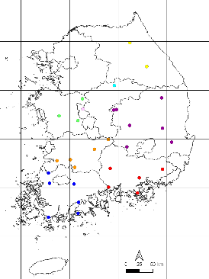 **(B)** 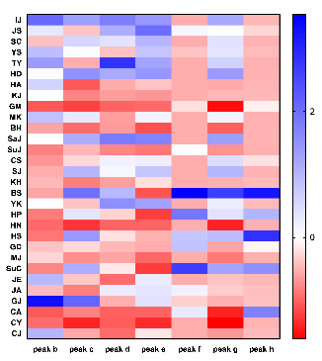

**Figure 1.** (A)Geographic distribution of *C. tricuspidata* samples collected across Korea; (B)Heatmap showing regional variation of major compounds in *C. tricuspidata*.

**Conclusion/Discussion.** This study demonstrated clear regional variation in both chemical composition and antidiabetic activity of *C. tricuspidata*. Identifying key compounds correlated with bioactivity and geography provides valuable insight for quality control and regional selection of functional materials Further studies are needed to focus on maximizing the functional potential of *C. tricuspidata* based on regional chemical variation.

**Acknowledgements:** This research was supported by the National Research Foundation of Korea grants funded by the Korean Government (RS-2019-NR040070 and NRF-2021R1A2C1093814).

**References:**

(1) Lee, D. H. et al (2023) Plants 12(11):2107