**Endogenic Transferrin-Targeted Cell Membrane-Coated Biomimetic Lipo-complexes for Efficient Targeting and Enhanced Antitumor Efficacy in Orthotopic Glioblastoma**

**Zhonggao Gao1**, Shuangqing Wang1.

1. State Key Laboratory of Bioactive Substance and Function of Natural Medicines, Institute of Materia Medica, Chinese Academy of Medical Sciences and Peking Union Medical College, Beijing 100050, China;

**Background and aims.** Due to the invasive growth of glioblastomas (GBM) and their resistance to conventional chemotherapy, the efficacy of GBM treatment remains limited. Biomimetic BBB-penetrating hybrid nanovehicles, engineered through homologous cell membrane fusion between cancer cells and protein corona (PC)-mediated liposomes coated with cancer cell membranes, have been explored for brain-targeted drug delivery.

**Methods.** T10 peptide-modified cell membrane-coated liposomes were used to construct an in situ transferrin (Tf) PC-mediated lipo-complex carrying a respiratory depressant agent (metformin, MET) and a photosensitizer (Chlorin, Ce6), creating a transferrin- and cancer cell-targeting delivery system (MET/Ce6@Lipo@CM@T10)..

**Results.** MET/Ce6@Lipo@CM@T10 possesses a spherical core–shell structure with uniform distribution while maintaining low systemic toxicity. Upon irradiation, MET/Ce6@Lipo@CM@T10 effectively inhibited cell proliferation and induced apoptosis via photodynamic therapy (PDT). Simultaneously, the loaded MET alleviated intracellular hypoxia caused by PDT, thereby enhancing anti-tumor efficacy. The establishment of an in vitro BBB model and 3D tumor spheroid experiments confirmed that MET/Ce6@Lipo@CM@T10 effectively crossed BBB and deeply accumulated within tumor tissues.

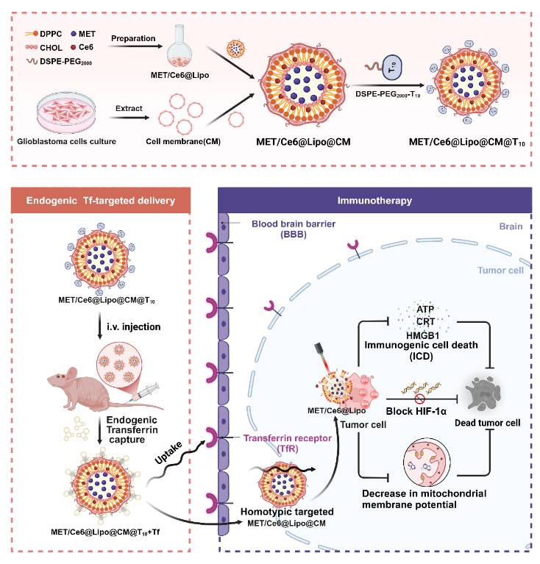

**Figure 1.** Schematic illustration of design and preparation of the MET/Ce6@Lipo@CM@T10 and enhanced photodynamic therapy of glioblastoma under dual-targeting by transferrin corona and cell membrane..

**Conclusion/Discussion.** *In vivo* animal experiments, MET/Ce6@Lipo@CM@T10 significantly inhibited tumor growth, promoted tumor necrosis and apoptosis, and demonstrated systemic safety. MET/Ce6@Lipo@CM@T10 demonstrated enhanced PDT effects on GBM, and will provide new insights and methods for GBM treatment.

**References:**

(1) Zhonggao Gao*, et al, Acta Pharmaceutica Sinica B, 2025, in press.