Photopharmacological Tools for the Precise in vitro and in vivo Modulation of β-Adrenoceptor Function
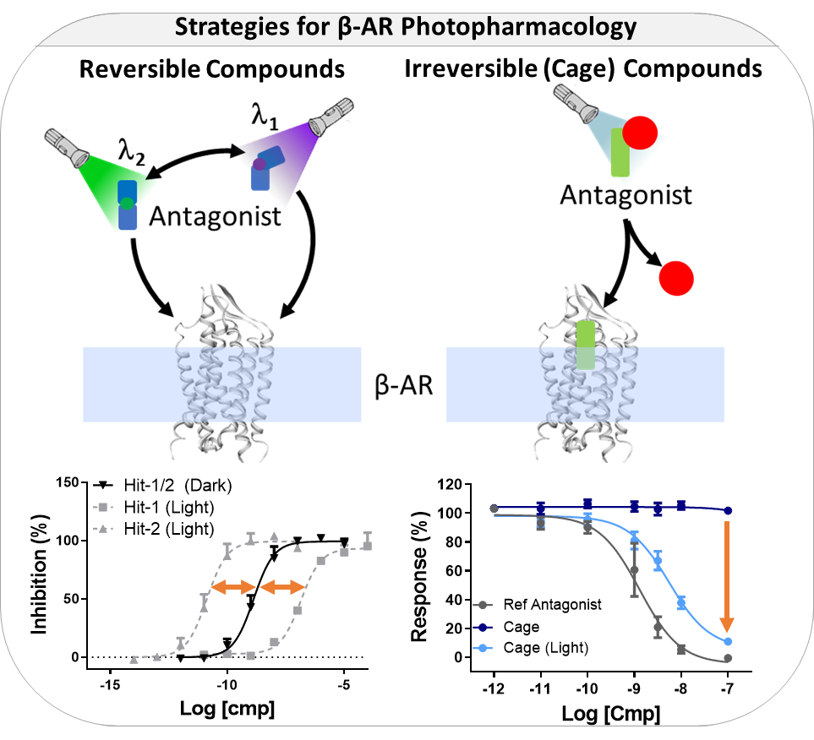
Xavier Rovira¹ Medicinal Chemistry & Synthesis, Institute for Advanced Chemistry of Catalonia (IQAC) ¹, Barcelona, Catalonia, Spain. (Cat)

Introduction. Photopharmacology is an emerging field in which light-sensitive molecules are used to spatiotemporally control the function of a given target in native tissues.
Aims. Our research focused on the generation of new molecular tools for β-adrenoceptors photopharmacology.
Methods. Libraries of photoresponsive compounds targeting β₁- and β₂-adrenoceptors were synthesized and validated in cells and animal models.
Results. Several molecules demonstrate potent, reversible and irreversible light-dependent pharmacology in vitro and in vivo.
Discussion. The discovered drugs enable a fine control of β-AR in their native environment.

GPCR signalling is currently recognized as a multidimensional process governed by molecular, spatial and temporal components. Uncovering the role of each of these dimensions is crucial to understand how different signalling pathways give rise to physiological effects. By using light to control drug action, both spatial and temporal regulation of compound activity can be achieved with unprecedented precision. We believe that these will open the door to innovative research procedures and may inspire future therapies targeting β-AR. These ligands have the potential to provide highly controllable therapeutic actions that may result in increased efficacies and reduced side effects. Importantly, photopharmacology may allow to gain mechanistic insight on the interplay between the activation time and the receptor location during signalling processes in non-modified cells, tissues and whole organisms.

Duran-Corbera A (2022) Angew Chem Int Ed Engl. 61(30):e202203449.
Duran-Corbera A (2022) iScience. 2022 Sep 13;25(10):105128

