**Collagen Disorder Domains in Human Anterior Cruciate Ligament Caused by Repetitive Sub-maximal Mechanical Loading**

*Mark M. Banaszak Holl,A Jinhee Kim,B Kevin Putera, A Stephen Schlecht,C So Young Baek,D James Ashton-Miller, D Edward Wojtys,E Lindsay BussauF*

AChemical Engineering, Monash University, Clayton, Australia; BChemistry, University of Michigan, Ann Arbor, United States; COrthopaedic Surgery, University of Indiana, Indianapolis, United States; DMechanical Engineering, University of Michigan, Ann Arbor, United States; EOrthopaedic Surgery, University of Michigan, Ann Arbor, United States. FOptiscan, Pty Ltd., Clayton, Australia.

**Introduction** Type 1 collagen is the most common structural protein found in the anterior cruciate ligament (ACL). The triple helix molecule self-assembles into fibrils, fibers, and then into macro hierarchical structures allowing shape and form of tissues to be defined and maintained. However, under mechanical stress such as fatigue, loading and injury, the tissue can undergo changes including unravelling of the collagen triple helix molecule as has been recently characterised by atomic force microscopy – infrared microscopy (AFM-IR), AFM, confocal fluorescence microscopy of a collagen hybridising peptide (CHP) TAMRA probe, and second harmonic imaging microscopy (SHIM).1 Additional studies are needed to understand the domain sizes and ACL locations associated with this molecular-level failure mechanism.

Figure 1. AFM-IR and CHP-TAMRA characterization of Collagen Unravelling in Anterior Cruciate Ligament

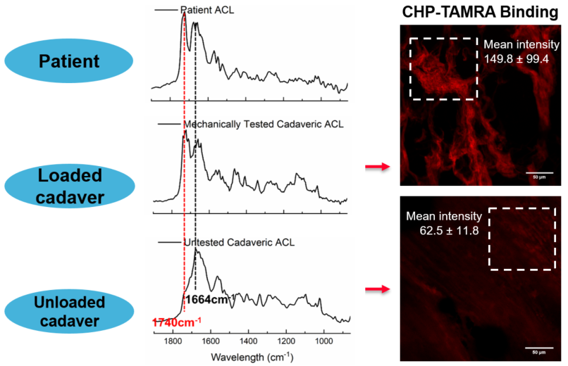

**Aims** The goal of this study is to understand the size and location of the unravelled collagen domains associated with mechanically induced material fatigue.

**Methods** One knee from an adult cadaver knees is repetitively loaded under 4x body-weight simulated pivot landings known to strain the ACL sub-maximally while the contralateral, unloaded, knee is used as a comparison. Changes to collagen structure are measured as a function of mechanical loading using confocal fluorescence endoscopy (CFE). Samples from patients who had undergone ACL reconstruction surgery are also analysed to compare with mechanically loaded cadaver samples. Both cadaver and patient ACL enthesis regions are sectioned and characterised by CFE, AFM-IR, AFM, and SHIM.

**Results** AFM-IR and fluorescence imaging with CHP indicate molecular level damage to collagen molecules through a sharp spectroscopic signature peak 1740 cm-1 and increased CHP binding, respectively (Fig. 1). SHIM identifies large scale regions of decreased signal consistent with collagen molecule unravelling. CFE allows direct probing of collagen damage at the microscopic level as well as the regions of CHP-TAMRA binding. Domain sizes and locations of collagen unravelling at multiple length scale measured by AFM-IR and optical microscopy (CFE, SHIM) will be presented.

**Conclusion** Signatures of material fatigue can develop across molecular, nano-, and micro-scale length scales on the human ACL as a response to repetitive sub-maximal mechanical loading. These findings suggest that some ACL injuries may be due to an exacerbation of pre-existing hierarchical tissue damage from activities known to place larger-than-normal loads on the ACL.

**References**

1. Chen, J.; Kim, J.; Shao, W.; Schlecht, S.H.; Baek, S.Y.; Jones, A.K.; Ahn, T.; Ashton-Miller, J.A.; Banaszak Holl, M.M; Wojtys E.A. (2019) An Anterior Cruciate Ligament Failure Mechanism. Am. J. Sports Med., 47, 2067-2076.