Epicatechin suppresses C-C motif chemokine ligand 19 expression and ameliorates periodontitis
Tomomi Sano¹, Meiqun Yuan¹, Akiko Mizokami², Takashi Kanematsu¹. Department of Cell Biology, Aging Science and Pharmacology¹, and OBT Research Center², Faculty of Dental Science, Kyushu University, Fukuoka, Japan

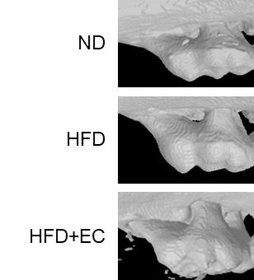
Introduction. Periodontitis is a prevalent chronic inflammatory disease requiring the development of drug-based therapies. Epicatechin (EC) is a major polyphenol in cocoa extract and possesses numerous pharmacological properties.
Aims. This study aimed to investigate the suppressive effect of epicatechin on C-C motif chemokine ligand 19 (CCL19)-mediated periodontitis using a mouse model.
Methods. Experimental periodontitis was induced by ligating 5-0 silk around the maxillary molar for 7 days. Immunohistochemical staining of gingival tissues was performed on paraffin sections using an anti-CCL19 antibody. Expression of CCL19 in gingival tissues assessed. Murine gingival fibroblasts ESK-1 cells were stimulated with LPS, and CCL19 expression was quantified. Mouse macrophage-like RAW264.7 cells were pretreated with EC and then stimulated with CCL19 to quantify the expression of inflammatory cytokines. Male mice were fed with a normal diet (ND), high-fat diet (HFD), or HFD containing EC (HFD + EC), and subjected to ligature-induced experimental periodontitis. 3D micro-CT images of the maxillary molar and alveolar bone loss areas were analysed.
Results. CCL19 expression was high in mouse gingiva with ligature-induced periodontitis. CCL19 expression was increased by LPS stimulation in ESK-1 cells, and CCL19 induced the production of TNF-α and IL-1β in RAW264.7 cells. Importantly, LPS-enhanced CCL19 expression in ESK-1 cells was significantly suppressed by pretreatment with EC. Consistently, EC administration significantly reduced alveolar bone resorption, and expression of CCL19 and proinflammatory cytokines in the inflamed gingiva in HFD-fed mice.
Discussion. We demonstrated that sustained systemic administration of EC significantly attenuates alveolar bone resorption during periodontitis. Moreover, EC intake suppressed the expression of proinflammatory cytokines in macrophages and ameliorated inflammation of gingival tissues by suppressing CCL19 expression in gingival fibroblasts. Therefore, consistent intake of EC may be a potential therapeutic strategy for treating periodontitis.

