**Mimicking systemic multi-organ interactions with microfluidics**

***Yi-Chin Toha,b***

aSchool of Chemistry, Physics and Mechanical Engineering, Queensland University of Technology

bInstitute of Health and Biomedical Innovation, Queensland University of Technology

Therapeutic agents, such as drugs and nanoparticles, administered into the systemic circulation often interact between multiple organs. Microfluidic in vitro culture systems offer the unique opportunity to mimic such physiological systemic interactions. Although conceptually straightforward, there are significant engineering challenges in synchronising the culture configurations and conditions of different cell types, and connecting them in a flexible format to depict different physiological processes. This talk will demonstrate the exploitation of 2 different classes of multi-compartment microfluidic devices to more accurately predict the therapeutic or adverse side effects of drugs mediated by multi-organ interactions. An array of compartmentalised micro-wells separated by diffusive micro-channels was used to emulate early upstream cellular processes involved in drug-induced skin sensitisation (Figure 1). This included the generation of antigenic reactive drug metabolites by the liver as well as the activation of the immune cascade, which can reliably measure the systemic skin-sensitization potential of different drugs. A modular microfluidic platform was developed to enable easy conversion of existing microfluidic devices into tissue and fluid control modules with self-aligning magnetic interconnects (Figure 2). This enables a ‘stick-n-play’ approach to assemble planar perfusion circuits, which are amenable to both bioimaging-based and analytical measurements. As a use-case demonstration, 2- or 3-tissue recirculating perfusion systems were implemented to emulate liver-mediated bioactivation of nutraceuticals and prodrugs to modulate their therapeutic efficacies in the context of atherosclerosis and cancer. The platform greatly facilitates the integration of existing organs-on-chip models to provide an intuitive and flexible way for users to configure different multi-organ perfusion systems.

***Figure 1.*** *A compartmentalised micro-well array for liver-immune coculture was used to predict the skin-sensitisation potential of drugs.*

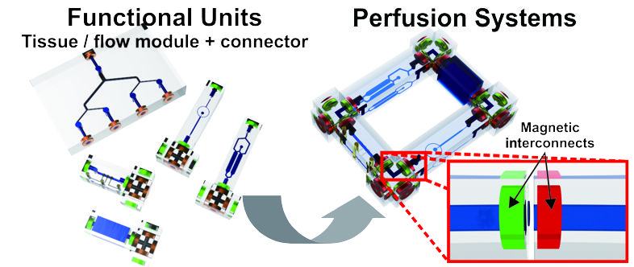***Figure 2.*** *A modular microfluidic platform that enables a user-intuitive and flexible way to configure multi-organ perfusion culture systems.*