ATG4B targeting peptide blocks autophagy flux and induces apoptosis of cancer cells
Chih-Wen Shu ¹, Wei-Lun Tsai ², Wan-Hsiang Hu ³, Pei-Feng Liu ⁴. Institute of BioPharmaceutical Sciences, National Sun Yat-sen University ¹, Kaohsiung, Taiwan; Department of Internal Medicine, Kaohsiung Veterans General Hospital ², Kaohsiung, Taiwan; Department of Colorectal Surgery, Kaohsiung Chang Gung Memorial Hospital ³, Kaohsiung, Taiwan; Department of Biomedical Science and Environmental Biology, Kaohsiung Medical University ⁴, Kaohsiung, Taiwan

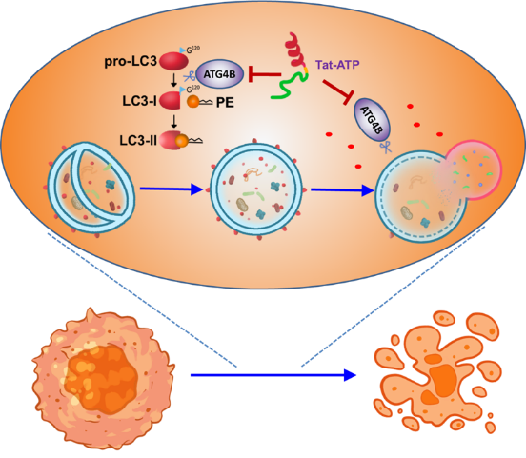
Introduction. Autophagin-1 (ATG4B) is a cytosolic cysteine protease to promote autophagy machinery, which is strongly associated with cancer progression. The α-helix secondary structure is important for protein-protein interactions (PPI), providing a way to design inhibitors to disrupt PPI.
Aims. This study aims to examine if the helical peptides derived from binding substrates of ATG4B could be valuable scaffolds to inhibit ATG4B and suppress cancer cells.
Methods. The α-helical peptides derived from ATG4B’s substrate of was synthesized to examine the effects on ATG4B proteolytic activity. The helical peptide, termed as ATG4B targeting peptide (ATP), fusion with cell permeable peptide Tat (Tat-ATP) were used to inspect its effects on cancer cell autophagy and apoptosis.
Results. The ATP peptide sufficiently reduced proteolytic activity of ATG4B. Tat-ATP significantly diminished cellular ATG4B activity, increased YFP-LC3B-II puncta and autophagic flux, whereas Tat and ATP peptides had no or modest effects on autophagic flux. Constituently, Tat-ATP decreased cell viability and colony formation of cancer cells. Tat-ATP peptide also largely increased dead cell population of cancer cells along with elevated reactive oxygen species (ROS) and caspase-3/7 activation. Tat-ATP induced cell death can be rescued by ROS scavengers and apoptosis inhibitor zVAD, implying Tat-ATP might trigger ROS to induce cancer cell apoptosis. In addition, Tat-ATP diminished the tumorsphere formation and viability. The tumor was further reduced by Tat-ATP in xenografted mouse model.
Discussion. Our results provide proof of concept for the utility of the Tat-ATP peptide as potent ATG4B inhibitor with therapeutic anticancer potential.

