**Microneedle-Mediated Delivery of keratinocyte Spheroid Enhances Diabetic Wound Healing**

**Qing Xia1**, Chenxi Yang2, Yiwei Wang1.

School of Pharmacy, Nanjing University of Chinese Medicine1, Nanjing, Jiangsu, China;

School of Medicine, Nanjing University of Chinese Medicine2, Nanjing, Jiangsu, China.

**Background and aims.** Diabetic wounds pose significant challenges in clinical practice due to high risk of infection, impaired circulation, prolonged inflammation and inadequate dermal structural support. There is an urgent need to develop new therapeutic strategies to enhance diabetic wound healing. While cell therapy holds great potential for chronic wound management, low cell viability in diabetic microenvironment remains a key obstacle to clinical translation. This study aims to develop a keratinocytes incorporated microneedle patch to modulate wound inflammation and accelerate re-epithelialization.

**Methods.** A novel microneedle patch loaded with cell spheroids was developed and characterized. Uniform-sized three-dimensional (3D) keratinocytes spheroids were generated using a U-shaped mold and encapsulated in gelatin methacryloyl (GelMA). qRT-PCR was used to determine whether the microneedle patch could induce M2 macrophage polarization and faster wound repair.

**Results.** Compared to conventional 2D cultures, 3D keratinocyte spheroids exhibited enhanced cytokine secretion and improved cellular activity. The microneedle structure preserved cell viability and enabled controlled delivery of cell spheroids into the wound area. In a diabetic wound healing model, the keratinocyte spheroids-loaded microneedle patch significantly accelerated wound closure and re-epithelialization compared to 2D cell spraying. Animals receiving 3D cell-loaded microneedle patch achieved earlier epidermal coverage and significantly faster healing rate.

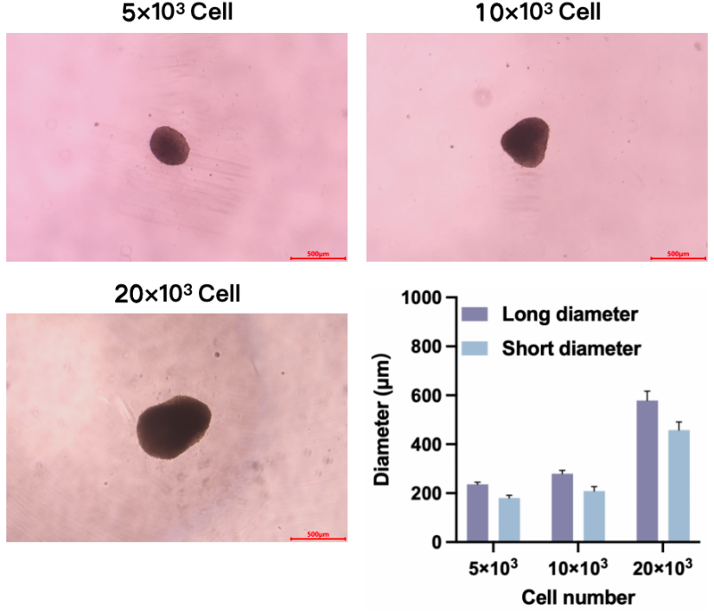

**Figure 1.** Optical microscopy images and diameter statistics of keratinocyte spheroids with different cell numbers.

**Conclusion/Discussion.** This study successfully developed a microneedle patch delivering 3D keratinocyte spheroids, which effectively modulated the inflammatory wound microenvironment and enhanced diabetic wound healing. This platform presents a promising approach for advancing cell-based therapies in tissue engineering application.

**References:**

(1) X. Wu et al (2023) Adv. Mater. 35:2301064

(2) S.-W. Kim et al (2021) Biomaterials 28:75