Population Pharmacokinetic Modelling of Docetaxel in Geriatric Patients with Solid Tumors
Shomita Shetty1, Khusboo Gandhi1, Aditi Shirsat1, Nitesh Chavan1, Manjunath Nookala1, Anant Ramaswamy2, Kumar Prabhash2, Vanita Noronha2, Amit Joshi2, Vikram Gota1; 1Clinical Pharmacology, ACTREC, Tata Memorial Center, Navi Mumbai, Maharashtra, INDIA; 2 Department of Medical Oncology, Mumbai, Maharashtra, INDIA

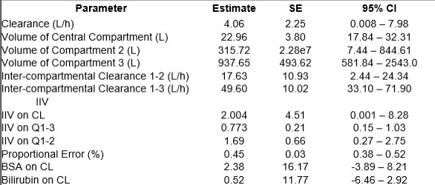
Introduction. Docetaxel is widely used for solid tumors but shows high pharmacokinetic (PK) variability, especially in elderly patients, likely due to age-related physiological changes. Characterizing its PK in this population may optimize efficacy and reduce toxicity.
Aims. To develop a population pharmacokinetic (PopPK) model of docetaxel in geriatric patients (≥60 years) with solid tumors. Methods A total of 122 patients was enrolled, and plasma
samples from 100 patients were analyzed. A published adult docetaxel PopPK model served as the structural model framework. A three-compartment model with 1st order elimination was implemented using nonlinear mixed-effects modeling (Pumas v2.4.1). Between-subject variability (BSV) was assumed log-normally distributed. Residual error was evaluated using additive, proportional, and combined error models. Covariates (age, sex, body surface area [BSA], albumin, bilirubin, α-acid glycoprotein, and genetic polymorphisms) were tested using stepwise forward inclusion (α = 0.05) and backward elimination (α = 0.001).
Results. A three-compartment model with proportional residual error best described docetaxel concentrations. Clearance (CL) was estimated at 4.06 L/h (95% CI: 0.008–7.98), markedly lower than reported adult values (18 L/h), indicating higher drug exposure in the elderly population. Covariate analysis identified BSA and bilirubin as significant predictors of clearance, reducing the objective function value.
Discussion. This study establishes a population PK model of docetaxel in geriatric patients, demonstrating substantially reduced clearance compared to adult populations. The significant influence of BSA and bilirubin on clearance highlights the need for individualized dosing strategies in elderly patients to optimize safety and efficacy. Acknowledgement. The authors are grateful to ICMR for funding this study (Grant #55/4/13/CARE-CP/2018-NCD-II )

