Changes in pregabalin use and misuse following government interventions and media coverage
Rose Cairns^{1,2}, Firouzeh Noghrehchi¹, Sallie-Anne Pearson³, Jonathan Brett^{2,3}, Andrea L Schaffer⁴, Nicholas A Buckley^{1,2}. Faculty of Medicine and Health, School of Pharmacy, The University of Sydney¹, Sydney, NSW, Australia; New South Wales Poisons Information Centre², Sydney, NSW, Australia; School of Population Health, University of New South Wales³, Sydney, NSW, Australia; The Bennett Institute for Applied Data Science, University of Oxford⁴, Oxford, UK.
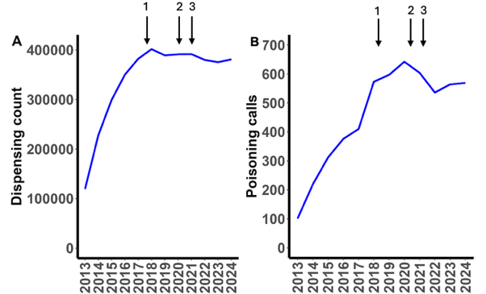
Introduction. Pregabalin use and overdose in Australia increased rapidly following its subsidy on the Pharmaceutical Benefits Scheme (PBS) in 2013, with several recent attempts to curb use and harms.
Aims. To evaluate trends in pregabalin use and overdose in Australia, including the impact of media coverage (December 2018), restrictions on prescribing/dispensing (April 2020), and boxed warnings (February 2021).
Methods. A changepoint and latent class analysis of dispensing (PBS) and overdose data (from NSW Poisons Centre, Australia’s largest poisons centre).
Results. Pregabalin use peaked in 2018 before plateauing and declining (Fig. 1). There were three breakpoints in dispensing data with significant changes in level and slope: December 2018, May 2020 and December 2021. The combined effect was a decrease in dispensing, rate ratio (RR) 0.748 (95% CI 0.700, 0.800). All breakpoints were also associated with slope changes for poisonings. This resulted in an estimated 41.3 (26.9, 52.4) fewer monthly pregabalin overdose calls in December 2021 (compared to counterfactual). The latent class analysis revealed four groups, with high-risk users (13.5%) more likely male, younger, dispensed more pregabalin, with shorter refill interval and high rates of opioids and benzodiazepine co-use (68.5% and 34.3%, respectively). Overall (i.e. in all users), concomitant use of pregabalin and opioids dropped from 56.1% in 2016-17, to 46.8% in 2023-24.
Figure 1: Yearly trends in (A) pregabalin dispensings and (B) pregabalin poisonings. Arrows show: 1. media coverage, 2. restrictions and 3. boxed warnings
Discussion. Pregabalin use and overdose in Australia has declined in recent years. Significant changes in trend were seen corresponding with widespread media coverage (December 2018), and re-scheduling (May 2020). The third breakpoint may be a delayed impact of boxed warnings (implemented February 2021). Co-use with opioids has also declined. Similar measures could be considered in other countries where pregabalin misuse is of concern.

