Optical interrogation of pain neuromodulatory mechanisms
Cyril Goudet, Institut de Genomique Fonctionnelle, IGF, Université de Montpellier, CNRS, INSERM, Montpellier, France

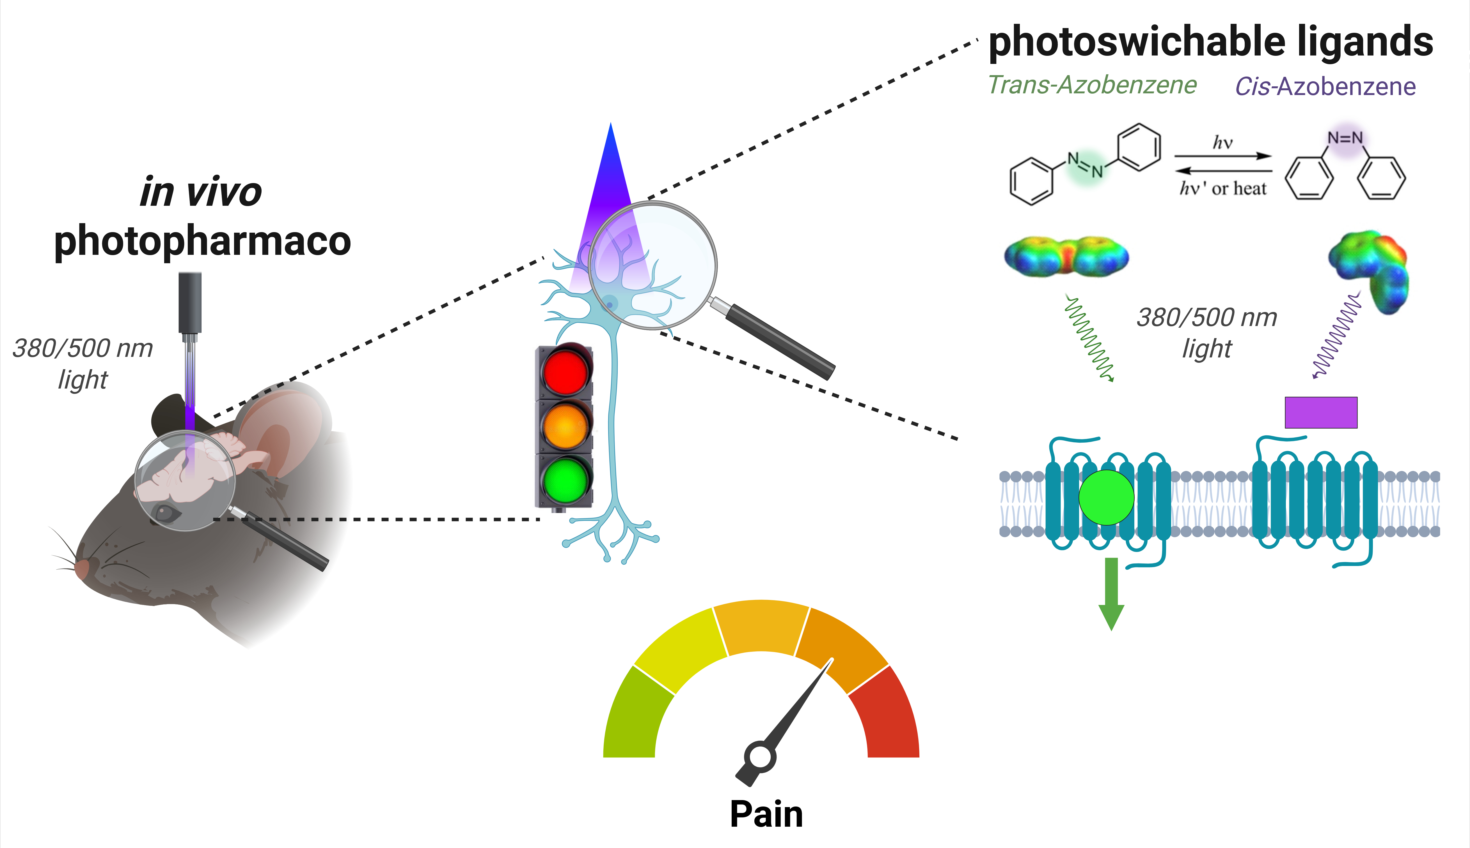
Introduction. Pain is an essential survival mechanism that helps maintain physical integrity and promotes healing and recovery. However, once pain becomes chronic, it has a significant negative impact on quality of life and requires appropriate management. Chronic pain is a common, intractable problem affecting approximately 20% of the world's population. In addition to causing exaggerated responses to both painful (hyperalgesia) and non-painful stimuli (allodynia), it is often associated with emotional and cognitive comorbidities, in particular mood changes such as depression, anxiety, fatigue and sleep disturbance.
Aims. Understanding molecular and cellular mechanisms of pain contributes to our general understanding of the nervous system and neurobiology. It is also essential for improving pain management, developing more effective and less harmful treatments, and improving the quality of life of people suffering from chronic pain.
Methods. Photopharmacology is an emerging light-based strategy to manipulate biological processes with high spatiotemporal precision. It relies on the use of photosensitive ligands, enabling the photocontrol of drug/target interactions and their consequent biological activities. To control endogenous brain mechanisms with light and explore their role in pain neuromodulation, we are developing freely diffusible, light-controlled ligands that will enable specific photocontrol of endogenous G protein-coupled receptors.
Results and discussion. During this presentation, I will present our efforts to develop photoswitchable ligands and their use in combinations with optical technologies to identify the specific role of certain GPCRs in the regulation of symptoms associated with chronic pain at different levels of the pain neuraxis.

