**Microglia membrane-mediated trans-blood-brain barrier prodrug micelles**

**enhance phagocytosis for glioblastoma chemo-immunotherapy**

**Sufen Li1, Jingyan Zhang1**

Zhejiang University, College of Pharmaceutical Sciences1, Zhejiang, China;

Department Name, Organisation2, City, State, Country.

**Background and aims.** We propose MM-camouflaged prodrug micelles (CSSOssMIT@MMPEP20) integrating mitoxantrone (MIT) and the anti-CD47 peptide PEP20 to enhance glioblastoma (GBM) treatment. This system targets the blood-brain barrier (BBTB). Mechanistically: 1) MIT chemotherapy kills GBM cells and induces immunogenic cell death ("eat me" signal); 2) PEP20 blocks the CD47 "don't eat me" signal, boosting phagocytosis of GBM cells by glioma-associated microglia/macrophages (GAMs); 3) Phagocytosis promotes antigen presentation, activating adaptive immunity against GBM. Efficacy was evaluated in vitro and in vivo.

**Methods.**

CSSOssMIT@MM-PEP20 was synthesized via lipid extrusion. Its BBTB traversal was tested in a BBTB-GL261 dual chamber model. Anti-GBM efficacy was evaluated through in vitro assays on GL261 cells and in vivo studies in an orthotopic GBM mouse model, with assessments of tumor inhibition, immune cell infiltration, and GAMs phagocytosis.

**Results.**

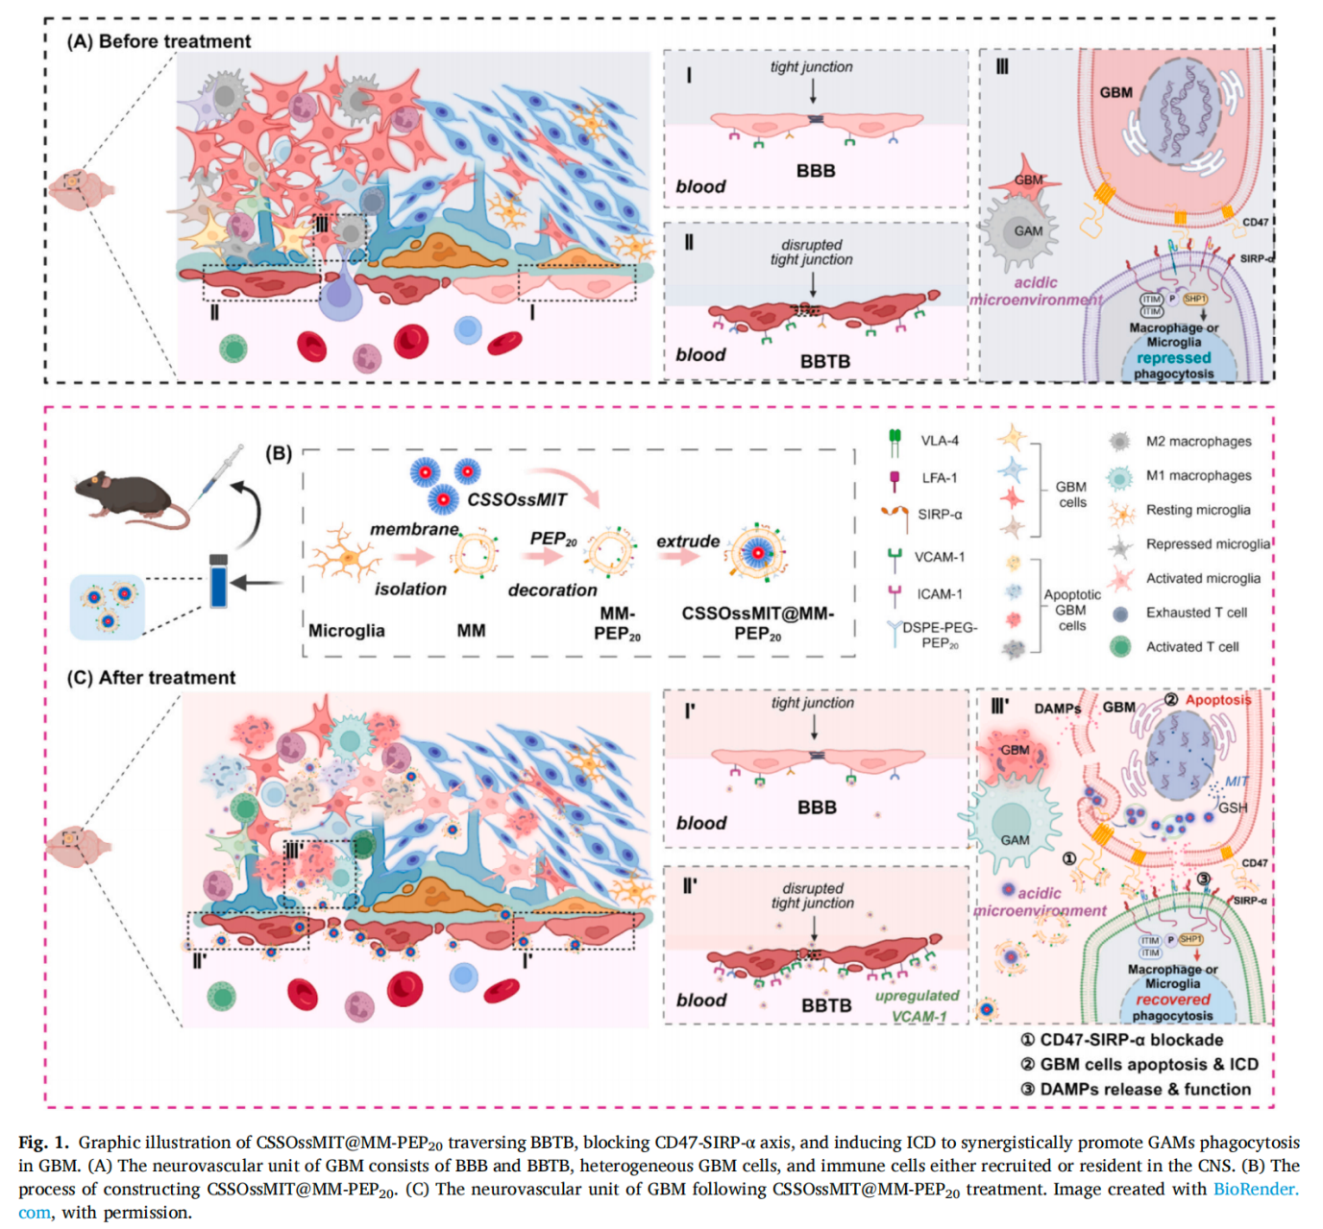

**Fig. 1.** Graphic illustration of CSSOssMIT@MM-PEP20 traversing BBTB, blocking CD47-SIRP-α axis, and inducing ICD to synergistically promote GAMs phagocytosis in GBM

**Conclusion/Discussion.** We developed microglia-mimicking membrane-camouflaged prodrug micelles (CSSOssMIT@MM-PEP20) for synergistic GBM chemoimmunotherapy. The MM camouflage significantly enhanced BBTB traversal and GBM targeting, enriching drug delivery. The system co-delivers the ICD inducer MIT and the CD47-SIRPα blocking peptide PEP20 into the GBM microenvironment. This dual action releases "eat me" signals while blocking "don't eat me" signals, promoting GAM phagocytosis of tumor cells. Concurrently, it reprograms GAMs from pro-tumor M2 to anti-tumor M1 phenotype and activates anti-GBM T cells, achieving remarkable tumor inhibition in vitro and in vivo.

**References:** We acknowledge the contributions of all team members in Hu&Yuan's lab andthe facilities provided by Zhejiang University.