Triterpenoids from Potentilla chinensis Inhibit RANKL-Induced Osteoclastogenesis in Vitro and in Vivo
Byung Sun Min¹, Trong Trieu Tran¹, Manh Tuan Ha¹, Jeong Ah Kim², Seung Eui Min³.
College of Pharmacy, Daegu Catholic University¹, Kyungsan, Gyeonbuk, Republic of Korea;
College of Pharmacy, Kyungpook National University², Daegu, Republic of Korea;
Human and Environmental Toxicology, Korea Institute of Toxicology³, Daejeon, Republic of Korea.

Background and aims. The purpose of this study was to investigate the inhibitory activity of the isolated triterpenoids from Potentilla chinensis on RANKL-induced osteoclast formation and function in vitro. Additionally, we investigated the effect of the most active compound on LPS-induced osteoclast formation and bone loss in a mouse model.

Methods. The dried aerial part of P. chinensis (3.1 kg) was extracted with MeOH. The combined extract was concentrated by using a rotary evaporator to finally obtain 900 g crude MeOH extract. The crude extract was suspended in 2L of H₂O, and then respectively partitioned with n-hexane, CH₂Cl₂, EtOAc, and n-butanol at a 1:1 volume ratio to yield n-hexane (30 g), CH₂Cl₂ (64 g), EtOAc (30 g), and n-butanol (82 g) fractions, respectively. We obtained eleven compounds (1-11) from CH₂Cl₂ and EtOAC fractions by various chromatography methods.

Results. A phytochemical investigation on the methanol extract of P. chinensis let to the isolation of eleven triterpenoids (1-11, Fig. 1). Their structures were identified using comprehensive spectroscopic analysis. Among them, 3-epi-corosolic acid (5) showed potential anti-osteoclastogenic activity against RANKL-induced osteoclast formation. 5 attenuated RANKL-induced MAPKs and NK-kB activation, leading to the inhibition of c-Fos and NFATc1 activation.

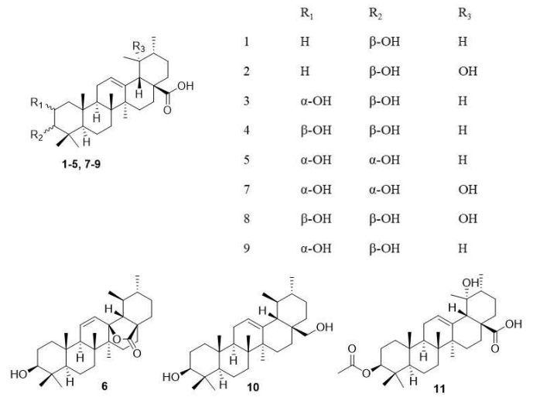

Figure 1. Structure of eleven triterpenoids (1-11) isolated from P. chinensis.

Conclusion/Discussion. 5 was isolated from P. chinensis for the first time and found to be a potent anti-osteoclastogenic agent. Mechanically, 5 effectively inhibited RANKL-induced activation of MAPKs and NF-kB pathways, therefore inhibiting the subsequent activation of c-Fos and NFATc1 transcription factors. Importantly, 5 protects against inflammation-induced bone loss by preventing OC formation in a mouse model.

References:
(1) Tran, TT. et al (2024) Chem. Biodiversity e202402011.
(2) Ha, MT. et al (2025) Bioorganic Chemistry 143:107066.

