GPCR drug discovery using DNA encoded libraries: Identification of novel GPR88 ligands
Natalie A Diepenhorst¹, Jon Merlin¹, Sheng Yu Ang¹, Luke Adams², Ylva Bozikis³, Greg Stewart¹, Chris Langmead¹. ¹Molecular and Translational Drug Discovery, Drug Discovery Biology, Monash Institute of Pharmaceutical Sciences, Australia; ²Monash Fragment Platform, Monash Institute of Pharmaceutical Sciences, Australia; ³Australian Translational Medicinal Chemistry Facility, Monash Institute of Pharmaceutical Sciences, Australia
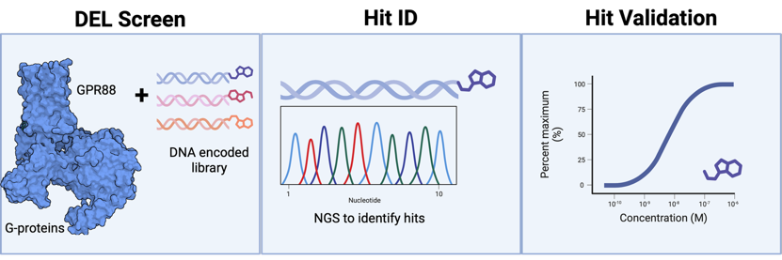
Introduction. GPR88, an orphan GPCR enriched in the striatum, regulates reward and cognition, and its agonism reduces alcohol self-administration, making it a promising therapeutic target for substance use disorders. However, previous small molecule drug discovery campaigns have failed to yield tractable leads, and published chemotypes lack drug-like properties.
Aims. We have leveraged our experience with GPR88 biochemistry collaborating with the Monash Fragment Platform (MFP) to perform a DNA-encoded library (DEL) screen to identify novel chemotypes for GPR88 drug development.
Methods. GPR88 with and without G-proteins was purified in detergent micelles for use in the HitGen DEL screen performed by the MFP. DEL hits were identified and triaged for synthesis based on their druglike properties and unique chemotypes. Synthesised hits were then validated using a cAMP assay testing for both agonist and antagonist behaviour of the compounds.
Results. This successful DEL screen identified several novel chemotypes for GPR88. Functional validation revealed a number of these displayed weak agonist properties in a cAMP assay and serve as a good starting point for future medicinal chemistry efforts.
Discussion. DEL screening for GPCRs is difficult due to the micelle/membrane embedded nature of this type of receptor. We leveraged our vast experience in GPR88 biochemistry with the DEL experience of the MFP to enable a successful screening campaign resulting in novel leads for the development of therapeutics targeting GPR88 as a novel means to treat substance use disorder.

