Quantification of non-persistence to medication across countries, dosing frequencies, and therapeutic areas
Antoine Pironet¹, David Faria Morgado¹, Bernard Vrijens^{1,2}. AARDEX Group¹, Belgium. Liège University², Belgium
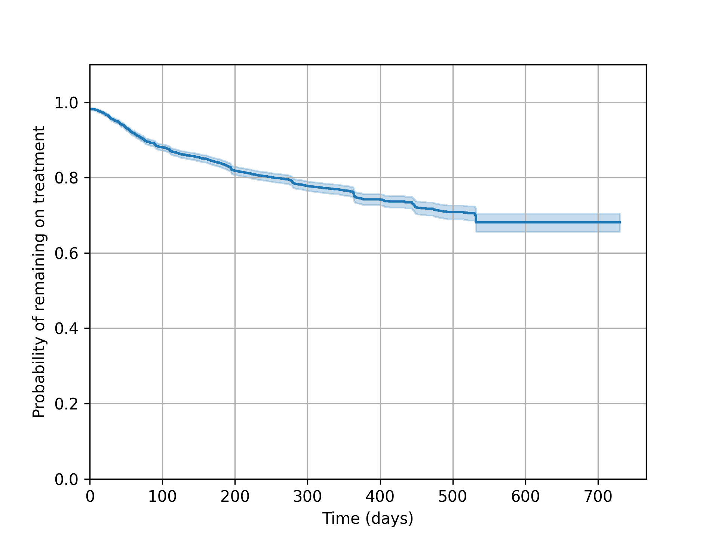
Introduction. Participant dropout is frequent in clinical trials and must be accounted for when planning and running such a trial. Electronic monitoring of medication intakes allows to precisely determine when a participant stopped taking their treatment.
Aims. Obtain insights into persistence to treatment across countries, dosing frequencies, and therapeutic areas.
Methods. Anonymized data from 21 studies totalling 6,477 participants were pooled. These studies enrolled a median number of 95 participants (Q1: 39, Q3: 500). Medications had to be taken mostly once (7/21) or twice (6/21) daily. Participants were followed up for a median number of 168 days (Q1: 84 days, Q3: 365 days). The time between the first and last dose was determined using a previously published algorithm [1]. When available, sponsor-provided information about whether a participant discontinued their treatment was used. A Kaplan-Meier survival curve was built from the pooled dataset.
Results. The figure shows the overall Kaplan-Meier survival curve. One-year persistence was 76%. The initial drop in the curve is caused by 3% participants who never initiated the prescribed treatment.
Discussion. A similar analysis was performed in 2012 on data from 95 studies using electronic monitoring of adherence [2]. In [2], non-initiation was 2%, corresponding with our findings. In [2], one-year persistence was 60 %. We believe this difference can be explained by the introduction of interventions to improve adherence based on electronic monitoring data. Non-persistence is only one aspect of medication adherence and the quality of implementation must also be taken into account when characterizing medication adherence.

[1] Misdrahi D et al (2018) Schizophr Res, 193 :114-118.
[2] Blaschke TF et al (2012) Annu Rev Pharmacol Toxicol, 52(1):275-301.

