Pongamia pinnata Extracellular Vesicles Protect Against Obesity-Related Blood–Brain Barrier Dysfunction
Vetriselvan Subramaniyan. Department of Pharmacology, Sir Jeffrey Cheah Sunway Medical School, Faculty of Medical and Life Sciences, Sunway University, Malaysia
Email: vetris@sunway.edu.my

Introduction. Bioactive phytochemicals with anti-inflammatory, anti-apoptotic, and antioxidant properties are abundant in the Southeast Asian tree Pongamia pinnata. These compounds have shown therapeutic potential in mitigating cellular dysfunctions, including blood–brain barrier (BBB) damage associated with obesity.
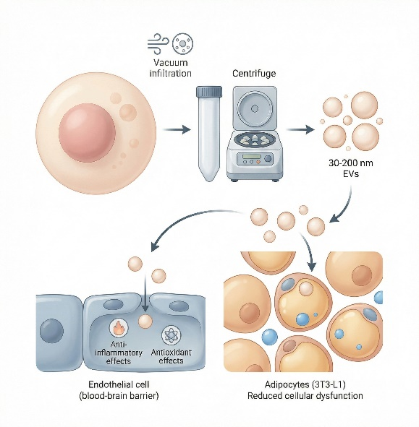
Aims. This study aimed to isolate and characterize extracellular vesicles (EVs) from P. pinnata
leaves and to evaluate their in vitro effects on obesity-related BBB dysfunction.
Methods. Fresh P. pinnata leaves were vacuum-infiltrated with phosphate-buffered saline, followed by apoplastic fluid collection and differential ultracentrifugation to obtain high-purity EVs (30–200 nm). Vesicles were characterized using zeta potential measurement, Fourier Transform Infrared Spectroscopy, Energy-Dispersive X-ray analysis, UV–Vis spectroscopy, Scanning Electron Microscopy, and HPLC for phytochemical profiling. The anti-inflammatory and antioxidant activities relevant to BBB integrity were assessed in vitro using 3T3-L1 adipocytes.
Results. The EVs were successfully isolated and characterized, confirming their size, stability, and phytochemical content. In vitro assays demonstrated that P. pinnata EVs exhibited significant anti-inflammatory and antioxidant effects on 3T3-L1 adipocytes, suggesting a protective role in maintaining BBB integrity under obesity-induced stress.
Discussion. This eco-friendly, plant-based approach provides a novel and cost-effective strategy to investigate the therapeutic potential of P. pinnata EVs. The findings support their use as a promising intervention for BBB dysfunction associated with obesity and related metabolic disorders.
Keywords
Pongamia pinnata; Extracellular vesicles; Blood–brain barrier; Obesity-induced dysfunction; Plant-based therapeutics

