Fruit Based Dual PI3K-mTOR Inhibitors Against Ovarian Cancer: AI-driven Bioinformatic Analysis
Mangala Shenoy K¹, Suvarna G Kini¹.

Department of Pharmaceutical Chemistry, Manipal College of Pharmaceutical Sciences¹, Manipal Academy of Higher Education (MAHE), Manipal, Karnataka, India.

Background and aims. Ovarian cancer is one of the most commonly affecting gynaecological cancers. Even though there are chemical drugs and their derivatives for the treatment of ovarian cancer, due to their side effects there is still way for new drugs to combat the disease. This study aims at developing an e-pharmacophore hypothesis for virtual screening of natural product database and to obtain best hits from natural origin against ovarian cancer.

Methods. In this project, we have developed an e-pharmacophore model for pharmacophore based virtual screening of different natural product databases using Schrodinger maestro 2025-1 version. We have retrieved herbal ingredient targets and watermelon database, which was screened against the built pharmacophore model and top ten hits from each were selected for docking¹. Selected hit compounds were docked against two proteins 5DXT and 5GPG for PI3K and mTOR respectively. The two hit compounds from each library were further taken for molecular dynamic simulation studies followed by ADME and MMGBSA analysis^{2,3}.

Results. A five-point e-pharmacophore was built using multi-ligand module in Schrodinger software as shown in Figure 1. Selected 2 hits revealed good binding affinity in pockets of both 5DXT and 5GPG which showed crucial interactions such as VAL851. Interestingly, these compounds were found to be Chrysoeriol glucuronide and Quercetagetin present in Citrullus lanatus (watermelon) and Citrus reticulata (mandarin orange) respectively. Docking scores of both the hit compounds are depicted in table 1. Simulation studies of these compounds showed stable RMSD plots.
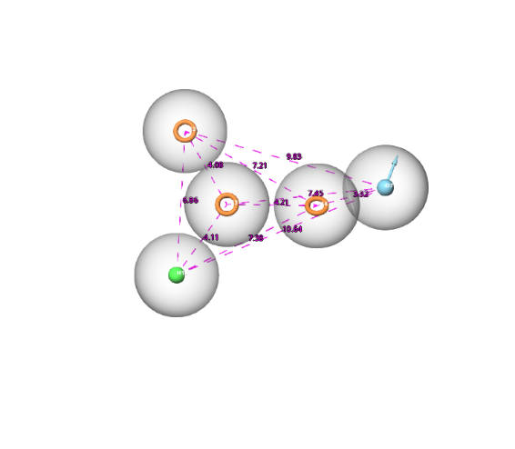
Hit compounds | 5DXT (Kcal/mol) | 5GPG  (Kcal/mol)
Chrysoeriol glucuronide | -16.407 | -8.905
Quercetagetin | -14.590 | -9.842

Table 1. Docking score of selected hits compounds.
Figure 1. e-pharmacophore model.

Conclusion/Discussion. We identified two best hits, Chrysoeriol glucuronide and Quercetagetin which have shown good interactions with 5DXT and 5GPG PDB for PI3K and mTOR respectively. Our study concludes that these fruit-based compounds can become new therapeutic agents against ovarian cancer.
References:
1. Mize, B. K., Salvi, A., Ren, Y., Burdette, J. E., & Fuchs, J. R. (2023). Discovery and development of botanical natural products and their analogues as therapeutics for ovarian cancer. Natural product reports, 40(7), 1250–1270. https://doi.org/10.1039/d2np00091a
2. Belaiba, M., Aldulaijan, S., Messaoudi, S., Abedrabba, M., Dhouib, A., & Bouajila, J. (2023). Evaluation of Biological Activities of Twenty Flavones and In Silico Docking Study. Molecules (Basel, Switzerland), 28(6), 2419. https://doi.org/10.3390/molecules28062419
3. Opo, F. A. D. M., Moulay, M., Zari, A., Alqaderi, A., Alkarim, S., Zari, T., Bhuiyan, M. A., Mahmoud, M. M., Aljoud, F., Suhail, M., Edris, S., Ramadan, W. S., Kamal, M. A., Nemmiche, S., & Ahammad, F. (2022). Pharmacophore-based virtual screening approaches to identify novel molecular candidates against EGFR through comprehensive computational approaches and in-vitro studies. Frontiers in pharmacology, 13, 1027890. https://doi.org/10.3389/fphar.2022.1027890

Acknowledgements: We thank Manipal College of Pharmaceutical Sciences and Manipal- Schrodinger center for molecular simulations for providing infrastructure for this work.

