Fetal rat ocular development after in utero exposure to elexacaftor-tezacaftor-ivacaftor
Yimin Zhu^{1,}, Holly R. Chinnery², Elena Schneider-Futschik¹. Dept of Pharmacology and Biochemistry, Univ of Melbourne¹, Parkville, VIC, Australia; School of Allied Health Optometry, Univ of Western Australia², Perth, WA, Australia.

Introduction. Elexacaftor-tezacaftor-ivacaftor (ETI) is a highly effective modulator therapy for cystic fibrosis, however there are limited data to confirm its safety on fetal development when used during pregnancy. Recent reports of bilateral cataracts developing in newborns after exposure to ETI in utero highlight the need to analyse its potential risks on fetal ocular development.
Aim. This study aims to investigate whether in utero exposure to ETI will impact the development of fetal rat eyes.
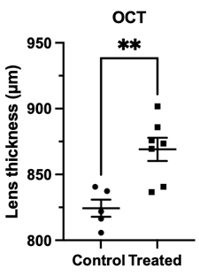
Methods. This study assessed embryonic day 19 (E19) Sprague Dawley rats born to dams given ETI (6.7 mg/kg/day elexacaftor + 3.5 mg/kg/day tezacaftor + 25 mg/kg/day ivacaftor) orally during E12-E19 (n=6 dams) and the control group with sham treatment (n=2 dams). Fetal ocular tissue samples were collected and were investigated using histological analysis, ex vivo optical coherence tomography imaging (OCT) and LC-MS.
Results. ETI was confirmed to maternally transfer into the fetal rat ocular tissues and plasma. There were no significant differences in the biometric parameters of anterior chamber depth, vitreous chamber depth, lens capsule thickness, corneal thickness, and axial length measured. Similarly, the hyper-reflective features and cell counts within the anterior chamber of the two experimental groups were comparable. While there was no compelling evidence of significant lens pathology arising such as lens opacity, the presence of lens cavities was observed in both groups within histology and OCT images. In particular, the median individual lens cavities area was significantly higher within the ETI-exposure rats’ eyes (p < 0.0001) measured on the histology sections. Furthermore, OCT measurements indicate an increase in the lens thickness in comparison to the control group (p < 0.01).
Discussion. Our results suggest that in utero exposure to ETI during E12-E19 does not significantly alter fetal ocular development. However, considering the lens-related observations in our studies, further investigation to confirm the nature of these phenomena and to ensure the safety of ETI during prenatal exposure is crucial.

