Diesel exhaust particles trigger mast cell alarmin release in asthmatic airway epithelium
Chih-Ming Weng, PhD^{1, 2}, Meng-Jung Lee, MSC¹, Han-Pin Kuo, MD, PhD^{1, 3}
¹Pulmonary Medicine Research Center, Taipei Medical University, Taipei, Taiwan; ²School of Respiratory Therapy, Taipei Medical University College of Medicine, Taipei, Taiwan; ³Department of Bioscience Technology, Center of Nanotechnology, Chung Yuan Christian University, Taoyuan, Taiwan; ⁴Department of Thoracic Medicine, Taipei Medical University Hospital, Taipei, Taiwan
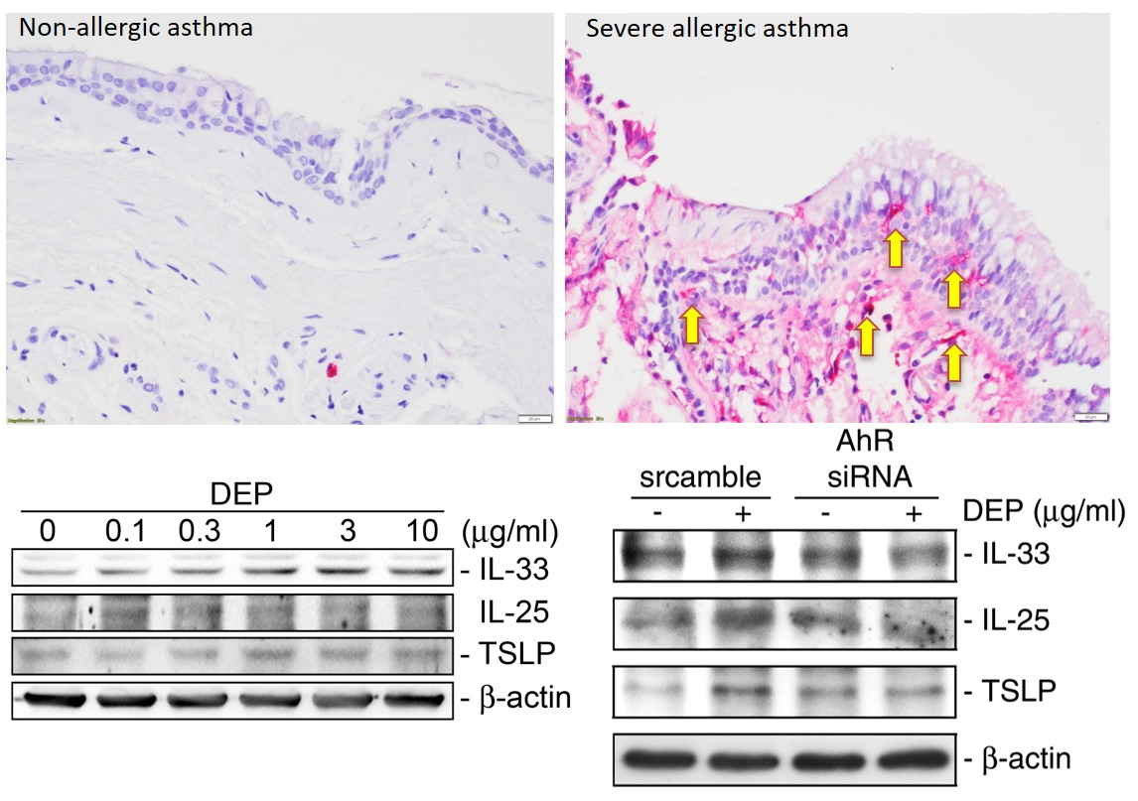
Introduction. Mast cells are implicated in the pathogenesis and severity of asthma in both children and adults. Pro-inflammatory mediators and cytokines released from activated mast cells are associated with evidence of Th2-skewed inflammation.
Aims. Human mast cells exposed to diesel exhaust particulate (DEP), through AhR canonical pathway, synthesized and released alarmins.
Methods. The IHC, western blot, and ChIP assay were performed to determent the effect of DEP on alarmin expression of human mast cells.
Results. The accumulation of mast cells in the airway wall of allergic asthma, as well as in air pollutant-challenged mice. DEP induced the release of IL-33, IL-25, and TSLP in HMC-1 via AhR or NF-κB pathway.
Discussion. Mast cells release a broad spectrum of inflammatory cytokines and chemokines, which drive the immune responses . Mast cells may migrate to airway epithelium resulting in epithelial instability . Our results revealed that increased number of mast cells was found in the airway epithelium of allergic asthmatics or animals. Thus, mast cells in allergic asthmatic patients may be more susceptible to direct exposure to air pollutants, including DEP. that DEP induced mast cells to produce IL-33, IL-25 and TSLP at mRNA and protein levels through AhR.
Galli et al (2008) Nat Rev Immunol 8: 478-486
Altman et al (2019) J Clin Invest 129: 4979-4991

