Pharmacokinetics, and efficacy/safety, of thioguanine suppositories in patients with refractory proctitis
Murray L Barclay¹, Nathan SS Atkinson², Zoe Raos², Chris JJ Mulder³, Tim Florin⁴. Dept of Clinical Pharmacology, Christchurch Hospital¹ NZ; Shakespeare Specialist Centre², Auckland, NZ; Dept of Gastroenterology & Hepatology, AUMC³, Amsterdam, The Netherlands; Mater Research⁴, University of Queensland, Woolloongabba, QLD, Australia.

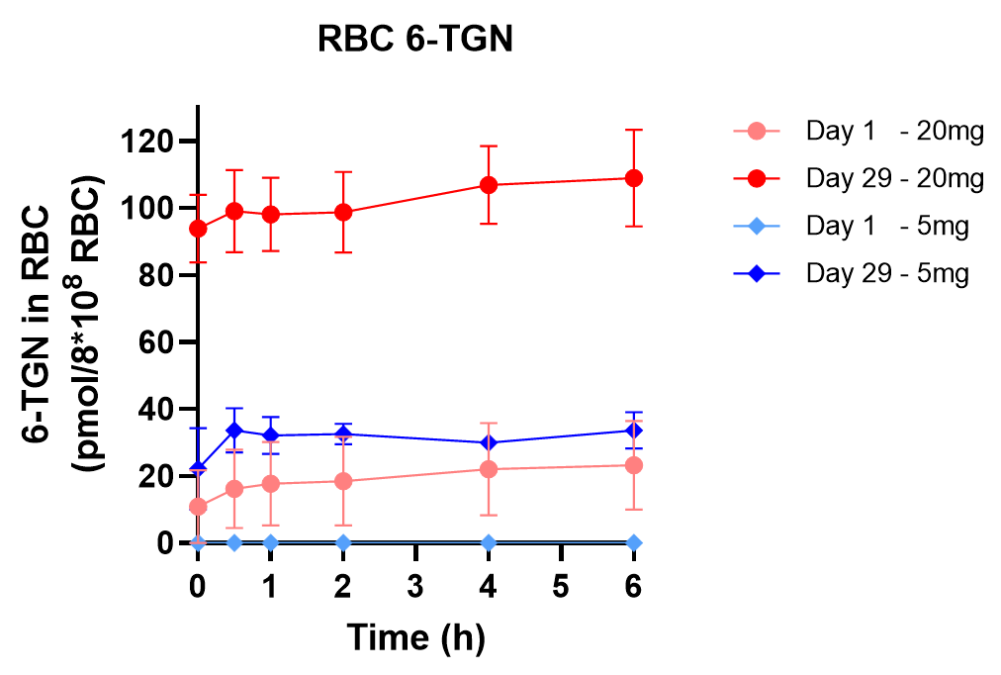
Introduction. Refractory proctitis can be difficult to manage even with newer inflammatory bowel disease treatments. A case series showed that rectal thioguanine appears to have a high rate of response. Thioguanine suppositories have been developed in NZ (Douglas Pharmaceuticals).
Aims. To assess the pharmacokinetics of thioguanine (TG) and its metabolite 6-thioguanine nucleotides (TGN), and assess for efficacy and safety signals, following rectal administration of thioguanine suppositories.
Methods. Eight patients with refractory ulcerative proctitis were prescribed either 20mg (n=6) or 5mg (n=2) thioguanine suppositories at night for 4 weeks. The pharmacokinetics of TG and TGN was assessed over 6h on days 1 and 29. Efficacy was assessed using weekly disease activity, and endoscopy scores before treatment and on day 29. Safety was assessed by weekly questionnaire and blood testing.
Results. RBC TGN concentrations on days 1 and 29 are shown in Figure 1. Clinical response at 4 weeks (SCCAI ≥3 point reduction) occurred in 8/8 patients (100%) and remission (SCCAI<3) in 3/8 (38%). Endoscopic remission (Mayo score 0 or 1) occurred in 6/8 patients (75%). UCEIS improved in 7/8 patients (88%) with remission in 4/8 (50%). No adverse effects were reported.
Discussion. In this phase IIa study, the efficacy at 4 weeks has high, without toxicity, with thioguanine 20mg or 5mg suppositories. TGN concentrations observed in RBCs were ~10-fold lower than seen with similar doses given orally.

