What attributes influence antihypertensive prescribing to older adults? A discrete choice experiment.
Edel O'Hagan¹, Ann Livingstone², Thomas Gadsden³, Timothy Usherwood^{1,3}, Tu Nguyen^{3,4}, Aletta E Schutte^{3,5}, Anne Tiedemann^{4,6}, Richard I Lindley¹, Anthony Rodgers³, Stephen Jan³, Clara K Chow^{1,7}.Westmead Applied Research Centre, USyd¹, NSW; Institute for Health Transformation, Deakin Uni², VIC; The George Institute for Global Health, UNSW³, NSW; Sydney School of Public Health, USyd⁴, NSW; School of Population Health, USyd⁵, NSW; Institute for MSK Health, USyd⁶, NSW; Dept of Cardiology, Westmead Hosp⁷, NSW, Australia.
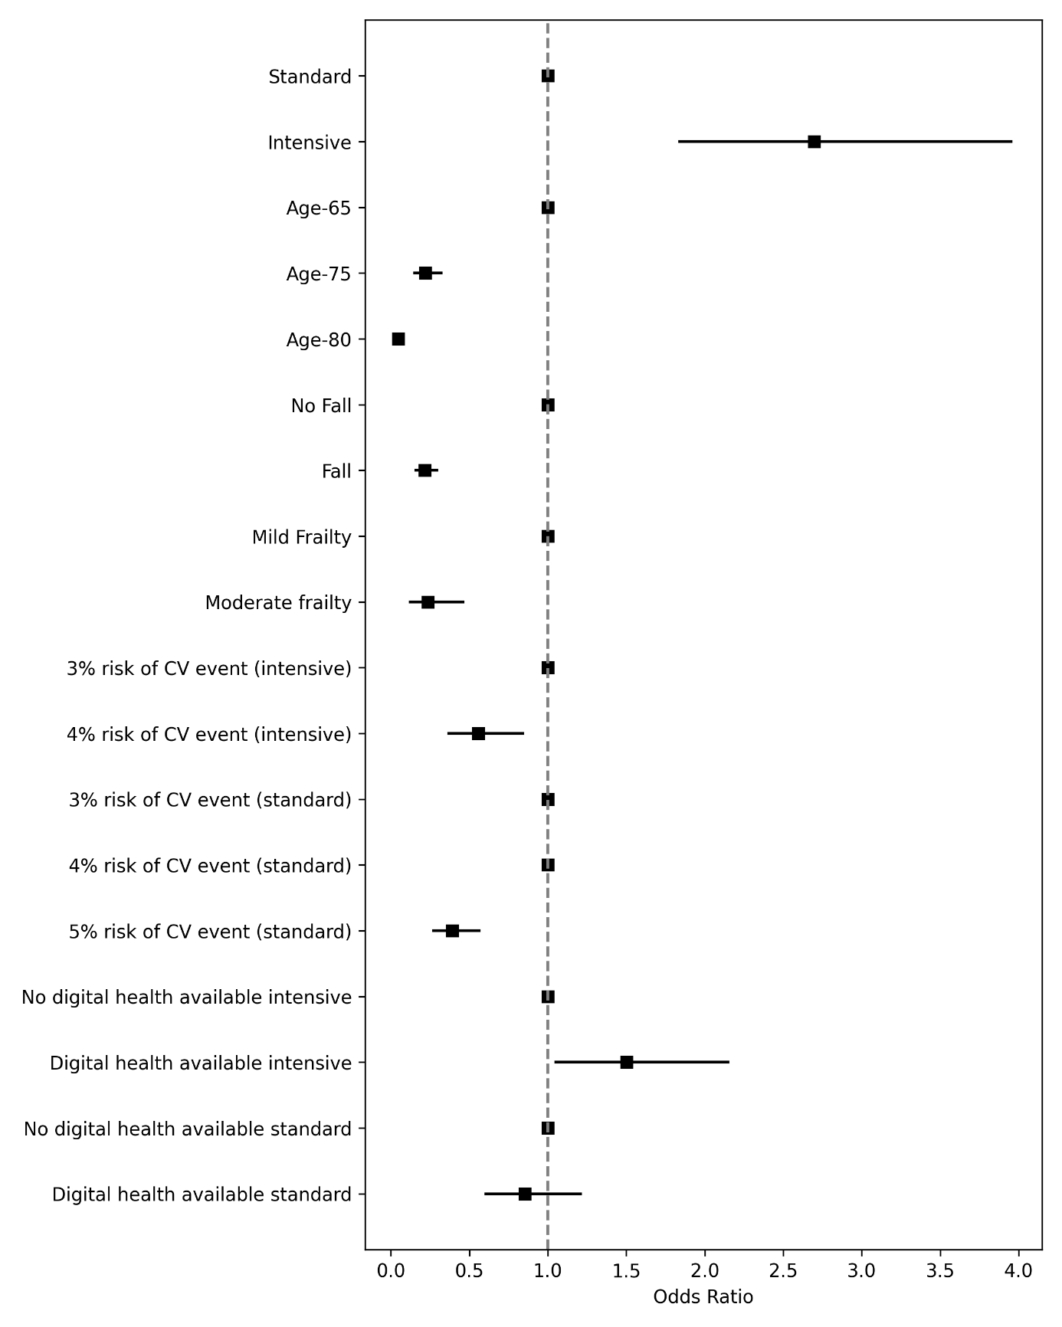
Introduction. Clinical inertia in managing high BP among older adults contributes to preventable cardiovascular events. Understanding prescribing preferences can inform strategies to support appropriate treatment intensification.
Aims. To explore how clinicians weigh patient characteristics and contextual factors when deciding whether to intensify antihypertensive treatment in adults aged ≥65 years.
Methods. An online discrete choice experiment surveyed Australian doctors who prescribe BP-lowering medications. Respondents chose between intensive (≤130 mmHg) and standard (131–150 mmHg) systolic BP targets across hypothetical patient scenarios varying by age, frailty, fall history, cardiovascular risk, and access to digital health data. Mixed logit models and latent class analysis were used.
Results. Clinicians favored intensive targets overall, but were less likely to do so for patients aged ≥80, with recent falls or moderate frailty. Higher cardiovascular risk and access to digital health data increased the likelihood of intensive prescribing. Two clinician subgroups emerged: digital health adopters and hesitant users.
Discussion. Prescribing decisions are shaped by clinical risk, patient vulnerability, and digital data availability. Digital health tools may support more intensive treatment decisions and help address clinical inertia.

