Hypertensive response to exercise, fitness, left ventricular hypertrophy and cardiovascular outcomes.
Catalina P Silva-Ruiz¹, James E Sharman¹, Petr Otahal¹, Tony Staton², Alison J Venn¹, Thomas H Marwick^{1,3}, Martin G Schultz¹. Menzies Institute for Medical Research, University of Tasmania¹, Hobart, TAS, Australia; Sunshine Coast University Hospital², Birtinya, QLD, Australia; Royal Hobart Hospital³, Hobart, TAS, Australia.

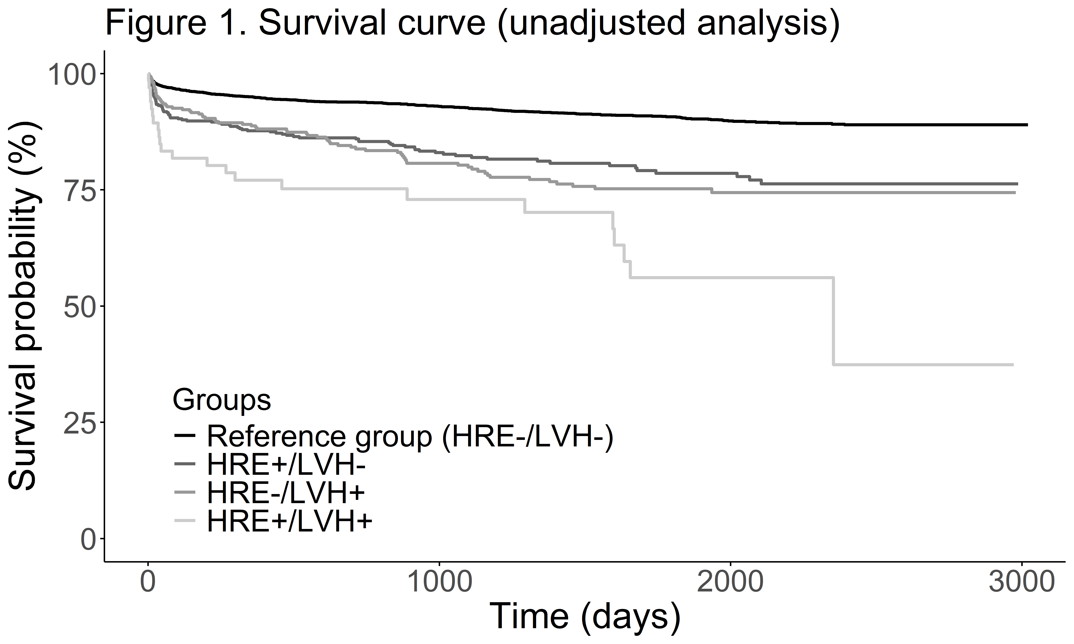
Introduction. A hypertensive response to exercise (HRE) is associated with left ventricular hypertrophy (LVH), both increasing cardiovascular disease (CVD) risk. However, aerobic capacity (fitness) may confound these associations.
Aims. To investigate the association of an HRE relative-to-fitness and LVH with risk of fatal and non-fatal CV events.
Methods. Data from 5,086 individuals (aged 57.9±12.7 years, 53.1% male) who underwent exercise stress echocardiography were linked to hospital records and death registers to assess CV events. An HRE relative-to-fitness was defined as peak systolic (SBP) divided by peak metabolic equivalents (MET) ≥90th percentile (30 mmHg/MET_{peak}). LVH was defined as LV mass indexed to body surface area ≥115 g/m² (men) and ≥95 g/m² (women). Cox-proportional hazard regression models, adjusted for age, sex, pre-exercise SBP, and CVD history, were used to evaluate CV event risk across groups defined by combinations of presence/absence of HRE (HRE+/HRE-) with LVH (LVH+/LVH-).
Results. A total of 543 CV events were observed over a mean follow-up of 46.7±27.3 months. There was a stepwise increased risk of CV events (Figure 1) across groups: HRE+/LVH- (adjusted HR:1.46, 95%CI:1.13,1.90), HRE-/LVH+ (adjusted HR:2.20, 95%CI:1.71,2.85), HRE+/LVH+ (adjusted HR:2.91, 95%CI:1.82,4.65) compared to reference (HRE-/LVH-). Results remained similar in those with pre-test BP <140/90 mmHg or without CVD history and were not apparent when an HRE was defined without consideration of fitness.
Discussion. Individuals with both HRE relative-to-fitness and LVH are at the highest risk of fatal and non-fatal CV events. These findings highlight the importance of evaluating an HRE relative-to-fitness in managing CVD risk, especially in individuals with LVH.

